Topic 1: Innovation and Ideas

<https://innolytics-innovation.com/what-is-innovation/>

What is Innovation? (Definition)

The word “innovation” is derived from the Latin verb innovare, which means to renew. In essence, the word has retained its meaning up until today. Innovation means to improve or to replace something, for example, a process, a product, or a service. In the context of companies, however, the term needs a definition. In the complex context of business, a definition is needed.

*Innovation is a process by which a domain, a product, or a service is renewed and brought up to date by applying new processes, introducing new techniques, or establishing successful ideas to create new value.*

## Why is innovation so important?

Organizations have several options to increase their competitiveness: they can strive for price leadership or develop a strategy of differentiation. In both cases, innovation is essential.

* Companies that choose price leadership must secure their long-term competitiveness by developing innovative, highly efficient processes. Process optimization and continuous improvement in terms of costs are important for them.
* Companies that strive for a differentiation strategy need innovation to develop unique distinguishing features to their competitors.
* Many start-ups launch their activities by developing an innovative product or service.

Continuous innovation is, therefore, crucial for all companies. The main difference is in the focus of the innovation strategy, which varies considerably from company to company.

This makes innovation one of the most important drivers for the long-term success of companies. Accordingly, methods of collaboration and teamwork are increasingly being used in numerous companies, for example,

* to promote digital innovations and
* overcome the challenges of digital change.

Innovation requires a higher degree of [creativity](https://innolytics-innovation.com/barriers-to-creativity-and-innovation/) than the operative business and a clear [innovation strategy](https://innolytics-innovation.com/innovation-strategy/), especially in the phase of the so called “[fuzzy front end of innovation](https://innolytics-innovation.com/fuzzy-front-end-of-innovation/)“.

* Concepts like [lean innovation](https://innolytics-innovation.com/lean-innovation/) and the establishment of community-based [innovation networks](https://innolytics-innovation.com/innovation-network/) become increasingly relevant.
* Companies are using modern [idea management software](https://innolytics-innovation.com/idea-management-software/) and [innovation management software](https://innolytics-innovation.com/innovation-management-software/) to manage innovation efficiently.

## The Right Mindset for Innovation

Innovation requires more creativity and more willingness to take risks than the implementation of typical projects. To successfully realize innovation projects, a different mindset is needed. We have created four cartoons, which you are welcome to include in presentations or on your website with reference (backlink) to this page.

[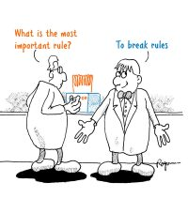](https://innolytics-innovation.com/wp-content/uploads/2020/03/break-rules-what-is-innovation.jpg)

### **Break the rules!**

With traditional approaches and conventional methods, you will often not get anywhere in the field of innovation. Challenge the status quo consistently! And explore new paths off the beaten track.

[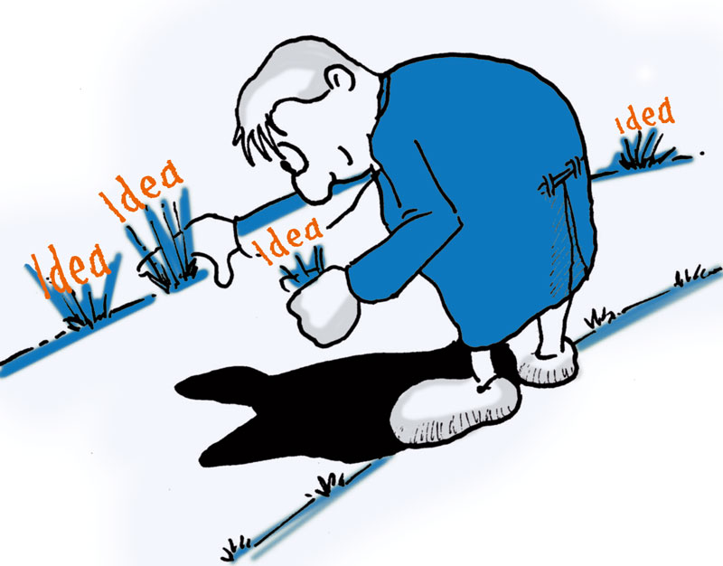](https://innolytics-innovation.com/wp-content/uploads/2020/03/harvest-ideas-what-is-innovation.jpg)

### **Collect ideas everywhere!**

Innovation projects constantly need new ideas: To overcome obstacles, to change concepts, and to optimize strategies.

[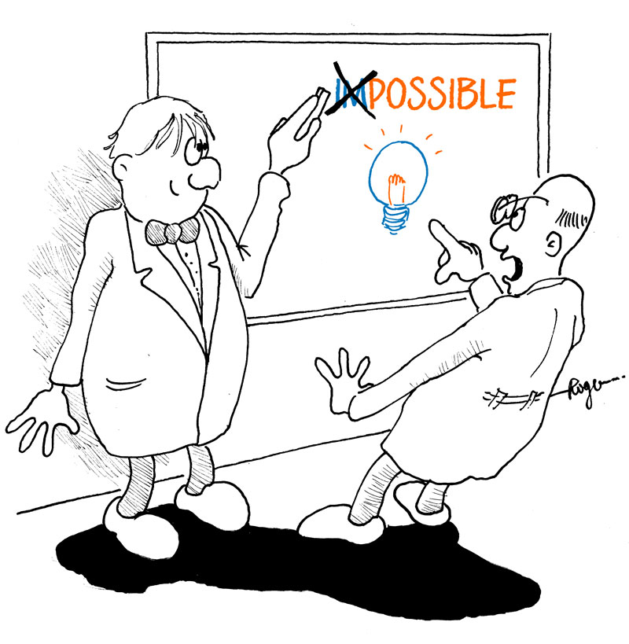](https://innolytics-innovation.com/wp-content/uploads/2020/03/impossible-what-is-innovation.jpg)

### **Believe in the impossible!**

Imagine how your innovation will look like in reality. And believe that you will be able to overcome all obstacles on the way to realization.

[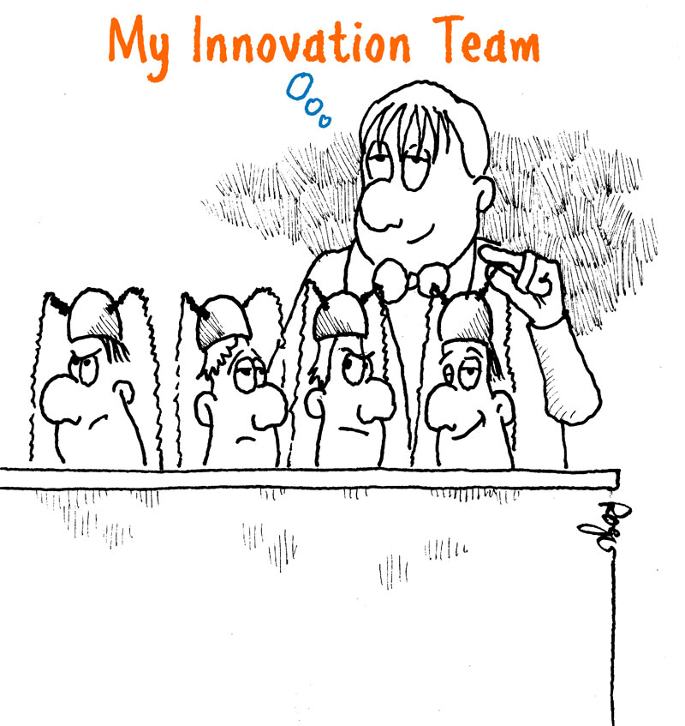](https://innolytics-innovation.com/wp-content/uploads/2020/03/my-innovation-team-what-is-innovation.jpg)

### **Put together an innovation team of individuals with different perspectives and thinking styles!**

Innovation needs the diversity of various competencies and diverse ways of thinking.

## The Different Types of Innovation

In the context of businesses, there are different types of innovation.

* [Process improvement](https://innolytics-innovation.com/key-success-factors-for-process-improvement/)**and**[**organizational innovation**](https://innolytics-innovation.com/organizational-innovation-examples/): The improvement of processes through [continuous improvement](https://innolytics-innovation.com/continuous-improvement-process/) and the development of new solutions.
* [**Product development**](https://innolytics-innovation.com/product-development/): The development of innovative products or product features.
* [**Service innovation**](https://innolytics-innovation.com/serviceinnovation/): The creation and introduction of new services for customers and partners.
* [**Business Model Innovation**](https://innolytics-innovation.com/business-model-innovation/): The development of innovative business models and new revenue streams.

[Digitalization](https://innolytics-innovation.com/what-is-digitalization/) and [digital transformation](https://innolytics-innovation.com/what-is-digital-transformation/) also require companies to rethink and develop new approaches.

VIDEO

https://www.youtube.com/watch?v=ez-YuXMFRTE&t=28s

RESEARCH AND DEVELOPMENT

<https://en.wikipedia.org/wiki/Research_and_development>

Research and development (R&D, R+D), known in [Europe](https://en.wikipedia.org/wiki/Europe) as research and technological development (RTD), is the set of innovative activities undertaken by corporations or governments in developing new services or products and improving existing ones.[[1]](https://en.wikipedia.org/wiki/Research_and_development#cite_note-investopedia-1) [Research](https://en.wikipedia.org/wiki/Research) and development constitutes the first stage of development of a potential new service or the production process.

R&D activities differ from institution to institution, with two primary models[[1]](https://en.wikipedia.org/wiki/Research_and_development#cite_note-investopedia-1) of an R&D department either staffed by [engineers](https://en.wikipedia.org/wiki/Engineers) and tasked with directly [developing new products](https://en.wikipedia.org/wiki/New_product_development), or staffed with [industrial scientists](https://en.wikipedia.org/wiki/Applied_science) and tasked with [applied research](https://en.wikipedia.org/wiki/Applied_research) in scientific or technological fields, which may facilitate future product development. R&D differs from the vast majority of corporate activities in that it is not intended to yield immediate profit, and generally carries greater risk and an uncertain [return on investment](https://en.wikipedia.org/wiki/Return_on_investment). However R&D is crucial for acquiring larger shares of the market through the marketisation of new products.[[1]](https://en.wikipedia.org/wiki/Research_and_development#cite_note-investopedia-1)

# Small & Medium Enterprise (SME) Entrepreneur v. Innovation Driven Enterprise (IDE) Entrepreneur

MIT Instructor Bill Aulet says there are two dramatically different types of entrepreneurs; the Small and Medium Enterprise (SME) Entrepreneur, and the Innovation Driven Enterprise (IDE) Entrepreneur. Learning the distinction is important for aspiring entrepreneurs.

Bill says the two types are fundamentally different. SME entrepreneurs are small companies that will stay small. They tend to focus on local markets, often as a service company, and aren’t particularly looking to go global. Think nail salon, drycleaner, or restaurant. They’re important to the economy and region they serve, but at some point linear growth taps out. There’s cash flow here, just not a tremendous amount of cash flow out again.

When it comes to what Bill calls IDE entrepreneurs, the big difference is you’re looking at global, or super general markets to serve. It’s going to require more cash because the dynamics of and IDE business usually show exponential growth. You’re likely to see negative cash flows here. It will initially require a lot of capital, but if it works, it will take off. Generally, there’s a lot more risk. You have to manage multiple stakeholders as well as the underlying innovation.

TOPIC 2

Value Proposition

<https://corporatefinanceinstitute.com/resources/knowledge/strategy/value-proposition/>

## What is a Value Proposition?

A value proposition is a promise of value stated by a company that summarizes how the benefit of the company’s product or service will be delivered, experienced, and acquired. Essentially, a value proposition specifies what makes the company’s product or service attractive, why a customer should purchase it, and how the value of the product or service is differentiated from similar offerings.

Generally, the value proposition is addressed to the company’s target customers or [target market segment](https://corporatefinanceinstitute.com/resources/knowledge/strategy/total-addressable-market-tam/). The proposition takes the form of a short, clear, and concise statement of the tangible and intangible benefits that will be delivered to customers. The perfect proposition must quickly transmit the values to potential customers without the need for further explanation. Each proposition must be unique, as it is a method to communicate the differentiation points of a company to the [target customers](https://corporatefinanceinstitute.com/resources/knowledge/other/types-of-customers/).

The value proposition must not be confused with slogans and [catchphrases](https://business.linkedin.com/marketing-solutions/blog/7/75-quotes-to-inspire-marketing-greatness), as the latter two may not clearly convey the benefits of a company and its products.

### Importance of a Value Proposition

The development of a value proposition is a vital part of a company’s [business strategy](https://corporatefinanceinstitute.com/resources/knowledge/strategy/corporate-strategy/). Since the proposition provides a company with a method to influence the decision-making of customers, it is frequently displayed on the company’s marketing materials, such as a website.

The value proposition is a powerful tool to drive sales and build a customer base. Additionally, a perfect and compelling value proposition can advance the effectiveness of the company’s [marketing strategies](https://corporatefinanceinstitute.com/resources/knowledge/other/walmart-marketing-mix/). Generally, it is regarded as the most effective and wide-reaching marketing activity.

### How to Create a Value Proposition

As we’ve already determined, the perfectly tailored value proposition can become a huge success factor for a company. However, the creation of a powerful proposition is a challenging yet rewarding task for every business. Below, we have listed some tips that will help you to create an effective one:

#### 1. Know your customers

Before creating your value proposition, you must analyze the market and potential customers. Identify your target customers and target market segment to understand their desired benefits.

#### 2. Understand your costs and benefits

Identify and assess the benefits delivered by your company and its products or services, along with the costs incurred to provide them. It is important to do this because the value to your customers is essentially the difference between the benefits and costs of your product or service.

#### 3. Don’t forget about your competitors

After the analysis of target customers and your own company, evaluate the competitive landscape in the market. Determine the strengths and weaknesses of your major competitors and identify ways you can differentiate your business from them.

#### 4. Be clear and concise

Don’t forget that an effective value proposition is clear and concise. Your target customers must quickly grasp the message you want to convey. It should not exceed two or three sentences.

#### 5. Design is king!

Make your proposition visible and appealing on all marketing materials (e.g., website). Remember that if you have created a powerful value proposition, but no one can see it, the effect of the proposition will be zero!

# Lesson 1:

# https://workshops.unbounce.com/lesson/4-2-features-versus-benefits/

# Features versus Benefits

The difference between features and benefits: A feature is a part of your product or service, while a benefit is the positive impact it has on your customer.

Think about your favorite pair of jeans.

Your favorite pair of jeans has a specific number of threads keeping everything together, a certain length and size, a particular metal for the buttons.

Those are features.

But when asked why you love your favourite jeans, you’re unlikely to say, “I just love the 30 inch waist, the metal buttons and the cotton thread sewn into the seams.”

You’re more likely to say: “They’re so comfortable, they fit really well and I love that they look good with heels or boots.”

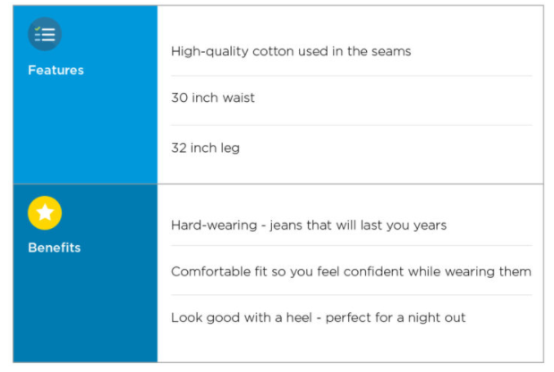

Can you see that the features are the ‘facts’ of the product, while the benefits provide a more compelling description?

Why benefits are so important:

Benefits are important because they answer your customer’s question:  “Why should I care what you have?”

Rather than simply telling your customer what you have or provide, you’re telling them how your product or offer is going to have a positive, valuable impact on their life.

How to identify benefits:

If you think about a feature as the facts and figures of what you offer, a benefit is a combination of:

1. The effect it has on your customer
2. How they feel because of this

A very simple 3-step approach to identifying the benefits of your product is:

1. What does it have or do?
2. What effect does this have on my customer’s life?
3. Does this cause a positive emotion or eliminate a negative emotion (or both)?

For example the benefits for an arthritis drug may be:

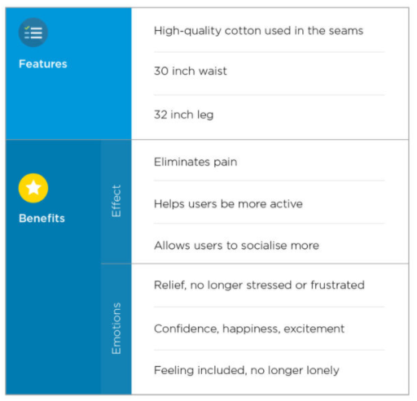

So the benefits of the above may be:

* You get fast-acting relief from pain
* The confidence to take part in the activities you love
* Spend more time with family and friends without the discomfort of arthritic pain

Why features are still important in copywriting:

The phrase: “Sell the benefits not the features” is slightly misleading.

Features are just as important as benefits because they give your customer the proof behind the promise you’re making.

When writing your copy, think about having a conversation with your customer that sounds like this: “This is what you can experience [benefits / emotions] with our product, and here is how we do this for you [features]”

For example: “We promise you best-fitting, most-flattering jeans so you can feel great wherever you wear them. How? By providing more than X combinations of leg and waist lengths to guarantee a fit as unique as you.”

A great copywriting exercise to do is to first break down the features, effects and emotions of your product, and then combine them to write copy that combines a powerful 1-2 punch of emotionally compelling benefits, and rock-solid features.

Solution driven or efficiency improvement

<https://www.idashboards.com/blog/2019/10/23/five-solutions-to-improve-business-efficiency/>

Efficiency is crucial in all business operations. However, to achieve optimal efficiency, several factors must be considered by organizational leaders.  Efficiency is fundamentally a result of the entire work system of a successful organization, which comprises of productive employees, proper utilization of tools and equipment, and an effective management approach.

When aiming for business efficiency, you must first pinpoint the aspects of your business that are simply not working. Identifying redundant tasks, counterproductive business processes, and out-of-date procedures is necessary to achieve efficiency. You and your employees will save a lot of valuable time and eliminate frustration, while also lowering annual business costs that are a direct result of inefficiencies you may not have even known you had.

## Smart time management



To increase efficiency and productivity, establish a smart time management system. That way, you will be able to structure time effectively and prevent employees from underperforming. Time management is crucial to minimize distractions, improve focus, and track progress. It also provides an adequate outline for tasks that are more pressing or require more allocated time and effort.

By implementing a [time tracking software](https://freetimetracking.amgtime.com/), you can help your organization achieve better focus and also save valuable time. This digital integration, as well as other task management software solutions, can significantly help streamline your organization’s workflow.

## Assign tasks according to skills

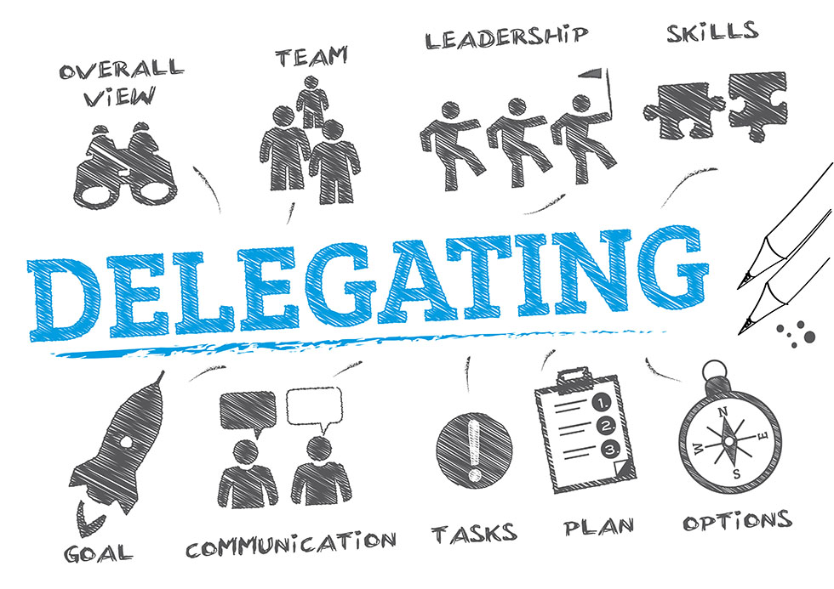

Delegation is very important when aiming for efficiency. The tricky part when delegating, however, is to know what tasks to delegate and to whom. When assigning tasks, you need to make sure to do so [according to skills](https://www.inc.com/jayson-demers/7-guidelines-for-delegating-tasks-to-employees.html).

Examine your employees’ strengths and weaknesses. One employee can only do so much and may be hindering their productivity if you assign tasks that do not align with their skills.

You should try to avoid overloading your employees. Single-tasking, or allowing your employees to focus on only one task until completion helps them to be more productive while eliminating work fatigue and frustration.

Additionally, assigning tasks that create moments of adaptive learning can help employees be more productive when they know certain tasks match what they desire to learn and how they learn best.

## Motivate your employees



Keep your employees engaged by doing your part in [motivating them](https://www.forbes.com/sites/rebeccaskilbeck/2019/02/12/six-strategies-to-maintain-employee-motivation/#74cc01a01d35). Demotivation often leads to poor performance, so it’s essential to keep your workforce motivated and connected. Dashboards and effective data visualization can help measure employee performance in real-time so adjustments in project management and organization can be made accordingly.

When motivating your employees, don’t just focus on giving perks and incentives. Pay attention in defining intrinsic motivators of your employees for a more lasting solution. Stay away from using fear as a motivator, as this can result in resentment or resistance.

Providing regular feedback, the correct tools, and a healthy work environment are great ways to motivate your employees. Here are some other helpful tips:

### Express your gratitude

Indicating your appreciation to your employees makes them feel that they are valuable and contributing to your company’s success.

Rewarding improvement and accomplishments of your employees is a great way to let them know that you are genuinely grateful for their efforts and are thankful for their service. Simply communicating specific behaviors that have been appreciated can go a long way in conveying to employees that their actions do not go unnoticed.

### Treat them

When your employees hit their goals and objectives, it’s nice to treat your team to something special, whether it’s a free lunch, happy hour, or work-from-home day. This is another way of making it known to your employees that they have significance and worth, which can in turn increase their drive and level of productivity.

### Encourage Work-Life Balance

Make your employees feel special by listening to their needs. Another way of letting them know you value and care for them is by encouraging work-life balance. Encouraging them to do so will help combat workplace burnout, excessive fatigue, and stress.

## Open Communication



Promoting a culture of open communication is another effective method in achieving business efficiency. Collaboration and feedback should always be welcome and encouraged so employees are comfortable voicing their concerns or recommendations they may have for improvement .

By encouraging clear and open communication you can eliminate and immediately act on problems that would otherwise be left untouched. Dashboards are a great way to communicate goals, benchmarks, and key performance indicators company-wide. [Transparency](https://www.idashboards.com/blog/2018/10/24/dashboards-tools-for-better-management/) across objectives can foster teamwork among employees who know their actions are influencing the success of their entire team.

## Learning and Development



Lastly, your employees’ professional development should be included in your priorities. Training and re-training your employees for the skills they need to improve and advance in their job boosts morale and helps them complete their tasks efficiently.

Boosting your business efficiency requires careful examination of your current business processes that aren’t working, implementing smart time management systems, delegating properly, motivating employees, communicating openly, and prioritizing professional development.

If you’re interested in gaining a better grasp on the meaning of your data and learn more about where data visualization can take your business,

Value = benefits/cost

https://en.wikipedia.org/wiki/Value\_(marketing)#:~:text=Value%20may%20also%20be%20expressed,%2C%20love%2C%20and%20self%20expression.

Value in [marketing](https://en.wikipedia.org/wiki/Marketing), also known as customer-perceived value, is the difference between a prospective customer's evaluation of the benefits and costs of one [product](https://en.wikipedia.org/wiki/Product_(business)) when compared with others. Value may also be expressed as a straightforward [relationship](https://en.wikipedia.org/wiki/Mathematical_relationship) between perceived benefits and perceived costs: Value = Benefits - Cost.

The basic underlying concept of value in marketing is human needs. The basic human needs may include food, shelter, belonging, love, and self expression. Both culture and individual personality shape human needs in what is known as wants. When wants are backed by buying power, they become demands.

With a consumers' wants and resources (financial ability), they demand products and services with benefits that add up to the most value and satisfaction.

The four types of value include: *functional value*, *monetary value*, *social value*, and *psychological value*. The sources of value are not equally important to all consumers. How important a value is, depends on the consumer and the purchase. Values should always be defined through the "eyes" of the consumer.

Functional Value: This type of value is what an offer does, it's the solution an offer provides to the customer.

Monetary Value: This is where the function of the price paid is relative to an offerings perceived worth. This value invites a trade-off between other values and monetary costs.

Social Value: The extent to which owning a product or engaging in a service allows the consumer to connect with others.

Psychological Value: The extent to which a product allows consumers to express themselves or feel better.

For a firm to deliver value to its customers, they must consider what is known as the "total market offering." This includes the reputation of the organization, staff representation, product benefits, and technological characteristics as compared to competitors' market offerings and prices. Value can thus be defined as the relationship of a firm's market offerings to those of its competitors.

Value in marketing can be defined by both [qualitative](https://en.wikipedia.org/wiki/Qualitative_data) and [quantitative](https://en.wikipedia.org/wiki/Quantitative_data) measures. On the qualitative side, value is the perceived gain composed of individual's emotional, mental and physical condition plus various social, economic, cultural and environmental factors. On the quantitative side, value is the actual gain measured in terms of financial numbers, percentages, and [dollars](https://en.wikipedia.org/wiki/Dollars).

For an organization to deliver value, it has to improve its value : cost ratio. When an organization delivers high value at high price, the perceived value may be low. When it delivers high value at low price, the perceived value may be high. The key to deliver high perceived value is attaching value to each of the individuals or organizations—making them believe that what you are offering is beyond expectation—helping them to solve a problem, offering a solution, giving results, and making them happy.

Value changes based on time, place and people in relation to changing environmental factors. It is a creative energy exchange between people and organizations in our marketplace.

Very often managers conduct customer value analysis to reveal the company's strengths and weaknesses compared to other competitors. the steps of which are as followed.

* To identify the major attributes and benefits that customers value for choosing a product and vendor.
* Assessment of the quantitative importance of the different attributes and benefits.
* Assessment of the company's and competitors' performance on each attribute and benefits.
* Examining how customer in the particular segment rated company against major competitor on each attribute.
* Monitor customer perceived value over time.

Topic 3: Customers\*

https://www.paldesk.com/popular-customer-pain-points/

## What are Customer Pain Points?

A customer pain point is a specific problem that prospective customers of your business are experiencing during his buying journey**.** In other words, you can think of pain points as problems.

When it comes to creating and developing products that will drive your business to success and make your life easier, start by identifying customers’ pain points. Each pain point refers to a specific problem your [customers](https://www.paldesk.com/customer-relationship-management-services/) are facing — the outdated processes that take too much effort and time, or the inefficiencies that inconvenience them. 



Picture 2. Customer pain points

Not all customers, however, will be aware of the pain points they are encountering, and this could make marketing difficult for them. You have to effectively help them realize they have a problem and convince them to use your product or service.

Once you nail down their pain points, you can attract a core group of people who crave for what you’re selling. The only touchpoint in their trek through your sales funnel is when they realize you can provide them with a solution.

Related: [How to Improve Sales Funnel with the Help of Live Chat?](https://www.paldesk.com/live-chat-sales-funnel/)

The worse problem is nagging them, the more chance you have to sell your solution. The better your solution or product is, the customers need it more and will pay faster.

## How Do I Identify My Customer’s Pain Points?

Now when we defined what pain points are, we need to find a way how to identify them.

Have in mind that not all your pain points are the same within every customer. Pain points can be various in different types of customers or industries. This is the checkpoint where you need to be focused on qualitative research as a fundamental part of identifying customer pain points.

There are two primary sources of the information you need to identify customer’s pain points, **customers** and your **sales and**[customer support](https://www.paldesk.com/what-is-customer-support/) team.

Let’s take a look at how to get more feedback from your customer.

### Organize Qualitative Customer Research

Worldwide brands are aware of the importance of [customer feedback](https://www.paldesk.com/customer-feedback-improve-cx/), but do they listen to their customers? It is essential for research to listen to your customers and hear their experience no matter good or bad, honestly, and openly.

Recently, Paldesk has developed inhouse new feature – [feedback form](https://www.paldesk.com/modules/feedback-form/)to have better insight into our customer pain points in our new dashboard and onboarding process. The feedback form was available to all users who made full registration. We have collected more than three months of all responses from the customer and got [essential feedback](https://www.paldesk.com/7-ways-to-use-customer-feedback-to-improve-your-brand-and-cx/) from them. The results showed that our dashboard was too complicated for them, and they were lost at the first touchdown.

We noticed that the bounce rate that was higher than we expected- almost 20%. After data that we collect from our customers, we prepared new UX and UI for our dashboard and implemented them after [A/B testing](https://www.paldesk.com/a-b-testing-in-marketing/).

The results?

Paldesk User delivered a **57% lower bounce rate**and more than **39% more installations**.

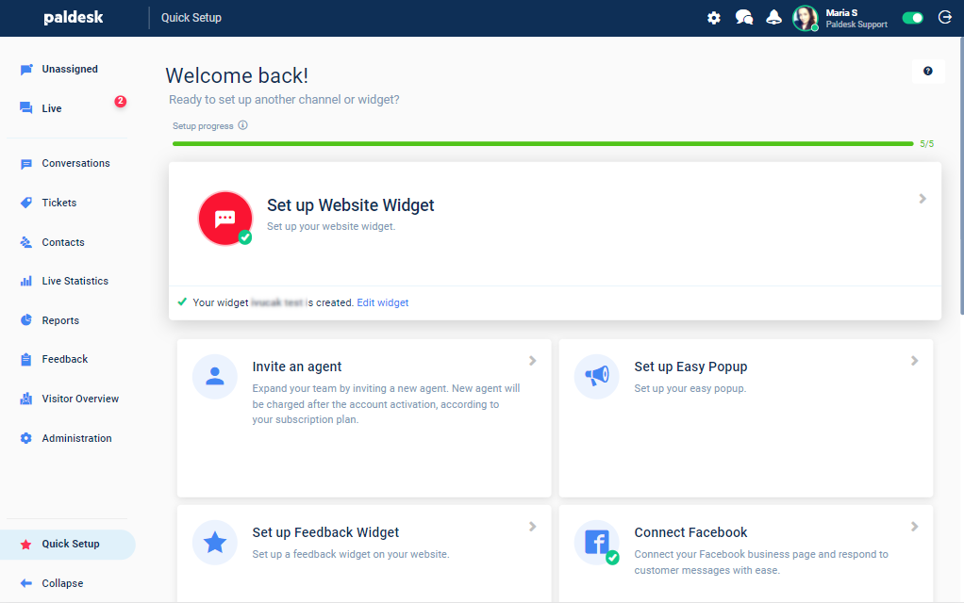

Picture 3. [Paldesk](https://www.paldesk.com/) new dashboard after testing

### Organize Qualitative Sales Research

Including your sales team in customer pain points research is very important. The first line of the customer’s battlefield is always your sales team, and you can gather amazing feedback data from them and at the same time hear the [voice of the customer](https://www.paldesk.com/voice-of-the-customer-how-to-generate-user-feedback/).

It is crucial to divide operational challenges from specific customer pain points. For example, your sales results are lower than the lost quarter. Listening to the reasons for your sales team can be different; the time of the year, bad sales leads, new competition, etc.

These complaints can be legitimate, but they don’t have any touching point with your customer’s pain points, and you need to filter out the noise to the actual problem.

### Use Live Chat to Find Customer Pain Points

If an email survey seems a little too Stone Age for you, try [live chat](https://www.paldesk.com/live-chat/). It’s an excellent tool for both email opt-in lead generation and collecting real-time customer feedback.

The amazing thing about live chat is that it allows you to communicate directly with a customer and fix the problem instantaneously. Another amazing thing? Recent studies show that website visitors are [82% more likely to convert to customers](https://www.intercom.com/blog/why-live-chat/#:~:text=According%20to%20our%20data%2C%20website,a%20conversation%20before%20sign%20up.) if they’ve chatted with you [in real-time](https://www.paldesk.com/micro-moments-real-time-chat).

By using live chat and walking your customers through different transactions and processes, you ensure their [memorable experience](https://www.paldesk.com/customer-experience-guide-how-to-put-your-customers-first/). At the same time, by helping your customers to complete the purchase, you have an opportunity to collect some valuable information regarding their pain points.

For example, when they [land on your site](https://www.paldesk.com/6-ingredients-of-a-high-converting-landing-page/), they might ask you something like:

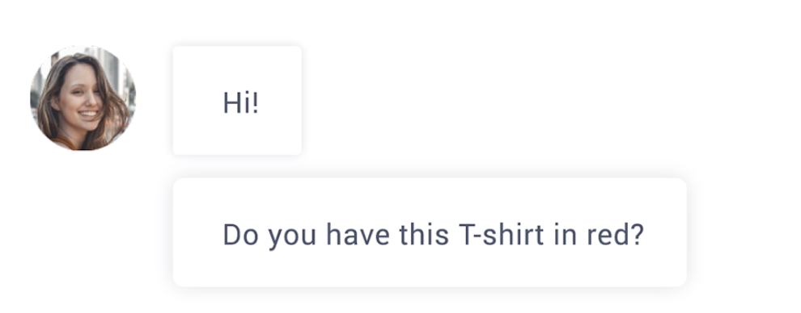

Picture 4. Address customer pain points in live chat

Their pain point? They want a specific item and perhaps, don’t have time to waste on scrolling down your site. With that information in hand, you can better address and advertise your product in a way that reaches directly to their needs. You can take it even a step further by using the help of tools like [Paldesk](https://www.paldesk.com/live-chat/).

### Go Through the Customer Journey

Mapping out your entire customer journey is crucial to understand the bigger picture. So, when you’re trying to find and understand the pain points, start from the very beginning and the way your customers find out about you.

Ask yourself everything – from how they find out about you all the way to the post-purchase process and the way your customers feel about your product when they make the purchase. This will move your focus from the purchasing part exclusively, which can often be misleading and it will give you a wider picture.

## 4 Pain Point Types

Although you can think of pain points as simple problems, they’re often grouped into several broader categories. Here are the four main types of pain points.

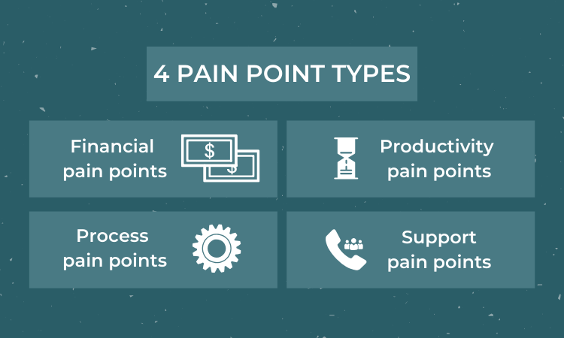

Picture 5. Pain point types

### 1. Financial pain points

This type includes the problems that consumers face regarding money:

* Subscription plans and membership fees
* A short duration of the product primarily made to last a significant length of time
* The high cost of (repeating) purchases

Many customers overpay for the products and services they use, which results in financial strain. Although you might think that high-end product should have high-end price tags, try to listen to your customers first. They might be spending too much money on their current product provider or solution, so they want to reduce their costs.

Having the lowest prices isn’t always the best strategy either. However, try to showcase how spending more money now will save your customer later. If you can, break down the costs of purchases on your competitive products and explain how long it will take for your item to *pay for itself*.

### 2. Productivity pain points

[Productivity](https://www.paldesk.com/ultimate-guide-to-productivity/) pain points hinder your customers’ ability to perform activities in an optimized way.

They might be facing problems concerning:

* Productivity
* Comfort
* Convenience

Your job is to show them how your product will resolve their everyday issues. Use your images and product descriptions to showcase the products in real-life situations. Explain how they could make their life more convenient.

### 3. Process pain points

There are also issues with a business’ systems and processes. Additional pain points, like productivity issues, also stem from process challenges. Your customers want to improve their internal processes. Such as assigning leads to sales representatives or nurturing lower-priority leads. In marketing, discovering customer pain points can dramatically improve how marketing messages and [outreach strategies](https://respona.com/blog/outreach-strategy/) are developed.

### 4. Support pain points

Your customers aren’t receiving the support they need at critical stages of the customer journey or sales process.

Nothing turns a customer off like an impersonal support [experience](https://www.paldesk.com/customer-experience-design-how-to-meet-customer-expectations/) – basic form letters promising to answer their questions in a few business days, off-putting [chatbots](https://www.paldesk.com/assistant-chatbot/) that skirt questions. Or lack of support center knowledge regarding past inquiries or preferences.

Thus, enable personalization services and smart support routing. For instance, an [omnichannel approach](https://www.paldesk.com/help-desk-software/) allows support representatives to answer questions not even asked yet by anticipating – and resolving – customer concerns before they become a problem.

## Questions That Can Identify a Customer’s Pain Points

To provide true value to your customers, it is important to ask the right questions. Avoid any assumptions. Whether you are aware of it or not, your preconceived notions influence your interaction with customers. For example, if you assume your client’s primary pain point is poor [time management](https://www.paldesk.com/5-essential-time-management-techniques)you may ask questions differently, inadvertently leading the conversation.

As a result, you will not gather relevant information into where your customers will actually need help.

So let’s look at three great examples of questions that can identify customer pain points.

### What are your gripes?

Not all questions need to be labeled with your prospects or customers. It’s essential to take the pulse of the rest of your sales and customer support team’s pipelines. It is crucial to understand what your prospect questions are not uncovering.  Sometimes issues that are not directly connected to the problem can lead you through the solution.

### Why are we losing deals?

If you offer more features at a lower cost than Competitor X but are still missing sales to them, you’ve uncovered a business pain point: budget. It’s essential to determine whether you need to get better at selling your product, qualifying your leads, or trimming unnecessary features from specific pricing or business plans.

Defining price for your product can be challenging but at the same time can give you information for the market and your customer – are they willing to pay your product.

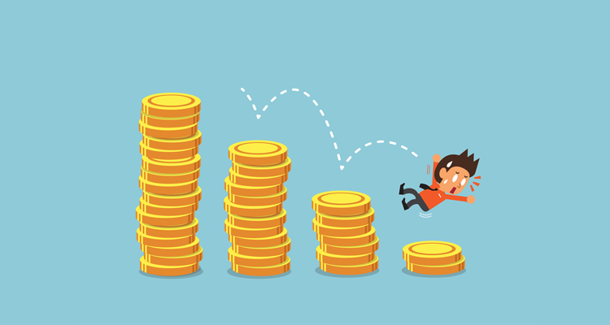

Picture 6. Pain point – budget

### Why are customers churning?

If you closed the deal, you have done a great job. But don’t think that is the end of the sales process or missing pain points.  If you’re losing business because your customer service wait time is too long or you have[bad customer service](https://www.paldesk.com/outcomes-of-bad-customer-service/), that’s a business pain point for both parties. For your customers, it’s an obstacle to them using your product or service to solve for their business. And your company can’t continue to grow in this manner either.

**Read:**[Customer Churn & How to Reduce It?](https://www.paldesk.com/customer-churn-how-to-reduce-it/)

### What are your biggest challenges?

Sometimes the easiest and most obvious solutions are right under your nose. So start from the biggest challenges you’re experiencing and then narrow the way to smaller and more particular problems which this challenge is made of.

In this way you allow for more questions which will surely pop up along the way.

### What is your biggest obstacle to growth?

This is a question not many actually think about, at least not in specific. And it can be tackled from many standpoints.

So try and figure out the broader picture first – is it the revenue, employees, product, marketing or somethign else and then dig deeper to find out the exact issues. After detecting the problem it will sure be much easier to find a solution and work towards it.

## Tips for Addressing Business Pain Points

Actions to take to identify these pain points and deliver products and services that cure them:

1. Think about the productivity in your company. Are your meetings too long? How complicated is your onbloarding? Is your administration under control? Do you meet the deadlines? This is a great starting point.
2. Talk to your current customers. Ask them these questions. If you know what problems plague their lives, you can help them out with it.
3. If you don’t have customers yet, try to come up with your customer’s responses metaphorically. Hop on Quora and [Reddit](https://www.reddit.com/) and search for threads on your industry. It may not be real insight, but it’s better than winging it.
4. Take your efforts to Google. Find [Frequently Asked Questions](https://www.paldesk.com/faq-page-perfect-way-power-business/) related to your industry. This is a good starting point. FAQs arise because they address common concerns of a general audience. However, they are surface-level, so use them to dig deeper.
5. Another great place to analyze pain points is through reviews and feedback. Reviews are valuable for your business as you can see what people value most about your company.

Take a look at some of the ones we’ve collected:

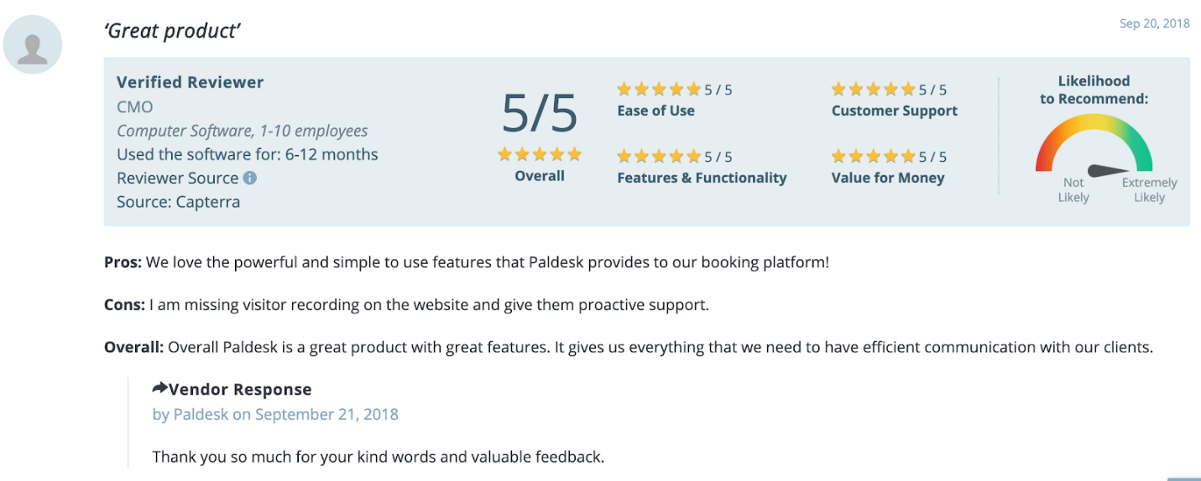

Picture 7. [Paldesk review](https://www.capterra.com/p/178274/Paldesk/)

Notice that it highlights the fact that we have a quality product and provide a great service. However, we also now know what to pay attention to regarding the development of the new features.

The same thing goes for you. Take a look through your reviews and look specifically for any common threads. It may not be an easy exercise or a quick endeavor, but it’s vital to the success of your business and the livelihood of the people you serve.

## In a Nutshell

What have we learned? If you take time to learn the specific challenges your customers face, you’ll be able to help them address them head-on. That’s a win-win for everyone.

We hope that you have a better idea of what your customers are trying to do when they’re looking for brands or products like yours. Although many customer pain points are similar, there’s no one solution to solving your customers’ pain.

Fortunately, nobody knows your customers as you do, so dive into your research and start helping your customers achieve what they want to do.

What other tips do you have for helping customers overcome pain points?

Thus, pain points are essential. Find them. Use them. Rinse. Repeat.

Market research and validation

https://blog.marketresearch.com/how-to-use-market-research-to-validate-insights

# How to Use Market Research to Validate Insights

by [Sarah Schmidt](https://blog.marketresearch.com/author/sarah-schmidt), on June 18, 2018

Using research to support decision making may sound appealing in theory, but how do companies actually use market research in practice? What are the common approaches?

As described in [our newly released white paper](https://content.marketresearch.com/the-importance-of-market-research-for-validation-and-decision-making), MarketResearch.com conducted dozens of in-depth phone interviews with corporate clients in different roles — including product managers, insight analysts, marketing directors, and category and portfolio leaders — at Fortune 500 companies in a variety of industries.

During these interviews, we asked open-ended questions to better understand the role of market research at these companies. Across different industries and types of companies, our client’s feedback repeatedly underscored the importance of market research for validating insights and supporting decision making.

Here’s a summary of how the companies we interviewed use market research to get a reality check. Carry out these five strategies in your own organization to help mitigate risks and facilitate decision making.

## 1. Gather points of comparison.

Compare how different researchers define and segment a market. Contrast internal and external estimates for market size, market growth, and market share to arrive at the most accurate conclusions. Combining multiple points of view, rather than relying on one, can help overcome knowledge gaps, misinformation, and systemic biases.

## 2. Deepen your knowledge of the market.

Validate numbers and understand the “why” behind the data. Where is the market going? What are the major market trends, drivers, and inhibitors to growth? What technologies or materials are gaining traction? Are there adjacent opportunities to pursue?

## 3. Assess the competitive landscape.

Get different points of view to better understand your company’s position. How do you stack up against the market? Who are the key players, and who are your biggest competitors? What companies are disrupting the market? Market research can also provide information on private companies that is otherwise difficult to gather.

## 4. Fill in gaps of consumer knowledge.

Explore new products and categories and how consumers are using them. Create a story about consumer trends and quantify opportunities. Understand how consumer habits and motivations are changing. Evaluate the role of technology in influencing consumer behavior.

## 5. Disseminate insights across the organization.

Use market research as a means to educate employees at different levels of the company. Incorporate the information into sales meeting presentations, marketing and new product development initiatives, executive reviews, and strategic-planning sessions.

As the clients we interviewed put it, third-party research shows you “how the marketplace is being perceived” and provides an “inside track on what’s happening.” When making important business decisions, market research is sometimes “the deciding factor on whether to green light or hit the kill switch.

The decision-making process

<https://www.umassd.edu/fycm/decision-making/process/>

Decision making is the process of making choices by identifying a decision, gathering information, and assessing alternative resolutions.

Using a step-by-step decision-making process can help you make more deliberate, thoughtful decisions by organizing relevant information and defining alternatives. This approach increases the chances that you will choose the most satisfying alternative possible.

## Step 1: Identify the decision

You realize that you need to make a decision. Try to clearly define the nature of the decision you must make. This first step is very important.

## Step 2: Gather relevant information

Collect some pertinent information before you make your decision: what information is needed, the best sources of information, and how to get it. This step involves both internal and external “work.” Some information is internal: you’ll seek it through a process of self-assessment. Other information is external: you’ll find it online, in books, from other people, and from other sources.

## Step 3: Identify the alternatives

As you collect information, you will probably identify several possible paths of action, or alternatives. You can also use your imagination and additional information to construct new alternatives. In this step, you will list all possible and desirable alternatives.

## Step 4: Weigh the evidence

Draw on your information and emotions to imagine what it would be like if you carried out each of the alternatives to the end. Evaluate whether the need identified in Step 1 would be met or resolved through the use of each alternative. As you go through this difficult internal process, you’ll begin to favor certain alternatives: those that seem to have a higher potential for reaching your goal. Finally, place the alternatives in a priority order, based upon your own value system.

## Step 5: Choose among alternatives

Once you have weighed all the evidence, you are ready to select the alternative that seems to be best one for you. You may even choose a combination of alternatives. Your choice in Step 5 may very likely be the same or similar to the alternative you placed at the top of your list at the end of Step 4.

## Step 6: Take action

You’re now ready to take some positive action by beginning to implement the alternative you chose in Step 5.

## Step 7: Review your decision & its consequences

In this final step, consider the results of your decision and evaluate whether or not it has resolved the need you identified in Step 1. If the decision has not met the identified need, you may want to repeat certain steps of the process to make a new decision. For example, you might want to gather more detailed or somewhat different information or explore additional alternatives.

Target customer profile, persona

<https://blog.hootsuite.com/buyer-persona/#:~:text=A%20buyer%20persona%20is%20a,%2C%20interests%2C%20and%20behavioral%20traits>.

## What is a buyer persona?

A buyer persona is a detailed description of someone who represents your [target audience](https://blog.hootsuite.com/target-market/). This is not a real customer, but a fictional person who embodies the characteristics of your best potential customers.

You’ll give this customer persona a name, demographic details, interests, and behavioral traits. You’ll understand their goals, pain points, and buying patterns.

You can give them a face using stock photography. Some businesses have gone so far as to create cardboard cutouts of their buyer personas to make them a real presence within the office.

The idea is to think about and speak to this model customer as if they were a real person. This allows you to craft marketing messages targeted specifically to them. Your buyer persona will guide everything from product development to your brand voice to the social channels you use.

Since different groups of people may buy your products for different reasons, you might need to create more than one buyer persona. You can’t get to know every customer or prospect individually. But you can create a customer persona to represent each segment of your customer base.

## How your business should use buyer or audience personas

### 1. Reframe your work from the customer’s perspective

Marketers too often use corporate-speak and a lot of buzzwords that don’t really mean anything. Buyer personas can help you avoid that trap by reminding you to think about the real humans who read your social posts and engage with your content.

Buyer personas keep you focused on addressing customer priorities instead of your own.

Think about your buyer personas every time you make a decision about your [social marketing strategy](https://blog.hootsuite.com/how-to-create-a-social-media-marketing-plan/) (or overall marketing strategy).

Does a new campaign address the needs and goals of at least one of your buyer personas? If not, you have good reason to reconsider your plan, no matter how exciting it may be.

Build your social strategy based on helping your personas meet their goals, and you’ll build a bond with the real customers they represent. It’s all about boosting sales while creating brand loyalty and trust.

### 2. Target your social ads more effectively

[Social advertising](https://blog.hootsuite.com/social-media-advertising/) offers incredibly detailed targeting options. Once you define your buyer personas, you can create social ads that speak directly to the target audience you have defined. Then, [use social ad targeting](https://blog.hootsuite.com/ad-targeting-guide-right-audience/) to get your ad in front of exactly the right people.

You can create separate ad content for each of your defined buyer personas. This advanced level of targeting increases conversion rates and improves social ad campaigns.

### 3. Increase ROI with the buyer persona spring

Developed by professors and authors Aleksej Heinze, Gordon Fletcher, Tahir Rashid, Ana Cruz, the buyer persona spring is a model for connecting your business objectives to your buyer persona. It’s called a spring because it involves three distinct loops:

* Content: What kinds of content will speak to your buyer persona?
* Channels: What social channels does your buyer persona use most?
* Data: Good data allows you to monitor your efforts, report on your success, and revise your strategy as needed.

Each loop includes four points, at which you plan, act, observe, and reflect.

We’ll get into the details of gathering and planning with this information in the next section.

## How to create a buyer persona

Gather your information as you work through these steps. We’ve created a free buyer persona template you can use to put it all together when you get to step five.

### 1. Do thorough audience research

Your buyer personas need to be based on real-world data, not gut instinct. Here’s a basic overview of how to learn about your audience. For a more in-depth look at these concepts, check out our [complete guide to audience research](https://blog.hootsuite.com/target-market/).

#### Compile data on your existing customers and social audience

Consider details like:

* Age
* Location
* Language
* spending power and patterns
* Interests
* Challenges
* Stage of life

For B2B, also consider size of business and who makes purchasing decisions.

Gather this information from:

* [Social media analytics](https://blog.hootsuite.com/social-media-analytics/), especially [Facebook Audience Insights](https://blog.hootsuite.com/facebook-audience-insights/)
* Your customer database
* [Google Analytics](https://blog.hootsuite.com/tracking-social-media-in-google-analytics/)

#### Learn which social channels your audience uses

You need to reach your customers using the right channels. Start by learning where they already spend time online. Some great tools to help include:

* [Hootsuite Insights Powered by Brandwatch](https://hootsuite.com/products/insights): Find top relevant sites, hashtags, and authors
* [Keyhole.co](https://keyhole.co/): Find top referring sites for relevant hashtags
* [Google Analytics](https://blog.hootsuite.com/tracking-social-media-in-google-analytics/): See which social networks appear in your referral traffic report

#### Check out the competition

Take some cues from the customer research your competitors have already done, using tools like:

* [Buzzsumo](https://buzzsumo.com/): To search for top shared content across social networks, including engagement data.
* Search streams: In your Hootsuite dashboard, set up streams to monitor your competitors’ posts and look for patterns in hashtags, post type, and content strategy.

For more detailed strategies, check out our full post on [how to conduct competitor research](https://blog.hootsuite.com/competitive-analysis-on-social-media/) using social tools.

### 2. Identify customer pain points

What problems or hassles are your potential customers trying to solve? What’s holding them back from success? What barriers do they face in reaching their goals?

One key way to find out is to engage in some [social listening](https://blog.hootsuite.com/social-listening-business/) and [social media sentiment analysis](https://blog.hootsuite.com/social-media-sentiment-analysis-tools/).

Setting up search streams to monitor mentions of your brand, products, and competitors gives you a real time look into what people are saying about you online. You can learn why they love your products, or which parts of the customer experience are just not working.

It’s also a good idea to check in with your customer service team to see what kinds of questions they get the most. Find out if they can help you identify patterns about which groups tend to face different kinds of challenges. You could even ask them to collect real customer quotes that you can use to help give your audience personas depth.

**Bonus: Get the free template** to easily craft a detailed profile of your ideal customer and/or target audience.

[Get the free template now!](https://hootsuite.com/resources/blog/buyer-persona-template)

### 3. Identify customer goals

This is the flip side of pain points. Pain points are problems your potential customers are trying to solve. Goals or aspirations are positive things they want to achieve.

Those goals might be personal or professional, depending on the kinds of products and services you sell. What motivates your customers? What’s their end game?

These goals might be directly related to solutions you can provide, but they don’t have to be. This is more about getting to know your customers than it is trying to match customers exactly to features or benefits of your product.

Your personas’ goals are important even if they don’t relate specifically to your product’s features. They can always form the basis of a campaign, or they might simply inform the tone or approach you take in your marketing.

Social listening can be a good way to gather this information, too. And just as your customer service team was a good source of insight for pain points, your sales team can be a good source of insight on customer goals.

Your salespeople talk to real people who are thinking about using your product. They have a deep understanding of what your customers are trying to achieve by using your products and services.

Ask them to collect real quotes that embody the customer experience. You can also ask them for any tactics they use to overcome buyer objections when selling your products or services, which leads us to…

### 4. Understand how you can help

Now that you understand your customers’ pain points and goals, it’s time to create a really clear picture of how your products and service can help. As part of this step, you’ll need to stop thinking about your brand in terms of features and dig deep to analyze the benefits you offer to customers.

It can be hard for marketers to get out of the feature mindset—which is one reason buyer personas are so important. They help you flip your thinking and consider your products and services from a buyer’s point of view.

A *feature*is what your product is or does. A *benefit* is how your product or service makes your customer’s life easier or better.

Ask yourself three key questions for each of the pain points and goals you’ve collected:

1. How can we help? Capture that in one clear sentence and add it to your persona template.
2. What are your audience’s main purchasing barriers? And how can you help overcome them?
3. Where are your followers at in their buying journey? Are they researching or ready to buy? Looking for reviews?

Again, talking to your colleagues who deal directly with customers can be a great way to learn. It can also be a good idea to consult your customers and social fans directly through a survey.

### 5. Create your buyer personas

Now, gather all of your research and start looking for common characteristics. As you group those characteristics together, you’ll have the basis of your unique customer personas.

Let’s say you identify a core customer group of fathers in their 30s who live in big cities, like to camp, and own motorcycles. Great—now it’s time to take this abstract collection of characteristics and turn them into a persona that you can identify with and speak to.

Give your buyer persona a name, a job title, a home, and other defining characteristics. You want your persona to seem like a real person.

Aim for about the amount of information you would expect to see on a dating site. Or what you might learn from a short conversation on an airplane or at a bus stop. Don’t forget to include pain points and goals.

For example, your group of motorcycle-owning urban dad campers could be represented by the persona you name Moto Mike. Based on research, you’ll give Mike representative characteristics that make him a real person:

* He is 40 years old
* He has two kids, aged 4 and 1
* He lives in Boston
* He works at a tech company
* He owns a touring motorcycle
* He likes to camp throughout New England
* He has limited vacation time

And so on.

Remember, a list of characteristics does not equal a persona. A persona is a realistic description of a person who represents one segment of your customer base.

Sure, not all people in this customer group match the characteristics of your persona exactly. But this persona represents this customer group to you and allows you to think about them in a human way rather than as a collection of data points.

It’s a lot easier to speak to Mike than it is to speak to “men.” Or even “35-year-old dads who own motorcycles.”

As you flesh out your customer personas, be sure to describe both who each persona is now and who they want to be. This allows you to start thinking about how your products and services can help them get to that place of ambition.

## 3. Real-life buyer persona examples

### 1. Amsterdam Dance Event

The Amsterdam Dance Event (ADE) is an annual electronic music festival and conference held in, you guessed it, Amsterdam.

A SurveyPlanet survey distributed through Facebook[provided](https://www.ingentaconnect.com/contentone/cog/em/2019/00000023/00000006/art00015) the building blocks for a buyer persona with the following characteristics:

* Aged 22 to 29
* Active on social media
* Is a student or worker
* Has attended ADE more than once
* Attends ADS to experience electronic music with friends, meet like-minded people, and express themself
* Has a medium level of disposable income
* Is price-sensitive for tickets an on-site spending

However, in order for this to be a true buyer persona, it would need to be even more specific. Remember, a buyer persona should describe a person, not just a set of characteristics. So, to take this to the next level, let’s create a persona for ADE, taking some additional cues from this ADE Facebook post.

Buyer persona: Dancing Dave

* 27-year-old business student at the University of Amsterdam
* A regular visitor to local dance clubs
* Attended ADE last year with two friends from school
* Works part-time in the university library
* Shares and likes images of Amsterdam’s nightlife on Instagram Stories
* Follows ADE on Facebook to be notified about early-bird tickets

### 2. Fan Fit

Fan Fit is an app that grew out of a project at the UK’s University of Salford. It combines fitness tracking with sports news and social networking through personal “leagues.” UK sports teams can whitelabel the app to engage their fans.

Two business professors [worked with the app founders](http://fanfit.co.uk/fan-fit-case-study/) to define their buyer personas in a case study for the university where the app was created. And these are not just any business professors. They’re the same business professors who developed the buyer persona spring mentioned above.

Here’s what they found:

Persona 1 (B2C): Jim Watson, a sports fan

* 52-year-old van driver living in Salford with his wife
* Season ticket holder with Salford Red Devils
* Avid soccer fan
* Uses TV, Twitter, Facebook, and YouTube
* A former athlete who has gained weight and thought about buying a fitness tracker but is unsure what to buy
* Motivated to use a mobile app to improve health and quality of life after a friend suffered a minor heart attack

In this Facebook video, two Fan Fit users who are Salford Red Devils fans talk about the weight they’ve lost using the team’s version of the app. They each say they’ve lost about three stone, or about 40 pounds.

Persona 2 (B2B): Andrea Rogers, works in marketing for a sports team

* Senior marketing and communications rep for a major soccer team
* Manages a small team of social marketers
* In her 30s and recently married
* Uses Facebook and Instagram to connect with her family, and Twitter and LinkedIn for professional networking
* Interested in apps, IoT, virtual reality, and eSports
* Wants to connect the team with younger and more female fans
* Is frustrated that her team has no plans to build its own app

### 3. HaparandaTornio Tourist Information Centre

This tourism office for the twin cities of Haparanda, Sweden, and Tornio, Finland, lacked a clear digital marketing strategy. A business administration student at the Lapland University of Applied Sciences [worked with](https://www.theseus.fi/handle/10024/263145) the tourism center to develop an audience persona as part of a new digital marketing plan.

Buyer persona: Maria Suomalainen

* Born in Germany but lives in Tornio
* Aged 25 to 34 years with two children
* Travels with her family
* Has a bachelor’s degree
* Uses the tourism centre’s website to look for events, restaurants, places to visit, and shops
* Is frustrated by the tourist centre’s boring social media, lack of visual content, and lack of interaction with visitors
* Uses Facebook, Instagram, TripAdvisor, and Pinterest
* Prefers video, photo, and text posts, along with Instagram Stories

The Tourist Centre is now using more visual content, shares loads of events, and has social share buttons for Twitter, Facebook, and Pinterest on its website.

One challenge with this buyer persona: No person is aged 25 to 34 years. While that age range may describe the tourist centre’s target audience, the buyer persona should have a specific age.

Think about your buyer personas every time you make a decision about your social media content and overall marketing strategy. Do right by these personas and you’ll build a bond with the real customers they represent—boosting sales and brand loyalty.

Topic 4: Competitive Advantage, Markets\*

<https://onceinteractive.com/blog/how-to-identify-your-competitors/#:~:text=There%20are%205%20types%20of,indirect%2C%20future%2C%20and%20replacement>.

## **Do you know who your primary competitors even are?**

It is possible to achieve success by ignoring the competition and doing your own thing, but it’s a risky road. So what are the advantages of knowing and studying your competition?

Your competitors are walking the same road you want to walk on to succeed in business. They are certainly doing some things right and some things wrong. By studying them, you can get a masterclass on what to do and what to avoid in your business niche.

Also, by knowing your competitors you can find out where you can stand out among the crowd. Knowing where you’re different and making a stand on that will give your audience a clear choice between competitors.

In other words, by looking at your competitors, you can save a LOT of time, money, and heartache. AND you can use your competition as a source of ideas. But maybe you think you have something so unique that you have no competition? While it’s possible, you may have more competitors than you think.

## Types of Competitors

Before we start on the ways that you can identify your competitors, let’s first talk about the types of competition that you have in the field. There are 5 types of competitors: direct, potential, indirect, future, and replacement.

Direct competitors are competitors who are directly vying for your customers. If you’re a residential painter, your direct competitors are other residential painters in your service area. If you have an online course about confidence, they’re the other ones who have courses about confidence. When most new business owners think about their competition, direct competitors are what come to mind.

Potential competitors are those competitors who do the same thing that you and target the same kinds of customers but aren’t selling in your market area and aren’t likely to do so. They could be your competition if they decided to enter, but either don’t have the infrastructure or have chosen to ignore your area. An example of a potential competitor would be a residential painting company in another city.

Indirect competitors are businesses that are in the same category, but they sell different products and services than you. This would be the difference between a strictly industrial painter and a residential painter. You’re still doing similar things, but the target market between the two of you are different.

Future competitors are like potential competitors, but they’re much more ready and likely to enter your market. This might be the larger national company that hasn’t entered your local market yet. Think of them as between potential and direct competition.

Replacement competitors are those who provide an alternative to the services that you offer that solves the same pain points. If there is more than one way to solve the problems you solve with your business, you may have a replacement competitor. For our residential painter, this would be any DIY store that sells painting supplies.

All these types of competitors can pull market share away from your company now or in the future. But how do you start finding out which ones are actually your competitors? Now that businesses [focus on digital marketing](https://onceinteractive.com/blog/digital-marketing-strategies-business/) to advertise their businesses, your first step is to visit a search engine.

Product differentiation, positioning

<https://www.investopedia.com/ask/answers/062415/what-are-similarities-between-product-differentiation-and-product-positioning.asp#:~:text=Product%20Positioning,-After%20identifying%20differences&text=This%20positioning%20is%20done%20to,marketers%20are%20trying%20to%20target>.

Product differentiation and positioning are important elements in a marketing plan, and most marketing strategies use both techniques. Though the two are different in a few key ways and sit at slightly different positions in the [product life cycle](https://www.investopedia.com/terms/p/product-life-cycle.asp), a product's differentiation and positioning are similar in purpose. Both are especially relevant in markets in which a product has several competitors.

## Product Differentiation

When it comes to [product differentiation](https://www.investopedia.com/terms/p/product_differentiation.asp), a company must identify the characteristics of its product that make it different from competing products. This is called the value proposition of a product--what makes it unique. Knowing the value proposition of a product, the goal is to highlight those qualities that consumers consider attractive compared to competing brands. As the number of brands proliferates, product differentiation becomes increasingly important.

Common differentiation strategies intend to draw consumers' attention to the value, quality, or uniqueness of the product. For example, a value differentiation strategy based on value could emphasize how the product represents a good deal financially compared to competitors. In industries such as insurance or amongst network providers, the differentiation strategy might be more conceptual than actually in value. For example, Geico is known for its efficiency and approachability for getting an insurance quote with its catchy slogan "15 minutes could save you 15% or more on car insurance."1﻿ Meanwhile, other insurance companies such as AAA stand behind its high-quality service and heritage in insurance.2﻿ For network providers ranging from AT&T and Verizon, claims such as "America's largest network" or "America's most reliable network" help to differentiate the various networks.3﻿4

﻿ T-Mobile, for example, also provides complimentary international cellphone coverage, which gives it a leg up above other networks.5﻿

## Product Positioning

After identifying differences, marketing moves on to figuring out ways to situate the product favorably in potential consumers' minds in relation to its competitors. The marketing and promotional plan manipulates symbols, such as in displays and packaging, and communicates tailored messages targeted to people most likely to value what is being marketed.

Product positioning places the differentiated product in the marketplace in ways and places to attract potential customers' attention. This positioning is done to affect consumers' perception of the product. While product differentiation is usually product-specific, product positioning is more about the audience that marketers are trying to target. For example, a brand wanting to market to a younger Millennial or Gen Z audience might position itself alongside popular TikTok stars or celebrities to make the brand trendier. On the flip side, even if a laundry detergent brand is the best on the market, if it's positioned towards younger audiences who don't do their own laundry, the product will flop.

## The Bottom Line

Overall, product differentiation can be part of a strategy in positioning a product amongst its competitors: by highlighting its unique qualities. Though product positioning alters customers' perceptions, the marketing message does not always influence people as desired. Marketers might misunderstand their market and the key characteristics important to consumers in that market, meaning marketing success requires both thoughtful product differentiation and positioning.

Market structures

<https://en.wikipedia.org/wiki/Market_structure>

# Market structure

From Wikipedia, the free encyclopedia

Market Structure in [economics](https://en.wikipedia.org/wiki/Economics), depicts how firms are differentiated and categorised based on types of goods they sell (homogeneous/heterogeneous) and how their operations are affected by external factors and elements. Market structure makes it easier to understand the characteristics of diverse markets.

## History[[edit](https://en.wikipedia.org/w/index.php?title=Market_structure&action=edit&section=1)]

*See also:*[*Laissez-faire*](https://en.wikipedia.org/wiki/Laissez-faire)

Market Structure has been a topic of discussion for many economists like [Adam Smith](https://en.wikipedia.org/wiki/Adam_Smith) and [Karl Marx](https://en.wikipedia.org/wiki/Karl_Marx) who have strong conflicting viewpoints on how the market operates in presence of political influence. Adam Smith in his writing on economics stressed the importance of [laissez-faire](https://en.wikipedia.org/wiki/Laissez-faire) principles outlining the operation of the market in the absence of dominant political mechanisms of control, while Karl Marx discussed the working of the market in the presence of a controlled economy [[1]](https://en.wikipedia.org/wiki/Market_structure#cite_note-1)sometimes referred to as a command economy in the literature. Both types of market structure have been in historical evidence throughout the twentieth century and twenty-first century.

## Types[[edit](https://en.wikipedia.org/w/index.php?title=Market_structure&action=edit&section=2)]

Based on the factors that decide the structure of the market, the main forms of market structure are as follows:

* [Perfect competition](https://en.wikipedia.org/wiki/Perfect_competition), refers to a type of market where there are many buyers and seller that feature free [barriers to entry](https://en.wikipedia.org/wiki/Barriers_to_entry), dealing with homogeneous products with no differentiation, where the price is fixed by the market. Individual firms are price taker[[2]](https://en.wikipedia.org/wiki/Market_structure#cite_note-2) as the price is set by the industry as a whole. Example: Agricultural products which have many buyers and sellers, selling homogeneous goods where the price is determined by the demand and supply of the market and not individual firms.
  + [Imperfect Competition](https://en.wikipedia.org/wiki/Imperfect_competition) refers to markets where standards for perfect competition are not fulfilled (such as no barriers for entry and exit, homogeneous products and many buyers and sellers). All other types of competition come under imperfect competition.
* [Monopolistic competition](https://en.wikipedia.org/wiki/Monopolistic_competition), a type of imperfect competition where there are many sellers, selling products that are closely related but differentiated from one another (e.g. quality of products may differentiate) and hence they are not perfect substitutes. This market structure exists when there are multiple sellers who attempt to seem different from one another. Examples: toothpaste, soft drinks, clothing as they all are homogeneous products with many buyers and sellers, no to low entry barriers but are different from each other due to quality, taste, branding. Firms have partial control over the price as they are not price takers (due to differentiated products) or Price Maker (as there are many buyers and sellers). [[3]](https://en.wikipedia.org/wiki/Market_structure#cite_note-3)
* [Oligopoly](https://en.wikipedia.org/wiki/Oligopoly), refers to market structure where only small number of firms operate together control the majority of the market share. Firms are neither price takers or makers. Firms tend to avoid [price war](https://en.wikipedia.org/wiki/Price_war) by following price rigidity. They closely monitor the prices of their competitors and change prices accordingly. Oligopoly firms focus on quality and efficiency of their products to compete with other firms. Example: Network providers[[4]](https://en.wikipedia.org/wiki/Market_structure#cite_note-4) ( Entry barriers, Small number of sellers, many buyers, products can be homogeneous or differentiated). Three types of oligopoly.
  + [Duopoly](https://en.wikipedia.org/wiki/Duopoly), a special case of an oligopoly where two firms operate and have power over the market.[[5]](https://en.wikipedia.org/wiki/Market_structure#cite_note-5) Example: Aircraft manufactures: [Boeing](https://en.wikipedia.org/wiki/Boeing) and [Airbus](https://en.wikipedia.org/wiki/Airbus).
  + [Oligopsony](https://en.wikipedia.org/wiki/Oligopsony), a market where many sellers can be present but meet only a few buyers. Example: Cocoa producers
  + [Cournot quantity competition](https://en.wikipedia.org/wiki/Cournot_competition), one of the first models of oligopoly markets was developed by [Augustin Cournot](https://en.wikipedia.org/wiki/Antoine_Augustin_Cournot) in 1835. In Cournot’s model, there are two firms and each firm selects a quantity to produce, and the resulting total output determines the market price.[[6]](https://en.wikipedia.org/wiki/Market_structure#cite_note-:0-6)
  + [Bertrand Price Competition,](https://en.wikipedia.org/wiki/Bertrand_competition) [Joseph Bertrand](https://en.wikipedia.org/wiki/Joseph_Bertrand) was the first to analyze this model in 1883. In Bertrand’s model, there are two firms and each firm selects a price to maximize its own profits, given the price that it believes the other firm will select.[[6]](https://en.wikipedia.org/wiki/Market_structure#cite_note-:0-6)
* [Monopoly](https://en.wikipedia.org/wiki/Monopoly), where there is only one seller of a product or service which has no substitute. The firm is the price maker as they have control over the industry. There are high barriers to entry, which an incumbent would conduct entry-deterring strategies if keeping out entrants reaping additional profits for the company.[[6]](https://en.wikipedia.org/wiki/Market_structure#cite_note-:0-6) Frank Fisher, a noticed antitrust economist has described monopoly power as “the ability to act in an unconstrained way,” such as increasing price or reducing quality.[[7]](https://en.wikipedia.org/wiki/Market_structure#cite_note-7) Example: Google
  + [Natural monopoly](https://en.wikipedia.org/wiki/Natural_monopoly), a monopoly in which [economies of scale](https://en.wikipedia.org/wiki/Economies_of_scale) cause efficiency to increase continuously with the size of the firm. A firm is a natural monopoly if it is able to serve the entire market demand at a lower cost than any combination of two or more smaller, more specialized firms.
  + Or natural obstacles, such as the sole ownership of natural resources, [De beers](https://en.wikipedia.org/wiki/De_Beers) was a monopoly in the diamond industry for years.
  + [Monopsony](https://en.wikipedia.org/wiki/Monopsony), when there is only a single buyer in a market. Discussion of monopsony power in the labor literature largely focused on the pure monopsony model in which a single firm comprised the entirety of demand for labor in a market (e.g., company town).[[8]](https://en.wikipedia.org/wiki/Market_structure#cite_note-8)

## Features of market structures[[edit](https://en.wikipedia.org/w/index.php?title=Market_structure&action=edit&section=3)]

The imperfectly competitive structure is quite identical to the realistic market conditions where some [monopolistic competitors](https://en.wikipedia.org/wiki/Monopolistic_competition), [monopolists](https://en.wikipedia.org/wiki/Monopoly), [oligopolists](https://en.wikipedia.org/wiki/Oligopoly), and [duopolists](https://en.wikipedia.org/wiki/Duopoly) exist and dominate the market conditions. The elements of Market Structure include the number and size of sellers, entry and exit barriers, nature of product, price, selling costs.

Competition is useful because it reveals actual customer demand and induces the seller (operator) to provide service quality levels and price levels that buyers (customers) want, typically subject to the seller's financial need to cover its costs. In other words, competition can align the seller's interests with the buyer's interests and can cause the seller to reveal his true costs and other private information. In the absence of perfect competition, three basic approaches can be adopted to deal with problems related to the control of market power and an asymmetry between the government and the operator with respect to objectives and information: (a) subjecting the operator to competitive pressures, (b) gathering information on the operator and the market, and (c) applying incentive regulation.

The correct sequence of the market structure from most to least competitive is perfect competition, imperfect competition, oligopoly, and pure monopoly.

The main criteria by which one can distinguish between different market structures are: the number and size of firms and [consumers](https://en.wikipedia.org/wiki/Consumer) in the market, the type of [goods](https://en.wikipedia.org/wiki/Product_(business)) and [services](https://en.wikipedia.org/wiki/Service_(economics)) being traded, and the degree to which [information](https://en.wikipedia.org/wiki/Information) can flow freely. In today's time, Karl Marx's theory about political influence on market makes sense as firms and industry are affected strongly by the regulation, taxes, tariffs, patents imposed by the government. These affect the barriers to entry and exit for the firms in the market.

## Measure of market structure[[edit](https://en.wikipedia.org/w/index.php?title=Market_structure&action=edit&section=4)]

* N-firm concentration ratio, N-firm concentration ratio is a common measure of market structure. This gives the combined market share of the N largest firms in the market.[[6]](https://en.wikipedia.org/wiki/Market_structure#cite_note-:0-6) For example, if the 5-firm concentration ratio in the United States smart phone industry is about .8, which indicates that the combined market share of the five largest smart phone sellers in the United states is about 80 percent.
* [Herfindahl index](https://en.wikipedia.org/wiki/Herfindahl%E2%80%93Hirschman_Index), The Herfindahl index defined as the sum of the squared market shares of all the firms in the market. Increases in the Herfindahl index generally indicate a decrease in competition and an increase of [maket power](https://en.wikipedia.org/wiki/Market_power), vice versal. Generally, the Herfindahl index conveys more information than the N-firm concentration ratio.

Besides market structure, many factors contribute to conduct and market performance. Thus, it is essential to assess all the circumstances affecting competition rather than rely solely on measures of market structure.

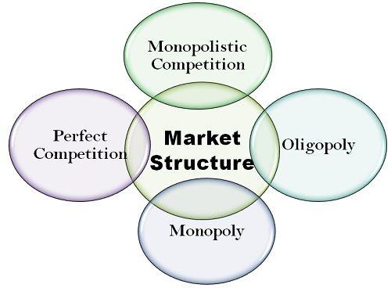

Market segments, size

<https://blog.alexa.com/types-of-market-segmentation/>

# 4 Types of Market Segmentation With Examples

Using different types of market segmentation allows you to target customers based on unique characteristics, create more effective marketing campaigns, and find opportunities in your market.

See how you can leverage market segmentation by learning:

* [What market segmentation is](https://blog.alexa.com/types-of-market-segmentation/#market-segmentation)
* [Why market segmentation is important](https://blog.alexa.com/types-of-market-segmentation/#important)
* [The four types of market segmentation](https://blog.alexa.com/types-of-market-segmentation/#types)
* [How to create a market segmentation strategy](https://blog.alexa.com/types-of-market-segmentation/#create)

## What Is Market Segmentation?

[Market segmentation](https://blog.alexa.com/marketing-research/market-segmentation/) is the process of dividing a [target market](https://blog.alexa.com/marketing-research/target-market) into smaller, more defined categories. It segments customers and audiences into groups that share similar characteristics such as demographics, interests, needs, or location.

## Eight Benefits of Market Segmentation

The importance of market segmentation is that it makes it easier to focus marketing efforts and resources on reaching the most valuable audiences and achieving business goals.

Market segmentation allows you to get to know your customers, identify what is needed in your market segment, and determine how you can best meet those needs with your product or service. This helps you design and execute better marketing strategies from top to bottom.

[Market segmentation helps you get to know your customers, identify what's needed in your market segment, and determine how you can best meet those needs with your product or service.CLICK TO TWEET](https://twitter.com/intent/tweet?url=https%3A%2F%2Fblog.alexa.com%2Ftypes-of-market-segmentation%2F&text=Market%20segmentation%20helps%20you%20get%20to%20know%20your%20customers%2C%20identify%20what%27s%20needed%20in%20your%20market%20segment%2C%20and%20determine%20how%20you%20can%20best%20meet%20those%20needs%20with%20your%20product%20or%20service.&via=AlexaInternet&related=AlexaInternet)

### 1. Create stronger marketing messages

When you know whom you’re talking to, you can develop stronger marketing messages. You can avoid generic, vague language that speaks to a broad audience. Instead, you can use direct messaging that speaks to the needs, wants, and unique characteristics of your target audience.

### 2. Identify the most effective marketing tactics

With dozens of marketing tactics available, it can be difficult to know what will attract your ideal audience. Using different types of market segmentation guides you toward the [marketing strategies](https://blog.alexa.com/the-complete-guide-to-marketing-strategies/) that will work best. When you know the audience you are targeting, you can determine the best solutions and methods for reaching them.

### 3. Design hyper-targeted ads

On digital ad services, you can target audiences by their age, location, purchasing habits, interests, and more. When you use market segmentation to define your audience, you know these detailed characteristics and can use them to create more effective, targeted digital ad campaigns.

### 4. Attract (and convert) quality leads

When your marketing messages are clear, direct, and targeted they attract the right people. You draw in ideal prospects and are more likely to convert potential customers into buyers.

[When your marketing messages are clear, direct, and targeted they attract the right people.CLICK TO TWEET](https://twitter.com/intent/tweet?url=https%3A%2F%2Fblog.alexa.com%2Ftypes-of-market-segmentation%2F&text=When%20your%20marketing%20messages%20are%20clear%2C%20direct%2C%20and%20targeted%20they%20attract%20the%20right%20people.%20&via=AlexaInternet&related=AlexaInternet)

### 5. Differentiate your brand from competitors

Being more specific about your value propositions and messaging also allows you to stand out from competitors. Instead of blending in with other brands, you can differentiate your brand by focusing on specific customer needs and characteristics.

### 6. Build deeper customer affinity

[When you know what your customers want and need, you can deliver and communicate offerings that uniquely serve and resonate with them](https://twitter.com/intent/tweet?text=When+you+know+what+your+customers+want+and+need%2C+you+can+deliver+and+communicate+offerings+that+uniquely+serve+and+resonate+with+them&url=https%3A%2F%2Fblog.alexa.com%2Ftypes-of-market-segmentation%2F&hashtags=&related=&via=AlexaInternet). This distinct value and messaging leads to stronger bonds between brands and customers and creates [lasting brand affinity](https://blog.alexa.com/building-brand-affinity/).

### 7. Identify niche market opportunities

[Niche marketing](https://blog.alexa.com/niche-marketing/) is the process of identifying segments of industries and verticals that have a large audience that can be served in new ways. When you segment your target market, you can find underserved niche markets that you can develop new products and services for.

### 8. Stay focused

[Targeting in marketing](https://blog.alexa.com/targeting-in-marketing/) keeps your messaging and [marketing objectives](https://blog.alexa.com/marketing-objectives/) on track. It helps you identify new marketing opportunities and avoid distractions that will lead you away from your target market.

## The Four Types of Market Segmentation

The four bases of market segmentation are:

* Demographic segmentation
* Psychographic segmentation
* Behavioral segmentation
* Geographic segmentation

Within each of these types of market segmentation, multiple sub-categories further classify audiences and customers.



### Demographic Segmentation

Demographic segmentation is one of the most popular and commonly used types of market segmentation. It refers to statistical data about a group of people.



**Demographic Market Segmentation Examples**

* Age
* Gender
* Income
* Location
* Family Situation
* Annual Income
* Education
* Ethnicity

Where the above examples are helpful for segmenting B2C audiences, a business might use the following to classify a B2B audience:

* Company size
* Industry
* Job function

Because demographic information is statistical and factual, it is usually relatively easy to uncover using various [sites for market research](https://blog.alexa.com/sites-for-market-research/).

A simple example of B2C demographic segmentation could be a vehicle manufacturer that sells a luxury car brand (ex. Maserati). This company would likely target an audience that has a higher income.

Another B2B example might be a brand that sells an enterprise marketing platform. This brand would likely target marketing managers at larger companies (ex. 500+ employees) who have the ability to make purchase decisions for their teams.

### Psychographic Segmentation

[Psychographic segmentation](https://blog.alexa.com/psychographic-segmentation/) categorizes audiences and customers by factors that relate to their personalities and characteristics.



**Psychographic Market Segmentation Examples**

* Personality traits
* Values
* Attitudes
* Interests
* Lifestyles
* Psychological influences
* Subconscious and conscious beliefs
* Motivations
* Priorities

Psychographic segmentation factors are slightly more difficult to identify than demographics because they are subjective. They are not data-focused and require research to uncover and understand.

For example, the luxury car brand may choose to focus on customers who value quality and status. While the B2B enterprise marketing platform may target marketing managers who are motivated to increase productivity and show value to their executive team.

Beachhead market and creating your market

<https://corporatefinanceinstitute.com/resources/knowledge/strategy/beachhead-strategy/>

## What is the Beachhead Strategy?

The beachhead strategy comes from the military [strategy](https://corporatefinanceinstitute.com/resources/knowledge/strategy/) of winning a small border area that becomes a stronghold, and from which you can advance to the rest of the territory. The small border area is referred to as a beachhead. In business, the idea is to focus your resources on a small market area (such as a product category or smaller market segment) to turn it into a stronghold before advancing to the broader market or [product categories](https://corporatefinanceinstitute.com/resources/knowledge/economics/substitute-products/). The beachhead strategy enables a company to dominate the small areas from which it can then enter and dominate the rest of the market.



The alternative to the beachhead strategy is the spray and pray technique. The latter strategy involves spreading a generic message to a wide market of prospects and relying on sheer numbers to make wins in that market. Businesses that use the spray and pray technique often set unrealistic larger plans for dominating the [market segments](https://corporatefinanceinstitute.com/resources/knowledge/strategy/total-addressable-market-tam/) or product categories. They reach a large number of people, but their efforts are not as targeted as is the case with a beachhead strategy.

### Beachhead Defined

The term beachhead is derived from a military strategy that advocates that, as you are approaching an enemy territory, you should plan and focus all your resources on winning a small border area that becomes a stronghold area from which to advance into the enemy territory.

The term references the 1944 invasion of Normandy where allied troops focused their attention on the Normandy beaches, which they used to stage a counter-invasion of Europe and win the Second World War. The concept was first presented in Geoffrey Moore’s book, [Crossing the Chasm](https://en.wikipedia.org/wiki/Crossing_the_Chasm).

### Beachhead Acquisition

The beachhead strategy is also replicated in [mergers and acquisitions](https://corporatefinanceinstitute.com/resources/knowledge/deals/mergers-acquisitions-ma-process/). A beachhead acquisition occurs when a business acquires another business in a new geographical location as a way of establishing itself in that location for future growth potential. A business can implement a beachhead strategy when the market is very large and it does not want to take the risk of making a huge investment in a new, untried market.

Beachhead acquisition also enables a company to test the acceptance of the company’s products in the new market, and decide whether to invest more capital into the market or abandon the whole plan if the market is unreceptive to its products.

The strategy can also be implemented by purchasing a [minority interest](https://corporatefinanceinstitute.com/resources/knowledge/accounting/non-controlling-interest/) in a company, as the first move in a hostile takeover. Most often, when the target is aware of the takeover plans of an acquirer, it may take actions that may prevent the takeover from happening. Some of these actions may include transferring majority shares into a voting trust, taking legal actions, or voting down the acquisition.

However, by acquiring a minority interest in the target company, the acquirer may advance its plans of owning a majority of the company’s shares gradually without raising the alarm. The strategy can also help the acquirer assess if the target is an ideal company for investment since it will get a better view of the company’s operations when it owns a minority interest in the target company.

### Beachhead Market

A beachhead market can be defined as a small market with specific characteristics that make it an ideal target to sell a new product or service. The choice of the market is based on the compatibility between the resources available, the product, and the market itself. The market should help the business serve specific goals that will help it advance from its infancy to other markets.

Here are some of the conditions that define a beachhead market:

#### Customers purchase similar products

A business should go into a market where the potential customers are already purchasing a similar product to that which the business intends to offer.

#### Customers have similar sales cycles

The customers within the potential market should have similar sales cycles, and they should expect to get the product value in similar ways. Sales cycles are predictable phases when a company expects to sell its products or services to customers in a specific market segment.

#### Word of mouth communication between customers

A market where customers frequently spread information or ideas by word of mouth is potentially a good market for implementing the beachhead strategy. The customers can belong to specific communities or regions where they share information with other potential customers. These markets, where existing customers serve as references for potential customers, serve as ideal hubs where new businesses can create dominance.

### Segmentations for the Beachhead Market

A business should have a focused segmentation for the beachhead market to enable it to refine its propositions. The market segmentation can be based on:

#### Geography

Geography refers to the home market where the business wants to launch its products or services. Since venturing into a home market will require relationship building and face-to-face confidence, local promoters will enjoy distinct advantages. The local promoters will be well-versed with the culture of the local market, the cost of travel and access to the market will be minimized, and the local customers will be comfortable dealing with local suppliers.

#### Industry vertical

Customers value products that are specifically designed for them. A business should target and position its products and services so that customers can differentiate the company’s products from those offered by its competitors.

#### Customer profiles

The characteristics of early adopters of the product or service offered by a company can be defined to identify which segment of the market to target. The ideal customer profiles should comprise early adopters and customers seeking specific solutions since they are more receptive to new relationships or product offerings.

#### Process

A company may decide to offer a new product in the target market that provides a variety of applications for different business processes and technology environments. For better targeting in a beachhead environment, the company should minimize the variety of uses so that it can focus on specific categories of customers first, before advancing to the rest of the market

**UNIT 2 – IDEA GENERATION AND MARKET ANALYSIS**

Topic 5: Introduction to Intellectual Property\*

<https://www.marsh.com/us/insights/research/importance-of-intellectual-property.html>

# The Importance of Intellectual Property Valuation and Protection

A recent spate of initial public offerings, high-profile mergers and acquisitions, and litigation has thrust intellectual property (IP) into an increasingly critical position in global economics. However, many organizations often fail to understand the value of and the risks to their IP, even when that IP accounts for a high percentage of the company’s value.

With limited resources and bottom -ine pressures from stakeholders, companies need a high rate of return on their intellectual property (IP) investments and appropriate protection for it. Not taking action could pose a serious threat to the success of the organization.

#### What Is Intellectual Property?

Intellectual property is a general term for the set of intangible assets owned and legally protected by a company from outside use or implementation without consent. Stemming from its ability to provide a firm with competitive advantages, defining IP as an asset aims to provide it the same protective rights as physical property. Obtaining such protective rights is critical as it prevents replication by potential competitors—a serious threat in a web-based environment or the mobile technology sector, for example.

An organization that owns IP can realize value from it in several ways, namely through utilizing it internally—for its own processes or provision of goods and services to customers—or sharing it externally. The latter can be achieved through legal mechanisms such as royalty rights.

There is an extensive international system for defining, protecting, and enforcing intellectual property rights, comprising both multilateral treaty schemes and international organizations. Examples of such treaties and bodies include the Trade-Related Aspects of Intellectual Property Rights (TRIPs), World Intellectual Property Organization (WIPO), World Customs Organization (WCO), United Nations Commission on International Trade Law (UNCITRAL), World Trade Organization (WTO), and European Union (EU). Nonetheless, there are variations in the respect for and enforcement of rights at a local level.

#### Types of Intellectual Property

IP as an asset category can be divided into four distinct types—copyrights, trademarks, patents, and trade secrets.

##### Copyrights

Copyrights, among the most widely used types of IP, are a form of protection granted to the authors of original works of authorship, both published and unpublished. A copyright protects a tangible form of expression (i.e. a book, work of art, or music), rather than the idea or subject matter itself. In the United States, under the original Copyright Act of 1909, publication was generally the key to obtaining a federal copyright. However, the Copyright Act of 1976 changed this requirement, and copyright protection now applies to any original work of authorship immediately from the time that it is created in a tangible form.

##### Trademarks

Trademarks are another common type of IP. A trademark, as defined by the U.S. Patent and Trademark Office (PTO), is “any word, name, symbol, or device, or any combination, used, or intended to be used, in commerce to identify and distinguish the goods of one manufacturer or seller from goods manufactured or sold by others.” While it is not as robust as the international protection regime for copyrights, the Trademark Law Treaty Implementation Act provides some international protection for U.S.-registered trademarks.

##### Patents

As compared to other types of intellectual property, patents are among the most valuable, costly, and difficult to obtain. A patent is defined by the PTO as “the grant of a property right to the inventor,” providing the owner “the right to exclude others from making, using, offering for sale, selling, or importing the invention.”

Patentable items may include objects or processes such as new technology or business methods, but excludes more abstract items such as web sites or ideas. Sufficient documentation from the applicant coupled with verification of originality by the PTO is required before the grant can occur, and is then typically valid for 20 years from the date of application.

Once received, a patent owner may grant licenses to others for use of the invention or its design and may charge a fee for such usage. Patents are valid only within the United States, including territories and possessions; however, 130 countries have agreed to honor patents across borders through instruments such as the Patent Cooperation Treaty (PCT).

##### Trade Secrets

Any idea or fact that is not disclosed by a business comprises the fourth type of intellectual property: trade secrets. A trade secret is a unique form of IP in that it does not have a defined time horizon—an issue could remain secret simply while filing for a patent, or it could remain closely guarded for the lifetime of the firm (i.e. Coca-Cola’s recipe).

A trade secret, by definition, is proprietary or business-related information that a company or individual uses or to which they possess exclusive rights. To be deemed a trade secret, the information must meet several requirements: that it is genuine and not obvious, provides the owner with competitive or economic advantage and thus has value, and is reasonably protected against disclosure. Examples of trade secrets include the aforementioned recipes, business methods, strategies, tactics, or any other piece of information that gives the business a competitive advantage.

#### Why Value Intellectual Property?

Changes in the global economic environment have influenced the development of business models where IP is a central element establishing value and potential growth. In addition to these systemic changes, U.S. and international accounting practices place pressure on firms to recognize and value all identifiable intangible assets of a firm as part of a transaction (in a merger or acquisition, for example).

As a result of these trends, proper valuation of IP, followed by measures to protect that value, have become a key element of the success and viability of a modern firm. Federal Reserve Chairman Ben Bernanke recently validated this notion during the “New Building Blocks for Jobs and Economic Growth” conference, where he discussed the importance of intangible capital and that its accumulation has accounted for more than half of the increase in U.S. output-per-hour during the past several decades.

#### Valuing Intellectual Property—Methodology

There are three methods of valuing intellectual property: cost-based, market–based, and income-based valuations.

* Cost-based valuation takes into consideration both how much it cost to create the asset historically and how much it would cost to recreate it given current rates.
* Market-based valuation looks at comparable market transactions, whether sale or purchase, of similar assets to arrive at conclusions of value.
* Income-based valuation looks at the stream of income attributable to the intellectual property based on the historical earnings and expected future earnings.

These methods can be applied concurrently in a combined approach to arrive at a final valuation.

There are several important factors to establish and take into consideration when performing an IP valuation. These include:

* Clear identification of the IP.
* Unambiguous title to the asset.
* Qualitative and quantitative characteristics of the IP.
* Earnings capacity and profitability relating to the IP.
* Market share supported by, or as a result of, the IP.
* Legal rights and restrictions, competition, barriers to entry, and risks associated with the IP.
* Product life cycles and positioning.
* Historical growth and prospects for the future.

#### What Should Be Valued and When

Different types of IP assets are treated differently when it comes to the frequency, focus, and organizational level where the valuation will occur. The table below outlines exactly when IP should be valued.

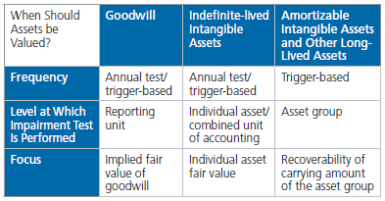

In addition to annual testing, many asset classes have guidance requiring impairment testing to be performed when a triggering event—defined as an event or change in circumstance indicating that the carrying amount of an asset may not be recoverable—occurs.

A disaster such as the Japan earthquake can impair assets. In some cases, buildings or other assets have been severely damaged or destroyed. In other cases, a company’s operations or financial performance may be significantly affected by the loss of an essential supplier or customer.

Assets potentially affected and in need of review include goodwill, intangibles, other long-lived assets, investments, inventories, and receivables. Due to the complexities involved in an IP valuation, it is important to engage a qualified, independent valuation specialist. Auditors are unable to perform these services for their audit clients as it constitutes a conflict of interest under the Sarbanes-Oxley Act of 2002.

#### Risk Transfer for Intellectual Property

There are four basic types of policies for risk transfer of intellectual property.

###### IP Infringement Coverage

IP infringement coverage, also known as intellectual property liability coverage, defends from patent infringement claims against the insured and defends the insured’s ownership rights in the IP. It also provides insurance to indemnify customers and distributors for allegations that the insured’s IP is in violation of another’s IP rights and indemnifies against damages the insured is legally liable for as a result of a verdict or settlement. This is the most typical type of coverage purchased when customers think of or ask for IP liability insurance. This is also the most elusive as insurers have historically experienced substantial losses with this type of coverage due to the self selection of purchasers, who tend to be those who are more litigious or subject to more frequent litigation.

###### IP Enforcement Coverage

IP enforcement coverage is a fund provided by insurers to indemnify the insured for its legal expenses in seeking to enforce or protect its IP rights against infringement. It provides IP owners with the financial resources to fund professional fees and expenses when pursuing infringers. This coverage does not insure against counterclaims or against any loss. It can be expanded with optional extensions to include contractual disputes and action against a third party for non-payment, enforcement of an agreement to indemnify the insured, and action against the insured for breach of a declared agreement. This extension can also include investigation costs to determine if there are grounds for pursuit.

###### IP Representations and Warranties

One of the least known and most used types of coverage is IP representations and warranties infringement liability insurance, which is generally associated with mergers and acquisitions or a purchase agreement. It certifies that the IP involved in the transaction is valid, similar to the function of title insurance in home purchases. This type of coverage defends against infringement/misappropriation liability and provides reimbursement for defense expenses and/or loss (awards or settlements). It is designed specifically for the representations and warranties applying to intangible assets, whether the sale or purchase of a single asset, a portfolio of assets, or as part of a corporate sale or merger.

###### IP Value Insurance

The last type of risk transfer product is IP value insurance, which is a direct loss cover rather than a defense cover. It is triggered by legal claims against the IP that result in loss of revenue or value associated with invalidity of findings or other legal claims against patents in an insured’s portfolio. This type of coverage is generally associated with IP-rich products’ future revenue streams, licensing revenues, royalty receipts, valuation by IP experts of patent portfolios, research and development expenditures, and financial arrangements involving IP such as IP loans, securitization, monetization, and investments in IP-rich companies.

#### Intellectual Property Risk Management

Another important element in the discussion of intellectual property valuations and protection in the modern economy involves the strategic management and mitigation of IP risks.

Firms of all sizes and purpose are motivated by similar goals in the creation of such programs:

* to identify what constitutes a risk sensitive intangible asset;
* to address new and emerging threats to IP;
* to properly allocate available risk resources given limited funds; and
* to achieve compliance within the legal and regulatory environment in which they operate.

In this context, there are several trends emerging within the space.

First, IP is transitioning from exclusively a legal matter to that of a business/strategic issue; this is evidenced by the increasing number of organizations trying to leverage the value of their intellectual property, launch joint ventures utilizing IP, gain from the value of their patents, and utilize IP as a central tenant of a M&A strategy.

Second, IP risk management is migrating from a defensive to an offensive effort, which will have significant implications for firms’ overall risk management strategies.

Third, a “collective relationship” model for managing risks is developing and its maturity is being accelerated through technological advancements. Enabling technologies, such as cloud computing, will allow for greater sharing of intellectual property in defined ways as firms look for heightened efficiencies. Concurrent to this trend, the increased sharing of proprietary material creates complex questions that will be central to defining risk management strategies. Namely, who is the custodian for maintaining the integrity/security around the IP while in electronic, sharable form?

While IP risk represents, at times, an opaque and ambiguous topic, developing risk management strategies to address the issue involves the implementation of several programmatic fundamentals—defining the value of its IP, and then identifying, assessing, and evaluating risk impacts. With this foundation established, organizations are better positioned to focus on properly executing mitigation programs by ensuring necessary levels of leadership commitment, aligning the program with strategic goals, creating the program framework through publication of policies and standards, reviewing network architecture, and education and training.

While such measures can prove challenging, the realities of the contemporary business environment require a robust valuation and risk mitigation effort to realize the upside potential of an organization’s intellectual property.

Topic 6: Execution and Business Plan\*

<https://www.inc.com/martin-zwilling/5-keys-to-successful-execution-of-a-business-strategic-plan.html>

## 5 Keys to Successful Execution of a Business Strategic Plan

### With strategic planning, a lot more gets said than done. Successful execution takes ruthless consistency.

BY [MARTIN ZWILLING](https://www.inc.com/author/martin-zwilling)[@STARTUPPRO](https://twitter.com/StartupPro)



Getty Images

In my years of advising business leaders, from entrepreneurs to enterprise executives, I often hear a passion for [strategic change planning](https://www.inc.com/robin-camarote/8-tips-to-writing-a-strategic-plan-that-works.html) but seldom see the same commitment to [strategic execution](https://www.inc.com/molly-reynolds/how-to-actually-execute-your-business-strategy.html).

I fully understand that real change is hard, but I'm convinced that more focus on the execution is required to overcome the current [70 percent failure rate](https://www.inc.com/brent-gleeson/1-reason-why-most-change-management-efforts-fail.html) for strategic transformations.

While pulling together my thoughts on how to better implement change initiatives, I was happy to see some specific guidance in a new book, [*Ruthless Consistency*](https://www.amazon.com/Ruthless-Consistency-Committed-Implement-Organizations/dp/1260459810?tag=wwwinccom-20), by Michael Canic, PhD. He brings a wealth of experience to the table, based on years of consulting work with middle-market companies around the world.

I support his summary of five key steps to get beyond the planning:

*Article continues after video.*

FEATURED VIDEO

How a New Brand Can Break Through the Noise

Volume 0%

## 1. First check your view of the reality of your situation.

If you start with a distorted or biased view of what your company needs, no execution is likely to achieve the results that win. Also, if you are not totally committed in spirit, as well as resources, to a strategic change, it probably won't happen. Doing what it takes to win involves risk and sacrifice.

Another reality is that sending mixed messages to your team will kill your change effort quickly. If a change initiative is "highest priority" today, but another takes its place next week, people will not take you seriously. Consistency and attention to detail are critical.

## 2. Replace strategic planning with a change process.

Strategy must be a process, with an implementation system behind it, rather than just a periodic event. The process must focus not only on the "what" but also on the "how." This must include metrics and tracking, with the necessary systems and resources to act, recalibrate, and iterate as required.

A [change process](https://www.inc.com/kate-l-harrison/business-process-changes-your-company-needs-to-make-to-survive-2017.html) gives you and your team a structure for execution, and clears the desk of non-value-added activities to focus on the strategic work. It means applying rigor to the execution, and being prepared to pivot the initiative in an ever-changing marketplace.

## 3. Create the environment and equip people to succeed.

Strategic execution requires a business environment where everyone is on board, and able to complete their part of the process. Team members must be engaged and enabled to do the job -- that means aligned, equipped, coached, supported, and valued for the work and changes ahead.

Communicate with people, not at people, before, during, and after you develop any strategic initiative. Validate everything you do from their perspective, as well as yours. Give primary attention to those who are promoters of change, not the recalcitrant few.

## 4. Be selective in recruiting and building the right team.

Look for people with a [growth mindset](https://www.inc.com/angelina-zimmerman/the-8-tremendous-ways-for-developing-a-growth-mindset.html), rather than a fixed mindset that may be hard to change. Give special attention to traits that fit your specific customer context, or a higher purpose you espouse, such as a focus on the environment. Beware of biases that can work against strategic initiatives.

It is very important to regularly assess your selection process, and all new team members, at the end of each period. Team members who don't meet expectations must receive special coaching or be replaced before they negate other team member efforts.

## 5. Personalize your commitment and lead the initiative.

Don't allow yourself to be the enemy by letting external distractions take priority, being selectively inaccessible, or not making timely decisions. Control your ego, and practice being vulnerable at the right time to maintain their respect. Your team commitment must be evident and actions consistent.

[Jeff Bezos](https://www.inc.com/scott-mautz/jeff-bezos-uses-this-1-emotionally-intelligent-sentence-to-sell-his-team-on-his-biggest-boldest-ideas.html), the legendary founder of Amazon, believes his commitment to his team is his key to sustained strategic leadership. He admits that he still has to sell his team on many of his biggest, boldest ideas, and he is indebted to them in keeping ahead of competitors.

In business, there are no guarantees of success, but the requirements for strategic change are certain. Whether you give only lip service to this requirement through strategic planning or implement a formal business infrastructure to attack these challenges consistently is up to you.

In my experience, the steps outlined here will definitely increase your odds of success and survival. Also remember that what you do and feel is not enough -- execution depends on team selection, engagement, and commitment.

It's up to you to align their hearts and minds on winning. Winning together is more fun anyway.

Roadmap for research, development, and production

# https://www.productplan.com/learn/product-development-roadmap/

# How to Create a Product Development Roadmap

## What is Product Development?

Product development refers to all of the work involved in taking a product from concept to the market.

The term does not just refer to the developers who build or code the product. Product development is a broad effort that involves many teams across a company: marketing, design, development, QA, sales, etc. In contrast, product management drives this effort from a strategic standpoint.

## What Does the Product Development Process Look Like?

There are several frameworks available to help businesses structure their [product development process](https://www.productplan.com/glossary/product-development-process/).

One popular example is the [design thinking framework](https://www.productplan.com/glossary/design-thinking/). Another is the fuzzy front end (FFE) approach. This framework identifies the broad stages of development but offers flexibility in how an organization arranges and prioritizes these steps. As TechTarget explains, the five elements of [the FFE approach](https://searchcio.techtarget.com/definition/product-development-or-new-product-development-NPD) are:

**1. Identify design criteria:** Brainstorming new product ideas.

**2. Idea analysis:** Using market data and other types of research to evaluate the viability of a product idea.

**3. Concept genesis:** Turning a product opportunity, the team agrees on viability into a tangled concept.

**4. Rapid prototyping:** Developing a simulated or “quick-and-dirty” model of the product for early user feedback. [Learn more about rapid prototyping.](https://www.productplan.com/glossary/rapid-prototyping/)

**5. Product development:** Gathering evidence of viability, making the business case, then beginning development.

## Why Roadmaps Are Important for Product Development

[Product development](https://www.productplan.com/what-is-product-development/) is a complex process. It encompasses many steps, involves several groups across the organization, and contains interdependencies among these groups. Also, the cross-functional team must frequently check on its progress to make sure they are continuing to execute according to plan. Product development requires continuous communication.

For these reasons, organizations should maintain a product development roadmap as a centralized resource to track and refer to everyone’s strategic role. A product development roadmap is an overview of the planned work and milestones involved in bringing a product to market.

### [Get Your Free Product Development Roadmap Template ➜](https://go.productplan.com/cs/c/?cta_guid=d2a50569-14fa-4697-a1f8-498fbfffd6dc&signature=AAH58kECYoHx7vjc4zKEvgHuuejzsbO30A&placement_guid=3452bc59-140b-4200-9877-4c8e5061b334&click=997daa3d-1714-45a6-8d19-5466bb53424f&hsutk=be04e3240086950e82dd056b7efcd848&canon=https%3A%2F%2Fwww.productplan.com%2Flearn%2Fproduct-development-roadmap%2F&utm_referrer=https%3A%2F%2Fwww.google.com%2F&portal_id=3434168&redirect_url=APefjpEjSfrXrqBn78BLaX2HwzI3_MlFKEl6UEEFhM3HJX1-euRW5OlTwFgYzITuK488QJw-wqVIzWy0UjJ0x4XfJ7Cvblg7FYVB-bQ3PkgHK3RWm86b_Z2eFVs2w0r24p40j4FvmprDqCAqKfErSGBNb_EQYBsEFGBn7_d1lrFp-QR-oJkPYtjYWiDzkbjTQ-Rk-Hv5lA6w0rKzFEnShVU-gcFqmGfafHhL672EaO7jOMISYf6HgDDcDBph_5gRcuTUEKWAZ4dKGfbLC-cqsSq2d_UyRITYnswFN2aSxOD9AxqdK7rbQ54&__hstc=48140984.be04e3240086950e82dd056b7efcd848.1619062424387.1619062424387.1619062424387.1&__hssc=48140984.1.1619062424387&__hsfp=2512781797" \o "Get Your Free Product Development Roadmap Template ➜)

### Product Development Roadmap vs. Product Roadmap

The product development roadmap should not be confused with the product roadmap. Both are designed to communicate an organization’s strategic thinking and planning for its product. But the two are separate tools, each focusing on a different aspect of the product’s strategy.

A product development roadmap is designed to track and communicate a product’s development initiatives and milestones. It covers a shorter time frame, only a couple of months, and agile organizations arrange it in sprints.

Whereas, a product roadmap is designed to map out a product’s strategic vision and priorities over time. It highlights the product’s major themes, and, according to research we gathered for [ProductPlan’s 2019 Product Planning Report](https://www.productplan.com/lp/2019-product-planning-report/), most organizations’ product roadmaps cover a timeframe of four to twelve months.

A product roadmap focuses on major strategic milestones and sometimes doesn’t include dates. In contrast, product development roadmaps are data-driven and focus on deadlines and release schedules.

## How to Build a Product Development Roadmap

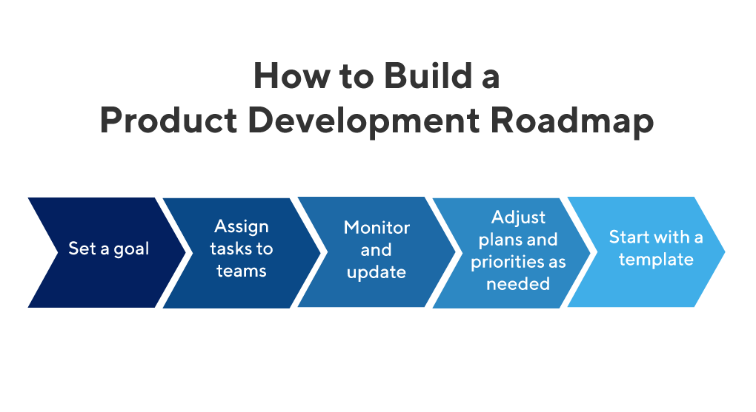

### 1. Set a clearly defined goal for your product’s development.

The product development roadmap should not be simply a task list. Each item on the roadmap must serve a strategic purpose for the product’s overall success.

Before adding items to your roadmap, you and your team need to set a strategic goal for the roadmap. Then you can gauge each item that you want to add afterward according to whether or not it contributes strategically to that goal.

### 2. Agree on which teams and individuals own which tasks.

A roadmap doesn’t help your team’s product development unless every item on it has a clear owner. Therefore, that owner has taken responsibility for completing the task in the agreed timeframe.

### 3. Monitor the roadmap frequently and update as needed to stay on course.

Since product development involves many moving parts and interdependencies, you need to revisit your roadmap often to make sure everyone is still on course.

### 4. Be willing to adjust plans and priorities based on new realities.

No complex initiative goes precisely according to plan from start to finish. You need to be prepared to shift resources or change priorities when realities force you to do so.

For example, if a portion of your marketing resources diverts to a higher-priority project, you need to be willing to adjust to that reality so that you can keep the product’s marketing efforts on track.

### 5. Start with a product development roadmap template, such as the one below.

Product development roadmaps include many short-term steps and milestones that can change frequently. It’s a good idea to build this blueprint with a tool designed for roadmaps—and not by drafting a static document from scratch.

Budget and timeline

<https://openclassrooms.com/en/courses/4055461-manage-your-code-project/4111386-write-the-timeline-and-budget-sections-of-a-project-brief>

## Write the timeline and budget sections of a project brief

[Log in](https://openclassrooms.com/en/login) or [subscribe](https://openclassrooms.com/en/register) for free to enjoy all this course has to offer!

The first few sections of your project brief were quite broad. They were at the overall project level and not concerned with exact project execution.

Enter the timeline and budget sections!

### Timeline

Unlike the very general **Goals** section of your project brief, the **Timeline** section can let you dive into specific to-do items and their associated deadlines.

Setting a timeline in advance of starting the project lets you clear up any possible misunderstandings between you and your client (or you and your team). For example, while you might think a certain code refactor is important to write before doing anything else, your client or company might be interested in having a first raw prototype as the first step in the process.

Unclear expectations or missed deadlines can lead to the worst types of workplace experiences. A planned project is a pleasant project!

Unsure where to begin for setting a project timeline? Start by writing down the largest, broadest steps either in a notebook or in your actual project brief. Next, break down the **individual** steps you'll need to take in order to accomplish the large tasks. Don't think about dates for the moment.

For example, a large step could be "Set Dough subscription pricing." This task is large and requires multiple smaller steps! Smaller steps therein could include "Finance team researches subscription options and budget," "Have meeting with finance team and CEO," or "Email payments processor with list of needs."

#### Timing

Once you've broken down each large step into its individual components, you can now break down the timeline of each. Depending on your project's timeline, you may breakdown down tasks into hourly, daily, weekly, or even monthly time chunks.

Even for tasks that are less clear timing-wise, it's better to give a **rough estimate** instead of no estimate at all. Some project steps depend on other preceding steps. When someone looks at your project brief, they should be able to understand the flow of task execution.

Give yourself some wiggle room! If you think something might be completed somewhere between November 3-6, for example, put November 6. Worst-case scenario, you finish early. 😎

You can detail your timeline in a format that suits you. Here's the above example in a spreadsheet format:

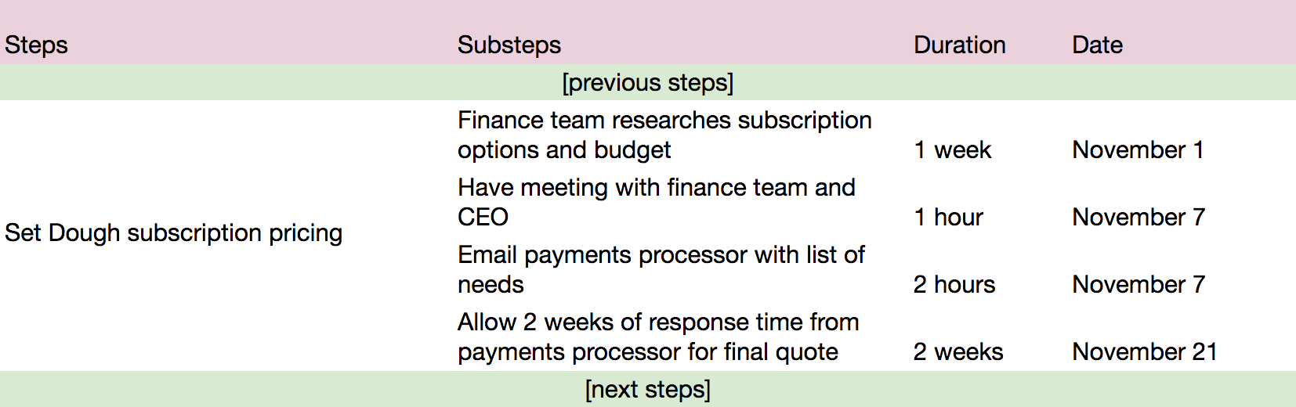Timeline breakdown

If you want to be really precise, you can measure every duration in the same unit (ex. above durations would be 40 hours / 1 hour / 2 hours / 80 hours).

The level of detail you want to set is up to you. No matter what though, writing the project brief timeline is an excuse to talk to each stakeholder, understand their constraints, and identify possible delay points.

### Budget

Setting a budget will depend hugely on the project itself! There are some best practices to follow though, whether your project is taking place in-house or with an external client. 💰

#### Core costs

There are core costs involved in almost any type of project, which include **salaries** (for in-house collaborators) and **rates** (for freelance collaborators), **travel costs**, **physical materials** (computers, supplies, etc), and **services** (web hosting, domain names, software tools, etc).

If your project only involves in-house collaborators, considering salaries is not as crucial, especially because you might not have access to this information.

Your project's piggy bank

To get an idea of possible costs, look back at projects you've done before, or ask other people in the company to share their experiences.

For example, while considering previous projects, you might notice several projects got stuck at the software testing phase because you only have one QA manager who's spread thin between a million projects, which resulted in paying a freelance QA person to lend a hand. You'll therefore want to add a line to your budget for a likely freelance QA person based on those previous experiences.

Some expenses, like last-minute travel or equipment that needs replacing, will be difficult to plan in advance. Consider budgeting a general amount for unforeseen situations.

#### Sneaky expenses

"Sneaky" isn't an official finance term, but it describes certain types of expenses very well! You'll have generally smaller costs that accumulate throughout your project. While they may seem negligible, their costs add up.

* Postage and shipping
* Licenses
* Recruitment
* Promotional material
* Phone bills

Sales and marketing plans

<https://www.inc.com/jeff-haden/how-to-write-a-great-business-plan-sales-and-marketing.html>

## How to Write a Great Business Plan: Sales and Marketing

### The sixth in a comprehensive series to help you craft the perfect business plan for your startup

BY [JEFF HADEN](https://www.inc.com/author/jeff-haden)[@JEFF\_HADEN](https://twitter.com/jeff_haden)



Shutterstock

This article is part of a series on [*how to write a great business plan*](https://www.inc.com/jeff-haden/how-to-write-a-great-business-plan-key-concepts.html).

Providing great products and services is wonderful, but customers must actually know those products and services exist. That's why marketing plans and strategies are critical to business success. (Duh, right?)

But keep in mind marketing is not just advertising. Marketing--whether advertising, public relations, promotional literature, etc--is an investment in the growth of your business.

Like any other investment you would make, money spent on marketing must generate a return. (Otherwise why make the investment?) While that return could simply be greater cash flow, good marketing plans result in higher sales and profits.

So don't simply plan to spend money on a variety of advertising efforts. Do your homework and create a smart marketing program.

Here are some of the basic steps involved in creating our marketing plan:

* **Focus on your target market.** Who are your customers? Who will you target? Who makes the decisions? Determine how you can best reach potential customers.
* **Evaluate your competition.** Your marketing plan must set you apart from your competition, and you can't stand out unless you know your competition. (It's hard to stand out from a crowd if you don't know where the crowd stands.) Know your competitors by gathering information about their products, service, quality, pricing, and advertising campaigns. In marketing terms, what does your competition do that works well? What are their weaknesses? How can you create a marketing plan that highlights the advantages you offer to customers?
* **Consider your brand.** How customers perceive your business makes a dramatic impact on sales. Your marketing program should consistently reinforce and extend your brand. Before you start to market your business, think about how you want your marketing to reflect on your business and your products and services. Marketing is the face of your to potential customers--make sure you put your best face forward.
* **Focus on benefits.** What problems do you solve? What benefits do you deliver? Customers don't think in terms of products--they think in terms of benefits and solutions. Your marketing plan should clearly identify benefits customers will receive. Focus on what customers get instead of on what you provide. (Take Dominos; theoretically they're in the pizza business, but really they're a delivery business.)
* **Focus on differentiation.** Your products and services have to stand out from the competition in some way. How will you compete in terms of price, product, or service?

Then focus on providing detail and backup for your marketing plan.

**Key questions to answer:**

* **What is your budget for sales and marketing efforts?**
* **How will you determine if your initial marketing efforts are successful?** In what ways will you adapt if your initial efforts do not succeed?
* **Will you need sales representatives (inside or external) to promote your products?**
* **Can you set up public relations activities to help market your business?**

The **Sales and Marketing**section for our cycling rental business could start something like this:

## Target Market

The target market for Blue Mountain Cycling Rentals is western VA, eastern WV, southwestern MD, and northern NC. While customers in the counties surrounding the George Washington National Forest make up 35% of our potential customer base, much of our market travels from outside that geographic area.

## Marketing Strategy

Our marketing strategy will focus on three basic initiatives:

* **Road signage.** Access to the forest is restricted to a few primary entrances, and visitors reach those entrances after traveling on one of several main roadways. Since customers currently rent bicycles in the local town of Harrisonburg, road signage will communicate our value proposition to all potential customers.
* **Web initiatives.** Our website will attract potential visitors to the resort. We will partner with local businesses that serve our target market to provide discounts and incentives.
* **Promotional events.** We will hold regular events with professional cyclists, like demonstrations and autograph signings, to bring more customers to the store as well as to extend the athletes' "brand" to our brand.

## Pricing Strategy

We will not be the low-cost provider for our target market. Our goal is to provide mid- to high-end equipment. However, we will create web-based loyalty programs to incent customers to set up online profiles and reserve and renew equipment rentals online, and provide discounts for those who do. Over time we will be able to market specifically to those customers.

Just like in the Market Opportunity section, you may want to include a few more categories. For example, if your business involves a commission-compensated sales force, describe your Sales Programs and incentives. If you distribute products to other companies or suppliers and those distribution efforts will impact your overall marketing plans, lay out your Distribution Strategy.

The key is to show you understand your market and you understand how you will reach your market. Marketing and promotions must result in customers--your goal is to thoroughly describe how you will acquire and keep your customers.

Also keep in mind you may want to include examples of marketing materials you have already prepared, like website descriptions, print ads, web-based advertising programs, etc. While you don't need to include samples, taking the time to create actual marketing materials might help you better understand and communicate your marketing plans and objectives.

Make sure your Sales & Marketing section answers the "How will I reach my customers?" question.

cost of customer acquisition, customer lifetime value

<https://www.klipfolio.com/resources/kpi-examples/saas/customer-lifetime-value-to-customer-acquisition-cost#:~:text=The%20Customer%20Lifetime%20Value%20to,of%20sales%20and%20marketing%20efficiency>.

### LTV: CAC = Customer Lifetime Value / Customer Acquisition Cost

### LTV:CAC Definition

The Customer Lifetime Value to Customer Acquisition (LTV:CAC) ratio measures the relationship between the lifetime value of a customer, and the cost of acquiring that customer. The metric is computed by dividing LTV by CAC. It is a signal of customer profitability, and of sales and marketing efficiency. Add this Klip to your [Excel dashboard](https://www.klipfolio.com/integrations/excel-dashboard).

### LTV:CAC Example

Consider a SaaS company that had a gross margin of 75% and monthly customer churn of 2%, and each customer spent an average of $40 with you every month, the calculation would look like this:

75% X ( 1 / 2% ) X $40 = $1,500 LTV

### Customer Acquisition Cost (CAC) Benchmarks

There are a number of factors should come into play in determining a target CAC, including Customer Lifetime Value projections, market size, business life cycle stage, level of funding, competitive positioning and marketing strategy. Here’s some expert advice and rules of thumb:

[*Mike Volpe, former CMO, Hubspot*](https://www.quora.com/What-is-the-typical-acquisition-cost-of-a-SaaS-customer-by-monthly-multiple)

* Strong B2B companies in their growth stage should have an LTV:CAC ratio of 3-5.

[*Jordan McBride, Marketing Manager, Price Intelligently*](http://blog.profitwell.com/the-complete-saas-guide-to-calculating-and-reducing-cac)

* The best rule of thumb is spending 33% or less of your customer’s lifetime value.

### LTV:CAC Challenges

Measuring and optimizing the CAC metric can be challenging on a number of fronts, especially if you’re attempting to attribute acquisition costs to individual accounts or customer segments - how much of your monthly ad spend or sales budget should be attributed to a specific win?

Even at the aggregate level, adding up marketing and sales costs over a given period can be misleading from a CAC perspective; in most cases marketing and sales resources are not solely focused on new customer acquisition.

### LTV: CAC Best Practices

According to Jordan McBride, to reduce your CAC and optimize profit, SaaS companies need to optimize their funnel by quantifying each step of the process and understanding how many visits to leads, how many leads lead to opportunities, and how many opportunities lead to customers. It’s also important to optimize your pricing because a huge portion of CAC feeds into the recovery period, as well as CAC ratio. McBride points out that if you optimize your pricing to gain cash up front to recover your CAC, in the form of mandatory training, integration costs, etc., you can ensure you start making a profit as a soon as possible.

### How to monitor LTV:CAC in Real-time

Once you have established metrics for measuring LTV:CAC, you’ll want to establish processes to monitor this and other SaaS KPIs on a continual basis. Dashboards can be critical in this regard.

Learn more about how to track your LTV:CAC on a [SaaS Dashboard.](https://www.klipfolio.com/resources/dashboard-examples/saas)

Lean concepts and organization

https://theleanway.net/what-is-lean

Lean is the concept of efficient manufacturing/operations that grew out of the Toyota Production System in the middle of the 20th century. It is based on the philosophy of defining value from the customer’s viewpoint, and continually improving the way in which value is delivered, by eliminating every use of resources that is wasteful, or that does not contribute to the value goal. Lean is centered on preserving value with less work; with the ultimate goal of providing perfect value to the customer through a perfect value creation process that has zero waste. This is done by empowering every individual worker to achieve his or her full potential, and so to make the greatest possible contribution.  
  
The goal of empowerment is based on the idea of showing respect for people. Respect for people extends beyond just the end customer and can include the workers, suppliers, and society. For the end customer, Lean strives to maximize value delivery while minimizing waste in the process. Lean aims to maximize human potential by empowering workers to continuously improve their work. Lean leaders facilitate this goal through problem-solving training. They help workers grow professionally and personally, allowing them to take pride in their work.  
  
At the heart of the Lean philosophy is the concept of “kaizen” or continuous improvement. The goal of [continuous improvement](https://theleanway.net/what-is-continuous-improvement) is to eliminate all [waste](https://theleanway.net/The-8-Wastes-of-Lean) in the value delivery process. To do this, Lean leaders must go where value is created – commonly known as the gemba. At gemba, they often spend their time coaching and developing their people. They encourage workers to actively identify problems and look for opportunities for improvement.

#### History of Lean

In order to understand the history of Lean, we must go back to the start of modern manufacturing. Henry Ford was the first to truly integrate a production system called ‘mass-production’, which manufactures large quantities of standardized products. Ford created what he called a flow production, which involves continuous movement of elements through the production process. Ford used mass production to fabricate and assemble the components of his vehicles within a few minutes rather than hours or days. Unlike craft production, the mass production system delivered perfectly fitted components that are interchangeable. This process was very successful and allowed the Ford Motor Company to produce over 15 million Model T cars between 1908 and 1927. During World War II, the US military adopted Ford’s mass production system.  
  
In 1926, Sakichi Toyoda founded the Toyoda Automatic Loom Works. Several years later, the company changed its name to Toyota when it began producing automobiles. In 1950, Eiji Toyoda, the nephew of Sakichi, participated in a three-month visit to the Rouge plant of Ford in Dearborn, Michigan. At the time, the Dearborn facility was Ford’s most complex and largest manufacturing facility. It produced nearly 8000 cars per day while Toyota only produced 2500 cars each year.  
  
After studying Ford’s production system, Eiji Toyoda understood that the mass production system employed by Ford cannot be used by Toyota. The Japanese market was too small and diverse for mass production. The customer’s requirements ranged from compact cars to the most luxurious vehicles. Ford’s mass-production system focused on the amount of production instead of the customer’s voice. Toyota collaborated with Taiichi Ohno to develop a new means of production. They concluded that through right-sizing machines for the actual required volume and introducing self-monitoring machines, they can make products faster, lower in cost, higher in quality, and most importantly higher in variety! Ohno faced the challenge of trading off between productivity and quality. His experiments led to developing several novel ideas that became known as the ‘Toyota Production System’.

#### The Toyota Production System

The Toyota Production System (TPS) was established based on two concepts: The first is called "Jidoka" (can loosely be translated as "automation with a human touch") which means that when a problem occurs, the equipment stops immediately, preventing defective products from being produced. The second is the concept of "Just-in-Time," in which each process produces only what is needed by the next process in a continuous flow.

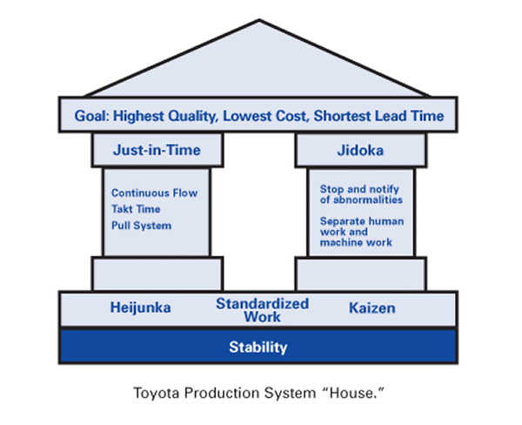

Toyota Production System (Lexicon, 2008)

With Jidoka, the equipment stops when a problem arises. This allows a single worker to visually monitor and efficiently control many machines. As problems arose, the workers must solve them right away otherwise the whole production line stops. This brings problems to the surface and promotes identifying and resolving problems at their root causes.  
  
TThe idea behind “Just-in-Time” is simple - make only “what is needed, when it is needed, and in the amount needed”. Using Just-in-Time, Toyota is able to produce high quality products efficiently through the elimination of waste. Based on the basic philosophies of Jidoka and Just-in-Time, the TPS can efficiently and quickly produce products of sound quality, one at a time, that fully satisfy customer requirements.

#### The Principles of Lean

The principles of Lean were first introduced in the book The Machine That Changed the World (1991) by James P. Womack, Daniel T. Jones and Daniel Roos. The authors studied several manufacturing systems and wrote the book based on their observations at Toyota. The Lean Enterprise Institute summarized these principles to the following:

1. 1. Specify value from the standpoint of the end customer by product family.
2. 2. Identify all the steps in the value stream for each product family, eliminating whenever possible those steps that do not create value.
3. 3. Make the value-creating steps occur in tight sequence so the product will flow smoothly towards the customer.
4. 4. As flow is introduced, let customers pull value from the next upstream activity.
5. 5. As value is specified, value streams are identified, wasted steps are removed, and flow and pull are introduced, begin the process again and continue it until a state of perfection is reached in which perfect value is created with no waste.

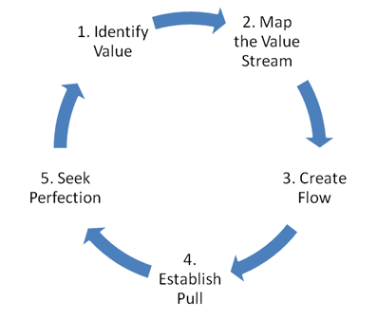

Figure 2: Lean Principles (Lean Enterprise Institute)

Womack and Jones recommend that managers and executives embarked on lean transformations think about three things:

* Purpose: What customer problems will the enterprise solve to achieve its own purpose of prospering?

* Process: How will the organization assess each major value stream to make sure each step is valuable, capable, available, adequate, flexible, and that all the steps are linked by flow, pull, and leveling?

* People: How can the organization ensure that every important process has someone responsible for continually evaluating that value stream in terms of business purpose and lean process? How can everyone touching the value stream be actively engaged in operating it correctly and continually improving it?

It is important to align the purpose, process, and people when developing a Lean organization. In a Lean organization, problems are seen as opportunities for meaningful learning rather than errors to be swept under the rug. Managers act as coaches and help others get comfortable with identifying problems and practice continuous improvement on a daily basis. Lean leaders also create an environment that is engaging and conducive to learning. They are hands-on and work with their team on the factory floor to truly understand problems.  
  
Lean was previously seen as a collection of tools and techniques, but it is now widely recognized as a fundamental business philosophy. According to Diekmann, “Lean cannot be reduced to a set of rules or tools. It must be approached as a system of thinking and behavior that is shared throughout the value stream”. Lean thinking is no longer limited to the manufacturing industry. It has been modified and applied to several other industries, such as the construction industry, healthcare, software, and many more. It has been shown that organizations that consistently practice Lean are more [innovative and competitive](https://theleanway.net/5-Benefits-of-Continuous-Improvement), which in turn allows them to be more profitable and sustainable.

Topic 7: Financial Analysis and Accounting Basics

Cash flow statements and projection

<https://www.patriotsoftware.com/blog/accounting/how-to-project-your-cash-flow/>

# **Glimpse into Your Business’s Financial Future By Creating a Cash Flow Projection**

[MIKE KAPPEL](https://www.patriotsoftware.com/author/mkappel/) | AUG 08, 2019

Your cash flow statement can give you an idea of your business’s current financial health. But, wouldn’t it be nice to see your company’s future cash flow? You don’t need a crystal ball to view your cash flow’s future. Instead, create a cash flow projection. Read on to learn about cash flow projection and how to project cash flow.

## What is cash flow projection?

First things first, if you want to learn about cash flow projections, you need to know what cash flow is.

Cash flow is the amount of money going in and out of your business. Healthy cash flow can help lead your business on a path to success. But poor or [negative cash flow](https://www.patriotsoftware.com/blog/accounting/what-is-negative-cash-flow/) can spell doom for the future of your business.

If you want to predict your business’s cash flow, create a cash flow projection. A cash flow projection estimates the money you expect to flow in and out of your business, including all of your income and expenses.

Typically, most businesses’ cash flow projections cover a 12-month period. However, your business can create a weekly, monthly, or semi-annual cash flow projection.

## Advantages of projecting cash flow

Estimating anticipated cash flow projections can help boost your business’s success.

Projecting cash flows has many advantages. Some pros of creating a cash flow projection include being able to:

* Predict cash shortages and surpluses
* See and compare [business expenses](https://www.patriotsoftware.com/blog/accounting/what-are-business-expenses/) and income for periods
* Estimate effects of business change (e.g., hiring an employee)
* Prove to lenders your ability to repay on time
* Determine if you need to make adjustments (e.g., cutting expenses)

Cash flow projection isn’t for every business. Your projected cash flow analysis can be time-consuming and costly if done wrong.

Keep in mind that cash flow predictions will likely never be perfect. However, you can use your projected cash flow as a tool to help [manage cash flow](https://www.patriotsoftware.com/blog/accounting/manage-small-business-cash-flow/).

The bottom line is, your cash projections give you a clearer picture of where your business is headed. And, it can show you where you need to make improvements and cut costs.

## How to calculate projected cash flow

If you’re ready to start calculating projected cash flow for your business, start gathering some historical accounting data.

You need to get reports detailing your business’s income and expenses from your accountant, books, or accounting software. Depending on the timeframe you want to predict, you might need to gather additional information.

Want to learn how to calculate cash flow projections? Use the projected cash flows steps below.

[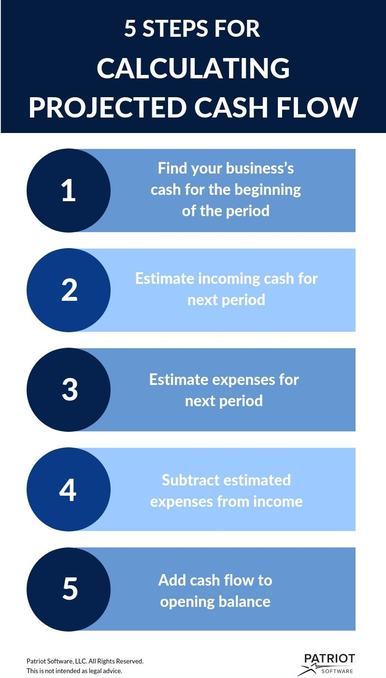](https://www.patriotsoftware.com/wp-content/uploads/2020/01/cash-flow-projection-new.jpg)

### 1. Find your business’s cash for the beginning of the period

To calculate your cash from the beginning of the period, you need to subtract the previous period’s expenses from income.

**Cash at Beginning of Period** = Previous Period’s Income – Previous Period’s Expenses

### 2. Estimate incoming cash for next period

Next, you need to predict how much cash will come into your business during the next period.

Incoming cash includes things like revenue, sales made on credit, loans, and more.

You can forecast future cash by looking at trends from previous periods. Be sure to account for any changes or factors that differ from previous periods (e.g., new products).

### 3. Estimate expenses for next period

Think about all the expenses you will pay next period. Consider things like raw materials, rent, utilities, insurance, and other bills.

### 4. Subtract estimated expenses from income

To calculate your business’s cash flow, subtract your estimated expenses from your estimated income.

**Cash Flow** = Estimated Income – Estimated Expenses

### 5. Add cash flow to opening balance

After you calculate cash flow, you need to add it to your opening balance. This will also give you your closing balance. Your closing balance will carry over to act as your starting balance for the next period.

To complete the next period’s projected cash flow, repeat the steps from above.

Confused? No worries! Take a look at an example of a project cash flow statement below:

[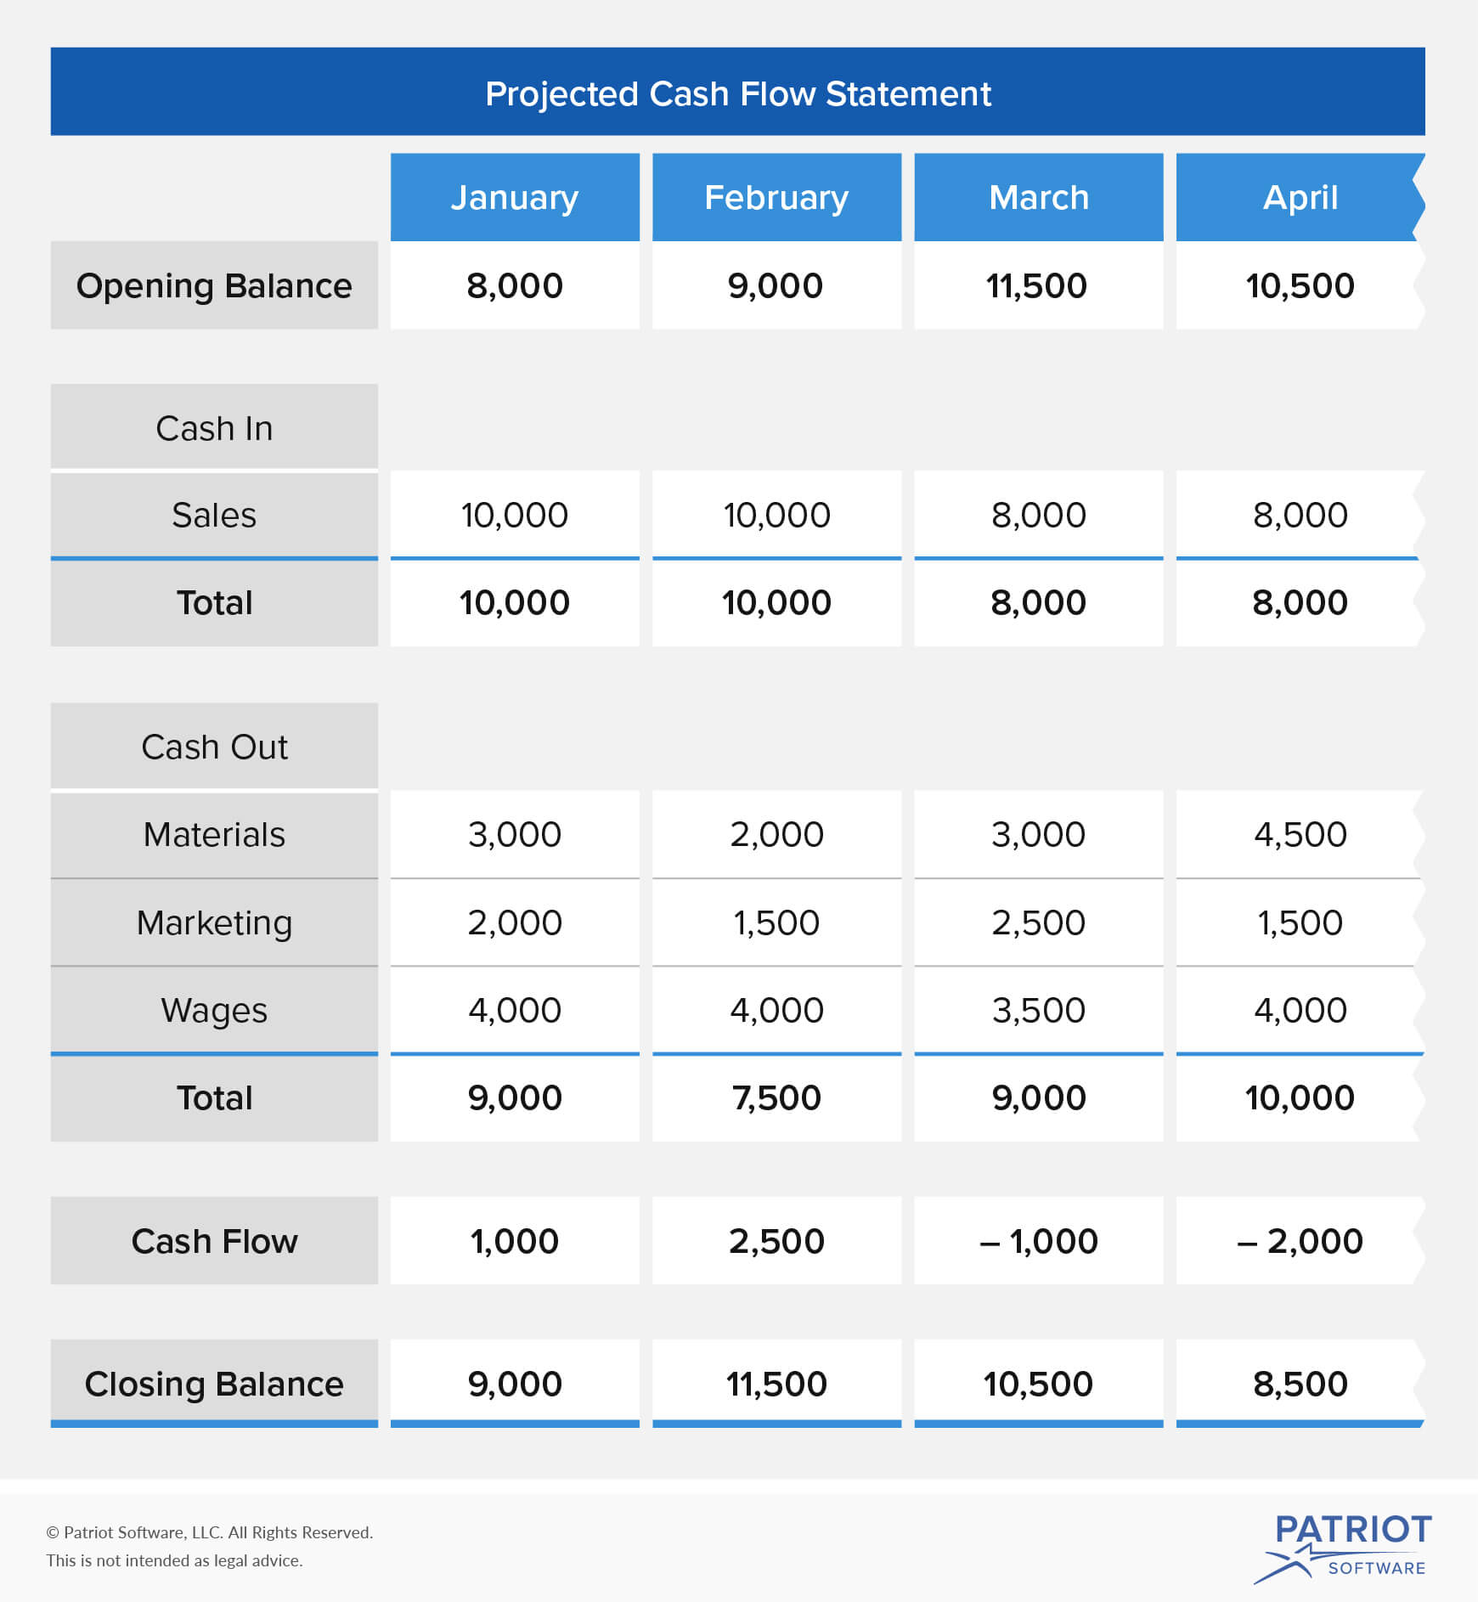](https://www.patriotsoftware.com/wp-content/uploads/2020/01/projected_cash_flow_69083.2.jpg)

## Creating a projection of cash flow

If you want to create your own cash flow projection, start drafting out columns for your future periods. Or, you can take advantage of a spreadsheet to organize your cash flow statement projections.

You should include the following categories in your cash flow projection:

* Opening balance
* Cash in (e.g., sales)
* Cash out (e.g., expenses)
* Totals for cash in and cash out
* Uses of cash (e.g., materials)
* Total cash flow for the period
* Closing balance
* Periods (e.g., month of January)

After you lay out the sections on your cash flow projection report, plug in your projected cash flow calculations.

## Revisiting your cash flow projection

Cash flow projections are not set in stone. Revisit your projection from time to time to see where you stand.

If you see major differences or flaws in your cash flow forecast, it may be time to crunch more numbers and do some digging. Pinpointing issues with your projection early on can prevent major inaccuracies in the future.

To ensure your projection stays as accurate as possible, consider variable expenses such as:

* [Months with three paychecks](https://www.patriotsoftware.com/blog/accounting/3-paycheck-months-extra-payroll/)
* Sales during peak seasons
* Months when premiums are due (e.g., insurance)
* Hiring additional workers

A good rule of thumb is to not project too far into the future. Too many variables can come into play with your business (e.g., dip in the economy) and affect your future cash flow.

As mentioned, a standard time period for cash flow projection is 12 months. Try to limit your cash flow projection time period to only a year in advance. That way, you can help prevent unforeseen expenses and errors impacting your projection.

If you don’t have time to track financial forecasts, consider delegating projection updates to a bookkeeper. Or, you can streamline the way you track cash flow with [basic accounting software](https://www.patriotsoftware.com/accounting/basic/).

For an accurate cash flow projection, you need to receive and track customer payments. Patriot’s online [*accounting software*](https://www.patriotsoftware.com/accounting/software/) lets you record your income and expenses to keep your finances in tip-top shape. What are you waiting for? Get started with your [*self-guided demo*](https://login.patriotsoftware.com/samplesystem/signup) today.

We’re always ready to keep the conversation going. Give us a like on [*Facebook*](https://www.facebook.com/patriotsoftware/) and share your thoughts on our latest articles.

This article has been updated from its original publication date of August 28, 2012

Income (P&L) statements

<https://www.investopedia.com/terms/p/plstatement.asp#:~:text=The%20profit%20and%20loss%20(P%26L,synonymous%20with%20the%20income%20statement>.

# Profit and Loss Statement (P&L)

## What Is a Profit and Loss Statement (P&L)?

The profit and loss (P&L) statement is a financial statement that summarizes the revenues, costs, and expenses incurred during a specified period, usually a fiscal quarter or year. The P&L statement is synonymous with the [income statement](https://www.investopedia.com/terms/i/incomestatement.asp).

These records provide information about a company's ability or inability to generate profit by increasing revenue, reducing costs, or both. Some refer to the P&L statement as a statement of profit and loss, income statement, statement of operations, statement of financial results or income, earnings statement, or expense statement.

For non-profit organizations, revenues and expenses are generally tracked in a financial report called the statement of activities (sometimes called statement of financial activities or statement of support).

P&L management refers to how a company handles its P&L statement through revenue and cost management.

### KEY TAKEAWAYS

* The P&L statement is a financial statement that summarizes the revenues, costs, and expenses incurred during a specified period.
* The P&L statement is one of three financial statements every public company issues quarterly and annually, along with the balance sheet and the cash flow statement.
* It is important to compare P&L statements from different accounting periods, as the changes in revenues, operating costs, R&D spending, and net earnings over time are more meaningful than the numbers themselves.
* Together with the balance sheet and cash flow statement, the P&L statement provides an in-depth look at a company's financial performance.

## Understanding a Profit and Loss Statement (P&L)

Investopedia/Grace Kim

The P&L statement is one of three financial statements every public company issues quarterly and annually, along with the [balance sheet](https://www.investopedia.com/terms/b/balancesheet.asp) and the cash flow statement. It is often the most popular and common financial statement in a business plan as it quickly shows how much profit or loss was generated by a business.

The income statement, like the cash flow statement, shows changes in accounts over a set period. The balance sheet, on the other hand, is a snapshot, showing what the company owns and owes at a single moment. It is important to compare the income statement with the cash flow statement since, under the accrual method of accounting, a company can log revenues and expenses before cash changes hands.

The income statement follows a general form as seen in the example below. It begins with an entry for revenue, known as the top line, and subtracts the costs of doing business, including the cost of goods sold, operating expenses, tax expenses, and interest expenses. The difference, known as the bottom line, is [net income](https://www.investopedia.com/terms/n/netincome.asp), also referred to as profit or earnings. You can find many templates for creating a personal or business P&L statement online for free.

It is important to compare income statements from different accounting periods, as the changes in revenues, operating costs, research and development spending, and net earnings over time are more meaningful than the numbers themselves. For example, a company's revenues may grow, but its expenses might grow at a faster rate.

accrual accounting, depreciation, operating expenses

<https://saylordotorg.github.io/text_exploring-business-v2.0/s16-03-accrual-accounting.html>

## What Is Accrual Accounting?

In situations such as these, firms use accrual accounting: a system in which the accountant records a transaction when it occurs, without waiting until cash is paid out or received. Here are a few basic principles of accrual accounting:

* A sale is recognized on the income statement when it takes place, regardless of when cash is collected.
* An expense is recognized on the income statement when it’s incurred, regardless of when payment is made.
* An item manufactured for later sale or bought for resale becomes part of inventory and appears on the balance sheet until it’s actually sold; at that point, it goes on the income statement under cost of goods sold.
* A long-term asset that will be used for several years—for example, a vehicle, machine, or building—appears on the balance sheet. Its cost is spread over its useful life—the number of years that it will be used. Its annual allocated cost appears on the income statement as a depreciation expense.

## Going to School on a New Business Idea

As we saw in our Stress-Buster illustration, it’s easier to make sense of accounting concepts when you see some real—or at least realistic—numbers being put to realistic use. So let’s now assume that you successfully operated the Stress-Buster Company while you were in college. Now fast-forward to graduation, and rather than work for someone else, you’ve decided to set up a more ambitious business—some kind of retail outlet—close to the college. During your four years in school, you noticed that there was no store near campus that met the wide range of students’ specific needs. Thus the mission of your proposed retail business: to provide products that satisfy the specific needs of college students.

*Figure 12.13 The College Shop*



You’ve decided to call your store “The College Shop.” Your product line will range from things needed to outfit a dorm room (linens, towels, small appliances, desks, rugs, dorm refrigerators) to things that are just plain fun and make student life more enjoyable (gift packages, posters, lava lamps, games, inflatable furniture, bean bag chairs, message boards, shower radios, backpacks). And of course you’ll also sell the original Stress-Buster Fun Pack. You’ll advertise to students and parents through the college newspaper and your own Web site.

## Accrual-Basis Financial Statements

At this point, we’re going to repeat pretty much the same process that we went through with your first business. First, we’ll prepare a beginning balance sheet that reflects your new company’s assets, liabilities, and owner’s equity on your first day of business—January 1, 20X6. Next, we’ll prepare an income statement and a statement of owner’s equity. Finally, we’ll create a balance sheet that reflects the company’s financial state at the end of your first year of business.

Although the process should now be familiar, the details of our new statements will be more complex—after all, your transactions will be more complicated: You’re going to sell and buy stuff on credit, maintain an inventory of goods to be sold, retain assets for use over an extended period of time, borrow money and pay interest on it, and deal with a variety of expenses that you didn’t have before (rent, insurance, etc.).

## Beginning Balance Sheet

Your new beginning balance sheet contains the same items as the one that you created for Stress-Buster—cash, loans, and owner’s equity. But because you’ve already performed a broader range of transactions before you opened for business, you’ll need some new categories:

* You’ve bought furniture and equipment that you’ll use over the next five years. You’ll allocate the cost of these long-term assets by depreciating them. Because you estimate that this furniture and equipment will have a useful life of five years, you allocate one-fifth of the cost per year for five years.
* You’ve purchased an inventory of goods for later resale.
* You’ve taken out two types of loans: one that’s current because it’s payable in one year and one that’s long term because it’s due in five years.

Obviously, then, you need to prepare a more sophisticated balance sheet than the one you created for your first business. We call this new kind of balance sheet a classified balance sheet because it classifies assets and liabilities into separate categories.

## Types of Assets

On a classified balance sheet, assets are listed in order of liquidity—how quickly they can be converted into cash. They’re also broken down into two categories:

1. Current assets—assets that you intend to convert into cash within a year
2. Long-term assets—assets that you intend to hold for more than a year

Your current assets will be cash and inventory, and your long-term assets will be furniture and equipment. We’ll take a closer look at the assets section of your beginning balance sheet, but it makes sense to analyze your liabilities first.

## Types of Liabilities

Liabilities are grouped in much the same manner as assets:

1. Current liabilities—liabilities that you’ll pay off within one year
2. Long-term liabilities—liabilities that don’t become due for more than one year

Recall that your liabilities come from your two loans: one which is payable in a year and considered current, and one which is long term and due in five years.

Now we’re ready to review your beginning balance sheet, which is shown in [Figure 12.14 "Beginning Balance Sheet for The College Shop"](https://saylordotorg.github.io/text_exploring-business-v2.0/s16-03-accrual-accounting.html#collins-ch12_s03_s01_s03_f01). Once again, your balance sheet balances: Your total assets of $275,000 equal your total liabilities plus owner’s equity of $275,000.

*Figure 12.14 Beginning Balance Sheet for The College Shop*

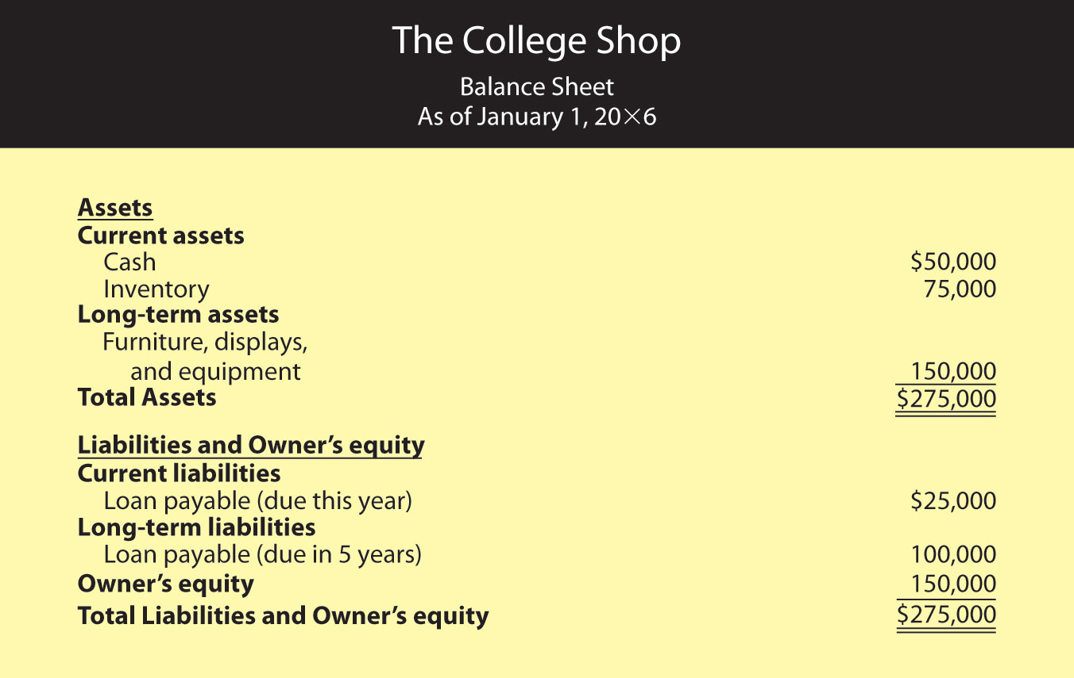

## Liabilities and Owner’s Equity

Let’s begin our analysis of your beginning balance sheet with the liabilities and owner’s-equity sections. We’re assuming that, thanks to a strong business plan, you’ve convinced a local bank to loan you a total of $125,000—a short-term loan of $25,000 and a long-term loan of $100,000. Naturally, the bank charges you interest (which is the cost of borrowing money); your rate is 8 percent per year. In addition, you personally contributed $150,000 to the business (thanks to a trust fund that paid off when you turned 21).

## Assets

Now let’s turn to the assets section of your beginning balance sheet. What do you have to show for your $275,000 in liabilities and owner’s equity? Of this amount, $50,000 is in cash—that is, money deposited in the company’s checking and other bank accounts. You used another $75,000 to pay for inventory that you’ll sell throughout the year. Finally, you spent $150,000 on several long-term assets, including a sign for the store, furniture, store displays, and computer equipment. You expect to use these assets for five years, at which point you’ll probably replace them.

## Income Statement

Finally, let’s look at your income statement, which is shown in [Figure 12.15 "Income Statement for The College Shop, Year Ended December 31"](https://saylordotorg.github.io/text_exploring-business-v2.0/s16-03-accrual-accounting.html#collins-ch12_s03_s01_s04_f01). Like your College Shop balance sheet, your College Shop income statement is more complex than the one you prepared for Stress-Buster, and the amounts are much larger. In addition, the statement covers a full calendar year.

*Figure 12.15 Income Statement for The College Shop, Year Ended December 31*

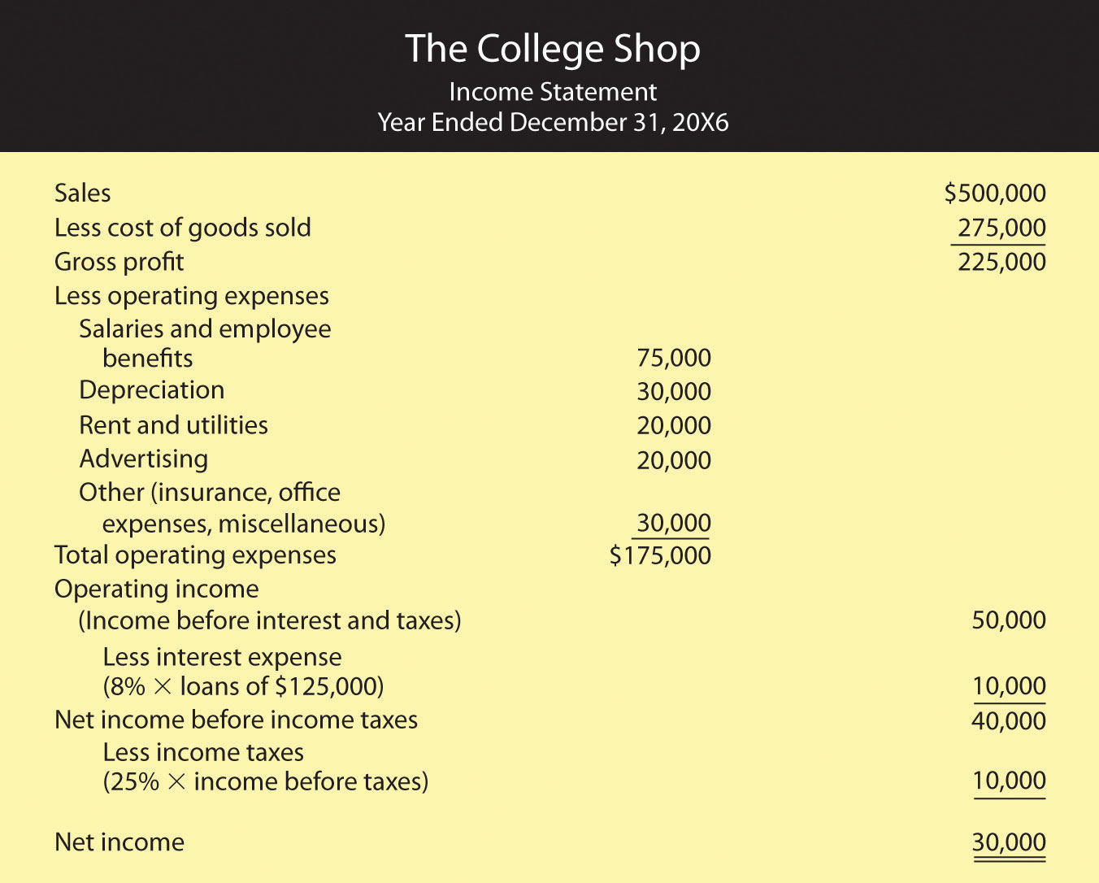

Note, by the way, that the income statement that we prepared for The College Shop is designed for a merchandiser—a company that makes a profit by selling goods. How can you tell? Businesses that sell services (such as accounting firms or airlines) rather than merchandise don’t have lines labeled cost of goods sold on their statements.

The format of this income statement also highlights the most important financial fact in running a merchandising company: you must sell goods at a profit (called gross profit) that is high enough to cover your operating costs, interest, and taxes. Your income statement, for example, shows that The College Shop generated $225,000 in gross profit through sales of goods. This amount is sufficient to cover your operating expense, interest, and taxes and still produce a net income of $30,000.

## A Few Additional Expenses

Note that The College Shop income statement also lists a few expenses that the Stress-Buster didn’t incur:

* Depreciation expense. Recall that before opening for business, you purchased some long-term assets (store sign, displays, furniture, and equipment) for a total amount of $150,000. In estimating that you would use these assets for five years (your estimate of their useful lives), you spread the cost of $150,000 over five years. For each of these five years, then, your income statement will show $30,000 in depreciation expense ($150,000 ÷ 5 years = $30,000).
* Interest expense. When you borrowed money from the bank, you agreed to pay interest at an annual rate of 8 percent. Your interest expense of $10,000 ($125,000 × 0.08) is a cost of financing your business and appears on your income statement after the subheading operating income.
* Income taxes. Your company has to pay income taxes at a rate of 25 percent of net income before taxes. This amount of $10,000 ($40,000 × 25%) appears on your income statement after the subheading net income before income taxes. It’s subtracted from income before income taxes before you arrive at your “bottom line,” or net income.

## Statement of Owner’s Equity

Our next step is to prepare a statement of owner’s equity, which is shown in [Figure 12.16 "Statement of Owner’s Equity for The College Shop"](https://saylordotorg.github.io/text_exploring-business-v2.0/s16-03-accrual-accounting.html#collins-ch12_s03_s01_s10_f99). Note that the net income of $30,000 from the income statement was used to arrive at the year-end balance in owner’s equity.

*Figure 12.16 Statement of Owner’s Equity for The College Shop*

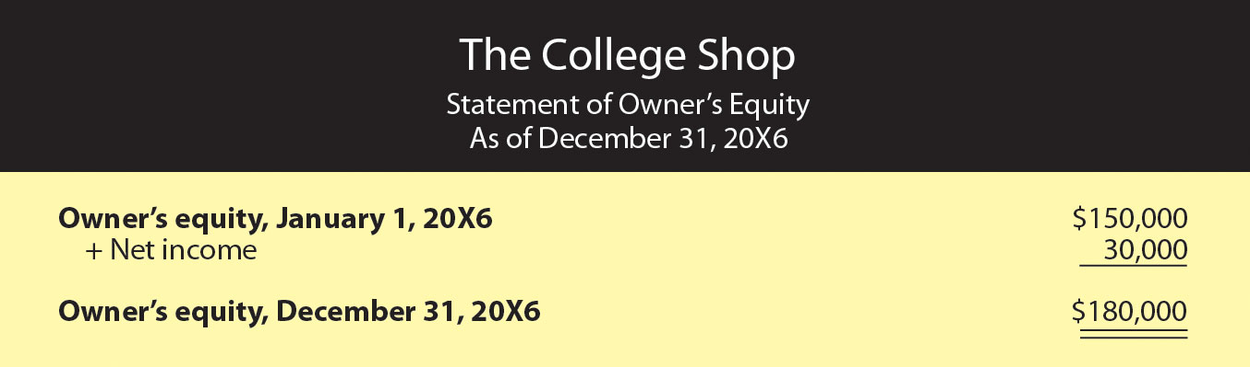

## End-of-First-Year Balance Sheet

We’ll conclude with your balance sheet for the end of your first year of operations, which is shown in [Figure 12.17 "End-of-Year Balance Sheet for The College Shop"](https://saylordotorg.github.io/text_exploring-business-v2.0/s16-03-accrual-accounting.html#collins-ch12_s03_s01_s06_f01). First, look at your assets. At year’s end, you have a cash balance of $70,000 and inventory of $80,000. You also have an accounts receivable of $90,000 because many of your customers have bought goods on credit and will pay later. In addition, the balance sheet now shows two numbers for long-term assets: the original cost of these assets, $150,000, and an accumulated depreciation amount of $30,000, which reflects the amount that you’ve charged as depreciation expense since the purchase of the assets. The carrying value of these long-term assets is now $120,000 ($150,000 - $30,000), which is the difference between their original cost and the amount that they’ve been depreciated. Your total assets are thus $360,000.

*Figure 12.17 End-of-Year Balance Sheet for The College Shop*

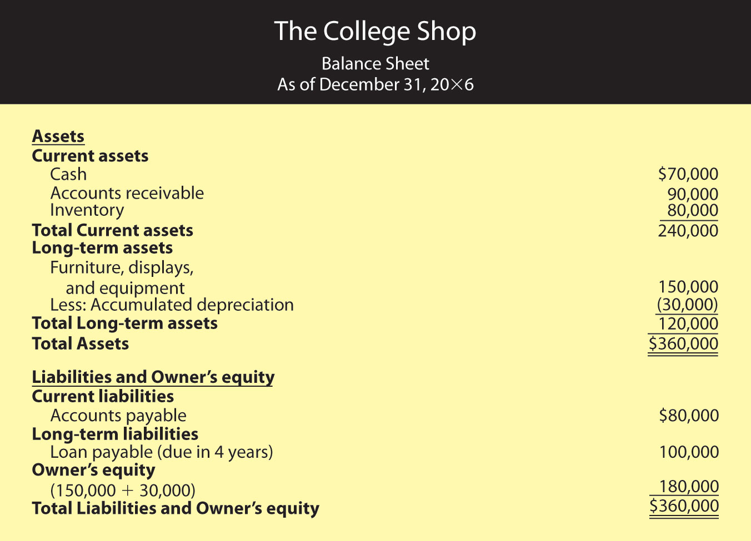

The total of your liabilities of $180,000 plus owner’s equity of $180,000 also equals $360,000. Your liabilities consist of a long-term loan of $100,000 (which is now due in four years) and accounts payable of $80,000 (money that you’ll have to pay out later for purchases that you’ve made on credit). Your owner’s equity (your investment in the business) totals $180,000 (the $150,000 you originally put in plus the $30,000 in first-year earnings that you retained in the business).

## Statement of Cash Flows

Owners, investors, and creditors can learn a lot from your balance sheet and your income statement. Indeed, each tells its own story. The balance sheet tells what assets your company has now and where they came from. The income statement reports earned income on an accrual basis (recognizing revenues when earned and expenses as incurred regardless of when cash is received or paid). But the key to surviving in business is generating the cash you need to keep it up and running. It’s not unusual to hear reports about companies with cash problems. Sometimes they arise because the products in which the firm has invested aren’t selling as well as it had forecast. Maybe the company tied up too much money in a plant that’s too big for its operations. Maybe it sold products to customers who can’t pay. Maybe management just overspent. Whatever the reason, cash problems will hamper any business. Owners and other interested parties need a financial statement that helps them understand a company’s cash flow.

The statement of cash flows tells you where your cash came from and where it went. It furnishes information about three categories of activities that cause cash either to come in (cash inflows) or to go out (cash outflows):

1. Cash flows from operating activities come from the day-to-day operations of your main line of business.
2. Cash flows from investing activities result from buying or selling long-term assets.
3. Cash flows from financing activities result from obtaining or paying back funds used to finance your business.

A cash flow statement for The College Shop would look like the one in [Figure 12.18 "Statement of Cash Flows for The College Shop"](https://saylordotorg.github.io/text_exploring-business-v2.0/s16-03-accrual-accounting.html#collins-ch12_s03_s01_s07_f01). You generated $45,000 in cash from your company’s operations (a cash inflow) and used $25,000 of this amount to pay off your short-term loan (a cash outflow). The net result was an increase in cash of $20,000. This $20,000 increase in cash agrees with the change in your cash during the year as it’s reported in your balance sheets: You had an end-of-the-year cash balance of $70,000 and a beginning-of-the-year balance of $50,000 ($70,000 − $50,000 = $20,000). Because you didn’t buy or sell any long-term assets during the year, your cash flow statement shows no cash flows from investing activities.

*Figure 12.18 Statement of Cash Flows for The College Shop*

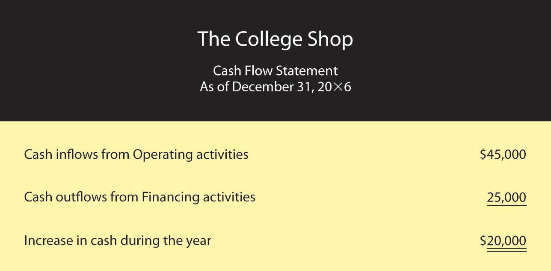

### KEY TAKEAWAYS

* There are two different methods for reporting financial transactions:
  + Companies using cash-basis accounting recognize **revenue** as earned only when cash is received and recognize **expenses** as incurred only when cash is paid out.
  + Companies using **accrual accounting** recognize revenues when they’re earned (regardless of when the cash is received) and expenses when they’re incurred (regardless of when the cash is paid out).
* An item manufactured for later sale or bought for resale appears on the balance sheet as an asset called **inventory**. When it’s sold, it goes on the income statement as an expense under the category cost of goods sold.
* The difference between sales and cost of goods sold is called **gross profit**.
* A merchandising company’s gross profit must be high enough to cover its operating costs, interest, and taxes.
* An asset that will be used for several years (say, a truck) appears on the balance sheet as a **long-term asset**. Its cost is allocated over its useful life and appears on the income statement as a **depreciation expense**.
* A **classified balance sheet** separates assets and liabilities into two categories—current and long-term:
  + **Current assets** include those that you intend to convert into cash within a year; **long-term assets** include those that you plan to hold for more than a year.
  + **Current liabilities** include those that you’ll pay off within a year; **long-term liabilities** include those that do not become due for more than a year.
* The **statement of cash flows** shows how much cash the business has coming in and going out.
* The statement of cash flows furnishes information about three categories of activities that cause cash either to come in or to go out: **operating activities**, **investing activities**, and **financing activities**.

Balance sheets; equity, liability  
Breakeven time

<https://www.business.qld.gov.au/running-business/finances-cash-flow/managing-money/financial-statements-forecasts/balance-sheets>

# Understanding balance sheets

A balance sheet is a summary of all of your business assets (what the business owns) and liabilities (what the business owes). At any particular moment, it shows you how much money you would have left over if you sold all your assets and paid off all your debts (i.e. it also shows 'owner's equity').

## What's in a balance sheet?

A balance sheet is also called a 'statement of financial position' because it provides a snapshot of your assets and liabilities — and therefore net worth — at a single point in time (unlike other financial statements, such as profit and loss reports, which give you information about your business over a period of time).

There are 3 different sections in a balance sheet, represented by the following formula:

**Assets – liabilities = owner's equity**

It is called a balance sheet because, at any given moment, each side of this equation must 'balance' out.

## Assets

### Current assets

Current assets are assets your business plans to keep for a short period of time, often less than 12 months. They include:

* cash at bank
* short-term investments
* stock
* trade debtors (people who owe the business money)
* petty cash.

### Fixed assets

Fixed assets, also called non-current or capital assets, are assets your business plans to keep, including:

* building improvements
* plant and equipment
* motor vehicles
* office equipment.

### Intangible assets

Intangible assets are assets you can't touch. They include any or all of the following:

* [intellectual property](https://www.business.qld.gov.au/running-business/ip) — knowledge, information or processes that set your business apart from others
* [trademarks](https://www.business.qld.gov.au/running-business/ip/types/trademarks)**and patents** — formally registered concepts that bring value to your business
* **goodwill** — the amount you pay for the reputation and performance of a business if you buy one, sometimes called 'business value'.

Learn more about [how to value business assets](https://www.business.qld.gov.au/running-business/leaving-business/valuing/assets).

## Liabilities

### Short-term liabilities

Short-term liabilities are usually those items you expect to pay for or could be expected to pay for during the next 12 months. They may include:

* overdrafts that must be settled, or overdraft charges
* short-term loans
* creditors, including trade creditors.

### Long-term liabilities

In accounting terms, long-term liabilities are debts not payable within 1 year of the balance sheet date. They include:

* long-term loans
* secured bills
* director's loans (to the business)
* residual value on leases due in more than 12 months.

## Owner's equity

Owner's equity - also called shareholders' equity — is the residual portion of a business that belongs to the owner/s after deducting total liabilities from total assets.

**Owner's equity = assets – liabilities**

The amount of equity available depends on the success or failure of the business.

## Depreciation

Depreciation is an important concept to consider when interpreting your balance sheet. Every time your business uses a fixed asset — such as office equipment or a vehicle — some of its value is lost.

Australian tax law requires you to spread the cost of assets over the years in which you use them (depreciation)

Topic 8: Raising Capital\*

Sources: debt and venture capital

<https://www.tutor2u.net/business/reference/finance-venture-capital>

Sources of Finance - Venture Capital

Venture Capital is a form of "risk capital". In other words, capital that is invested in a project (in this case - a business) where there is a substantial element of risk relating to the future creation of profits and cash flows. Risk capital is invested as shares (equity) rather than as a loan and the investor requires a higher"rate of return" to compensate him for his risk.

The main sources of venture capital in the UK are venture capital firms and "business angels" - private investors. Separate Tutor2u revision notes cover the operation of business angels. In these notes, we principally focus on venture capital firms. However, it should be pointed out the attributes that both venture capital firms and business angels look for in potential investments are often very similar.

**What is venture capital?**

Venture capital provides long-term, committed share capital, to help unquoted companies grow and succeed. If an entrepreneur is looking to start-up, expand, buy-into a business, buy-out a business in which he works, turnaround or revitalise a company, venture capital could help do this. Obtaining venture capital is substantially different from raising debt or a loan from a lender. Lenders have a legal right to interest on a loan and repayment of the capital, irrespective of the success or failure of a business . Venture capital is invested in exchange for an equity stake in the business. As a shareholder, the venture capitalist's return is dependent on the growth and profitability of the business. This return is generally earned when the venture capitalist "exits" by selling its shareholding when the business is sold to another owner.

Venture capital in the UK originated in the late 18th century, when entrepreneurs found wealthy individuals to back their projects on an ad hoc basis. This informal method of financing became an industry in the late 1970s and early 1980s when a number of venture capital firms were founded. There are now over 100 active venture capital firms in the UK, which provide several billion pounds each year to unquoted companies mostly located in the UK.

**What kind of businesses are attractive to venture capitalists?**

Venture capitalist prefer to invest in "entrepreneurial businesses". This does not necessarily mean small or new businesses. Rather, it is more about the investment's aspirations and potential for growth, rather than by current size. Such businesses are aiming to grow rapidly to a significant size. As a rule of thumb, unless a business can offer the prospect of significant turnover growth within five years, it is unlikely to be of interest to a venture capital firm. Venture capital investors are only interested in companies with high growth prospects, which are managed by experienced and ambitious teams who are capable of turning their business plan into reality.

**For how long do venture capitalists invest in a business?**

Venture capital firms usually look to retain their investment for between three and seven years or more. The term of the investment is often linked to the growth profile of the business. Investments in more mature businesses, where the business performance can be improved quicker and easier, are often sold sooner than investments in early-stage or technology companies where it takes time to develop the business model.

**Where do venture capital firms obtain their money?**

Just as management teams compete for finance, so do venture capital firms. They raise their funds from several sources. To obtain their funds, venture capital firms have to demonstrate a good track record and the prospect of producing returns greater than can be achieved through fixed interest or quoted equity investments. Most UK venture capital firms raise their funds for investment from external sources, mainly institutional investors, such as pension funds and insurance companies.

Venture capital firms' investment preferences may be affected by the source of their funds. Many funds raised from external sources are structured as Limited Partnerships and usually have a fixed life of 10 years. Within this period the funds invest the money committed to them and by the end of the 10 years they will have had to return the investors' original money, plus any additional returns made. This generally requires the investments to be sold, or to be in the form of quoted shares, before the end of the fund.

Venture Capital Trusts (VCT's) are quoted vehicles that aim to encourage investment in smaller unlisted (unquoted and AIM quoted companies) UK companies by offering private investors tax incentives in return for a five-year investment commitment. The first were launched in Autumn 1995 and are mainly managed by UK venture capital firms. If funds are obtained from a VCT, there may be some restrictions regarding the company's future development within the first few years.

**What is involved in the investment process?**

The investment process, from reviewing the business plan to actually investing in a proposition, can take a venture capitalist anything from one month to one year but typically it takes between 3 and 6 months. There are always exceptions to the rule and deals can be done in extremely short time frames. Much depends on the quality of information provided and made available.

The key stage of the investment process is the initial evaluation of a business plan. Most approaches to venture capitalists are rejected at this stage. In considering the business plan, the venture capitalist will consider several principal aspects:

- Is the product or service commercially viable? - Does the company have potential for sustained growth? - Does management have the ability to exploit this potential and control the company through the growth phases? - Does the possible reward justify the risk? - Does the potential financial return on the investment meet their investment criteria?

In structuring its investment, the venture capitalist may use one or more of the following types of share capital:

**Ordinary shares** These are equity shares that are entitled to all income and capital after the rights of all other classes of capital and creditors have been satisfied. Ordinary shares have votes. In a venture capital deal these are the shares typically held by the management and family shareholders rather than the venture capital firm.

**Preferred ordinary shares** These are equity shares with special rights.For example, they may be entitled to a fixed dividend or share of the profits. Preferred ordinary shares have votes.

**Preference shares** These are non-equity shares. They rank ahead of all classes of ordinary shares for both income and capital. Their income rights are defined and they are usually entitled to a fixed dividend (eg. 10% fixed). The shares may be redeemable on fixed dates or they may be irredeemable. Sometimes they may be redeemable at a fixed premium (eg. at 120% of cost). They may be convertible into a class of ordinary shares.

**Loan capital** Venture capital loans typically are entitled to interest and are usually, though not necessarily repayable. Loans may be secured on the company's assets or may be unsecured. A secured loan will rank ahead of unsecured loans and certain other creditors of the company. A loan may be convertible into equity shares. Alternatively, it may have a warrant attached which gives the loan holder the option to subscribe for new equity shares on terms fixed in the warrant. They typically carry a higher rate of interest than bank term loans and rank behind the bank for payment of interest and repayment of capital.

Venture capital investments are often accompanied by additional financing at the point of investment. This is nearly always the case where the business in which the investment is being made is relatively mature or well-established. In this case, it is appropriate for a business to have a financing structure that includes both equity and debt.

Other forms of finance provided in addition to venture capitalist equity include:

- Clearing banks - principally provide overdrafts and short to medium-term loans at fixed or, more usually, variable rates of interest.

- Merchant banks - organise the provision of medium to longer-term loans, usually for larger amounts than clearing banks. Later they can play an important role in the process of "going public" by advising on the terms and price of public issues and by arranging underwriting when necessary.

- Finance houses - provide various forms of installment credit, ranging from hire purchase to leasing, often asset based and usually for a fixed term and at fixed interest rates.

Factoring companies - provide finance by buying trade debts at a discount, either on a recourse basis (you retain the credit risk on the debts) or on a non-recourse basis (the factoring company takes over the credit risk).

Government and European Commission sources - provide financial aid to UK companies, ranging from project grants (related to jobs created and safeguarded) to enterprise loans in selective areas.

Mezzanine firms - provide loan finance that is halfway between equity and secured debt. These facilities require either a second charge on the company's assets or are unsecured. Because the risk is consequently higher than senior debt, the interest charged by the mezzanine debt provider will be higher than that from the principal lenders and sometimes a modest equity "up-side" will be required through options or warrants. It is generally most appropriate for larger transactions.

**Making the Investment - Due Diligence**

To support an initial positive assessment of your business proposition, the venture capitalist will want to assess the technical and financial feasibility in detail.

External consultants are often used to assess market prospects and the technical feasibility of the proposition, unless the venture capital firm has the appropriately qualified people in-house.ganttered accountants are often called on to do much of the due diligence, such as to report on the financial projections and other financial aspects of the plan. These reports often follow a detailed study, or a one or two day overview may be all that is required by the venture capital firm. They will assess and review the following points concerning the company and its management:

- Management information systems - Forecasting techniques and accuracy of past forecasting - Assumptions on which financial assumptions are based - The latest available management accounts, including the company's cash/debtor positions - Bank facilities and leasing agreements - Pensions funding- Employee contracts, etc.

The due diligence review aims to support or contradict the venture capital firm's own initial impressions of the business plan formed during the initial stage. References may also be taken up on the company (eg. with suppliers, customers, and bankers).

Incubators, accelerators

<https://www.techrepublic.com/article/accelerators-vs-incubators-what-startups-need-to-know/>

For early stage startups, accelerators and incubators offer great ways to grow their businesses. Here are some of the key differences between a startup accelerator and a startup incubator.

Startup founders looking to start off on the right foot often turn to a startup accelerator or startup incubator for help.

The terms "accelerator" and "incubator" are often assumed to represent the same concept. However, there are a few key distinctions that first-time founders should be aware of if they are planning on signing up.

**SEE:**[Quick glossary: Startups](http://www.techproresearch.com/downloads/quick-glossary-startups/)**(Tech Pro Research)**

Accelerators and incubators both offer entrepreneurs good opportunities early on. Founders get help to quickly grow their business and they often better their chances of attracting a top venture capital (VC) firm to invest in their startup at a later point. Still, the programs are different frameworks for startup success.

Let's start by breaking down the goals of each of these types of programs. Accelerators "accelerate" growth of an existing company, while incubators "incubate" disruptive ideas with the hope of building out a business model and company. So, accelerators focus on scaling a business while incubators are often more focused on innovation.

While both types of programs were popularized in startup hubs like Silicon Valley, nowadays they can be found all over the world. Although most people associate these programs with tech startups, most of them accept companies from a wide variety of verticals.

## Accelerators

One of the big differences between accelerators and incubators is in how the individual programs are structured. Accelerator programs usually have a set timeframe in which individual companies spend anywhere from a few weeks to a few months working with a group of mentors to build out their business and avoid problems along the way. [Y Combinator](https://www.techrepublic.com/article/how-y-combinator-became-the-founder-of-startup-accelerators/), [Techstars](http://www.techstars.com/), and the [Brandery](http://brandery.org/) are some of the most well-known accelerators.

Accelerators start with an application process, but the top programs are typically very selective. Y Combinator accepts about 2% of the applications it receives and Techstars usually has to fill its 10 spots from around 1,000 applications.

Early stage companies are typically given a small seed investment, and access to a large mentorship network, in exchange for a small amount of equity. The mentor network--typically composed of startup executives, venture capitalists, industry experts, and other outside investors--is often the biggest value for prospective companies.

The mentor networks aren't small, either. TechStars, for example, has [hundreds of mentors](https://www.techstars.com/mentors/) in its program.

Aaron Harris, a partner at Y Combinator, said he's not sure that accelerators necessarily work as a whole, but Y Combinator's success is due to the way it approached incentives.

"A lot of that success comes back to the alignment of incentives," Harris said. "Good programs completely align all parties -- at YC all the partners who advise the companies have a stake in their success. We also do as much as we can to limit distractions. We don't schedule unnecessary meetings, don't force them to work in a big loud co-working space, etc."

At the end of an accelerator program, you're likely to see all the startups from a particular cohort pitch at some sort of demonstration day (often shortened and referred to as a demo day) attended by investors and media. At this point, the business has hopefully been further developed and vetted.

"The goal of the accelerator is to help a startup do roughly two years of business building in just a few months," said Mike Bott, general manager of the Brandery. "If you go through a good one, you'll know at the end where your startup founding team and business stand."

## Incubators

Startup incubators begin with companies (or even single entrepreneurs) that may be earlier in the process and they do not operate on a set schedule. If an accelerator is a greenhouse for young plants to get the optimal conditions to grow, an incubator matches quality seeds with the best soil for sprouting and growth.

While there are some independent incubators, they can also be sponsored or run by VC firms, angel investors, government entities, and major corporations, among others. Some incubators have an application process, but others only work with companies and ideas that they come in contact with through trusted partners. A good example of an incubator is [Idealab](http://www.idealab.com/).

### More about Innovation

* [5G: What it means for edge computing (free PDF)](https://www.techrepublic.com/resource-library/whitepapers/5g-what-it-means-for-edge-computing-free-pdf/)
* [Microsoft and NASA learning pathways serve as a STEM career launchpad](https://www.techrepublic.com/article/coding-and-space-microsoft-and-nasa-learning-pathways-serve-as-a-stem-career-launchpad/)
* [40 women leading the way in AI innovation](https://www.techrepublic.com/article/40-women-leading-the-way-in-ai-innovation/)
* [Quantum computing 101: How to get up to speed](https://www.techrepublic.com/article/to-do-in-2021-get-up-to-speed-with-quantum-computing-101/)

Depending on the sponsoring party, an incubator can be focused on a specific market or vertical. For example, an incubator sponsored by a hospital may only be looking for health technology startups.

In most cases, startups accepted into incubator programs relocate to a specific geographic area to work with other companies in the incubator. Within the incubator, a company will refine its idea, build out its business plan, work on product-market fit, identify intellectual property issues, and network in the startup ecosystem.

A typical incubator has shared space in a co-working environment, a month-to-month lease program, additional mentoring, and some connection to the local community.

Co-working is a big part of the incubator experience and has been split off as its own separate business offering around country, with co-working spaces charging rent for access to utilities. Some accelerators offer a co-working space, but most provide companies with private office space or let them find it on their own.

"If you need private space, most incubators are open seating, and this can be distracting for larger teams," TechStars mentor Troy Henikoff said. "The economics are usually on a per-seat basis, which is great for the first few people, but at a certain point it may be less expensive to get your own office."

Both incubators and accelerators offer a great opportunity to help young companies and ideas for startups get headed in the right direction, but it's up to you where you need to start.

Grants, competitions

<https://www.startups.com/library/expert-advice/what-is-a-business-grant#:~:text=A%20business%20grant%20is%20a,corporations%2C%20foundations%2C%20or%20trusts.&text=State%20level%20grants%20are%20also,of%20them%20are%20matching%20grants>.

## What is a business grant?

A business grant is a sum of money given to a business in order to help them further their business. They’re usually distributed by governments, corporations, foundations, or trusts. Unlike many other types of business funding, grants don’t have to be paid back and business owners aren’t required to give up equity in exchange for a grant.

However, most small businesses probably won’t qualify for a small business grant, as they’re tied directly to US government agencies that have specific goals. There are some categories of business that are an except, though, including research and development companies, as well as some high tech companies.

State level grants are also tied to the direct economic or social needs and many of them are matching grants. That means that you’re expected to match the amount you’re loaned with your funds.

Finally, there are local small business grants that are usually less competitive than federal or state grants, but are often for less money. If your startup is clearly helping your local community, this could be a good avenue for getting some funding.



## Types of business grants

Before we talk about how to get a business grant, let’s take a look at the main types of business grants out there.

### Government business grants

Government grants for small businesses come in three forms: federal, state, and local. Federal grants usually offer the most money — and have the most competition. They’re also pretty specific and usually tied to a government agency that has clear requirements for qualifying for the money — and for what they expect you to do with it.

State grants, on the other hand, are usually less money than federal grants but also — depending on your state — less competitive. State governments may work with the federal government to administer money that’s been set aside specifically for small business grants.

And on the local level, grants tend to be even smaller but they may be easier to get, because personal connections still mean something! Usually these grants are about improving your local community, so if your startup or small business is focused on bettering your town or county, definitely take a look at local grants.

In addition to agency-specific government grants for small businesses, there are grants available that are much, much more specific. Your best bet for finding a grant that matches your startup closely is to search the Grants.gov database to find out what’s currently available and what most closely matches your startup. You should also check back periodically, as government grants for small businesses end and are added frequently.

Another thing to know about when you’re looking at government grants is that a lot of grant management is handled through the Small Business Association or SBA. The SBA doesn’t actually manage the money — that’s done through partner organizations, like community grants — but rather they act as a go-between for the government and partner lending organizations.

Click here for more information on [government grants for small business](https://www.startups.co/articles/federal-government-grants-for-small-business?__hstc=219066822.93c3759ae3141805e78610b7cd164569.1619222441689.1619222441689.1619222441689.1&__hssc=219066822.1.1619222441691&__hsfp=2512781797).

### Grants for veterans

Grants for veterans are a little harder to list out than government grants (even though almost all grants for vets are government-funded) because grants are usually open for a set period of time, after which that money is no longer accessible. So it’s not actually possible to list out business grants for veterans, because by the time you read this, they may or may not still be available. But that doesn’t mean there aren’t some great financing options — including grants — out there for vets!

For example, in addition to all of the federal and state loans that are available to small businesses and startups founded by veterans and non-veterans alike, the government also runs a few loan programs specifically for veterans. There are also private loans for veterans and training programs to help vets who want to become entrepreneurs or who want to improve their entrepreneurial skills. Basically, there are a bunch of great options of veteran entrepreneurs, including but not limited to grants!

Click here for [more information on government grants](https://www.startups.co/articles/business-grants-for-veterans?__hstc=219066822.93c3759ae3141805e78610b7cd164569.1619222441689.1619222441689.1619222441689.1&__hssc=219066822.1.1619222441691&__hsfp=2512781797) (and other funding opportunities) for veterans.

### Grants for women

Business grants for women is a popular topic — and no wonder. According to research from Kaufman, 40 percent of first time entrepreneurs in the United States are women. Even more impressive? The number of women-run businesses in the US is growing at twice the rate of man-owned businesses. The rate of women starting businesses and startups throughout the country is at an all-time high.

But women aren’t getting nearly as much money for those businesses as men are. In the startup world, women founders got only 2 percent of VC funding in 2017. That means women are forced to look to other money sources when they’re looking to launch a startup or small business. With access to that funding source so dramatically limited (some might even say unaccessible) many female founders are looking for business grants for women.

Another women-only financing option for people look for business grants for women is women-only incubators and accelerators. Incubators and accelerators both offer varying combinations of funding, workspace, mentorship, and community.

While many women-only incubators and accelerators are based in bigger metropolitan areas, it’s worth doing search for women-only incubators and accelerators in your region, as this is an area that has seen a lot of growth in recent years. It seems like maybe the tech industry is starting to recognize how important it is to include women?

In addition to instructions for searching on government databases, we’ve listed out a few government grants for women. We’ve also included private small business grants for women, investors who are looking specifically to invest in woman-founded startups, women-only crowdfunding sites and equity financing platforms, and women-only incubators and accelerators.

Click here for more information on [small business grants for women](https://www.startups.co/articles/business-grants-for-women?__hstc=219066822.93c3759ae3141805e78610b7cd164569.1619222441689.1619222441689.1619222441689.1&__hssc=219066822.1.1619222441691&__hsfp=2512781797), as well as other funding options.

### Grants for immigrants and minorities

While there aren’t too many small business grants that are specifically for immigrants and other minority groups, they do exist! Refugees in particular may find that they have more options than other groups for small business grants.

The federal government also has the [Minority Business Development Agency](https://www.mbda.gov/), which helps women and minorities grow their businesses. They often have [grant opportunities](https://www.mbda.gov/page/grants-and-loans), so definitely check them out!

## How to get a business grant

Your best bet for finding a business grant is Grants.gov, which is a searchable government database of all the government grants currently available.

You should also check back periodically, as government grants for small businesses end and are added frequently.

Here’s how to apply for a federal grant for small business on Grants.gov

Grants.gov has a clear process for learning about and applying for federal grants for small businesses:

* [Learn about grants](https://www.grants.gov/web/grants/learn-grants.html)
* [Check eligibility](https://www.grants.gov/web/grants/learn-grants/grant-eligibility.html)
* [Search grants](https://www.grants.gov/web/grants/search-grants.html)
* [Register](https://www.grants.gov/web/grants/register.html)
* [Apply for a grant](https://www.grants.gov/web/grants/applicants/workspace-overview.html)
* [Track your application](https://www.grants.gov/web/grants/applicants/track-my-application.html)

You can click on each term to be brought to the relevant, but here’s a quick overview of each step:

**Step #1: Learn about grants**

The [Learn](https://www.grants.gov/web/grants/learn-grants.html) page includes a video explaining how Grants.gov works, a community blog to help guide potential grantees, and a series of topics about government grants, including “[Grants 101](https://www.grants.gov/web/grants/learn-grants/grants-101.html)” and “[Grant Policies](https://www.grants.gov/web/grants/learn-grants/grant-policies.html),” among others.

**Step #2: Check eligibility**

The [Check Eligibility](https://www.grants.gov/web/grants/learn-grants/grant-eligibility.html) page is really important — don’t skip this one! This site helps you figure out whether or not your startup is even eligible to apply for a federal grant. They list some general requirements and also point you toward other resources to determine whether or not your startup is eligible.

**Step #3: Search grants**

[Searching grants](https://www.grants.gov/search-grants.html?agencyCode=SBA) is probably pretty self-explanatory. It’s where you search for grants! You can search by keywords, opportunity number, or CFDA, as well as more specific criteria.

**Step #4: Register**

Once you’ve learned about the grants, checked your eligibility, and searched for the right fit, you have to register yourself and your company. The [Register](https://www.grants.gov/web/grants/register.html) page includes links for registration, as well as links out for more information about the process, and an explanatory video.

**Step #5: Apply for a grant**

And now, finally, it’s time to apply! The [Apply](https://www.grants.gov/web/grants/applicants/workspace-overview.html) for a grant page includes instructions on how to use Workspace, which is the system that grants.gov uses to manage applications. It also gives various options for the type of application you’re going to fill out, depending on the level of complexity and sophistication your company is at.

**Step #6: Track your application**

Just like an order from Amazon, you can track the status of your grant submission. The [Track](https://www.grants.gov/web/grants/applicants/track-my-application.html) your application page asks for tracking numbers to locate your submission and give you all the info you need to know about where in the process your application is.

### How to get state and private business grants

When it comes to finding state and private business grants for your startup, it’s time to utilize those search engine skills! Isolate a few keywords that describe your business and then search them in combination with “grants” or “business grants.” Also try adding your geographical location. You might be surprised to find industry-specific grants that will help boost your startup to the next levelTopic 9: The Product or Service

<https://corporatefinanceinstitute.com/resources/knowledge/other/products-and-services/#:~:text=What%20are%20Products%20and%20Services,of%20one%20or%20more%20individuals.&text=In%20fact%2C%20a%20majority%20of,them%20an%20element%20of%20service>.

## What are Products and Services?

A product is a tangible item that is put on the market for acquisition, attention, or consumption, while a service is an intangible item, which arises from the output of one or more individuals. Although it seems like the main distinction between the two concepts is founded on their tangibility, that is not always the case. In most cases services are intangible, but products are not always tangible.



One thing to keep in mind is that products and services are closely aligned. In fact, a majority of products carry with them an element of service. For example, when a [consumer](https://corporatefinanceinstitute.com/resources/knowledge/other/types-of-customers/) buys a car, the product comes with a lot of other service responsibilities, such as tune-up and maintenance.

Nonetheless, there is a clear difference between the two concepts, and it’s imperative for one to understand their working definitions.

### Tangible vs. Intangible

Assessing the quality of a tangible product is very easy. Since most products are countable, touchable, and visible, a consumer can assess its durability by examining it. A good case in point is when an individual is buying a home. The buyer will check every nook and cranny of the house, including the attic, basement, foundation, each individual room, and more.

In contrast, a service is not something that one can feel or try out before paying for it. Say an individual needs a professional inspector to identify any hidden issues before deciding to purchase a home. Just how experienced is the inspector with regard to plumbing, roofing, and other structural matters?

In a nutshell, the client lacks sufficient knowledge about the inspector’s expertise until the task is already in progress. The customer can read online reviews, ask for the inspector’s credentials, as well as before and after pictures of his previous work, but there’s no definite way of evaluating the quality of a service until it’s rendered.

### Production vs. Interaction

A potential car buyer usually checks the car’s body lines, feels the leather used on the seats, and takes the car for a test drive before deciding whether to buy the car or not. Since it’s a product, the buyer is aware of the specific production line the vehicle hails from, and there are many more like it. In fact, there are other cars identical to the one being bought.

But what about the service the car buyer receives from the car dealer? The way a car salesperson interacts with one buyer is not the same way he interacts with another buyer. If the car buyer is lucky, he may find a salesperson who is well-informed, courteous, and is willing to negotiate. If he’s not, the car salesperson might be one who lacks information or behaves in a nonchalant way.

### Perishable vs. Imperishable

The best way to illustrate perishable products is to consider a restaurant owner. If such an individual does not understand the concept of [spoilage](https://corporatefinanceinstitute.com/resources/knowledge/other/spoilage/) and waste reduction, he risks ruining his business since most fresh foods spoil within a few days. Another example is technology. Even some intangible products like software become obsolete at some point. Imperishable products include items like jewelry and automobile parts.

However, does the distinction between perishable and imperishable exist in services? Services can be described as perishable but not imperishable. A perishable service simply means that it’s short-lived. Ideally, such a service is consumed as soon as it is produced. Unlike products, the service cannot be stored for later use.

Perishable services are such as airline flights, auto repair, theater entertainment, and manicures. If an individual purchases an air ticket for a particular day, and then he suffers a cold and is not able to travel, the ticket expires. The perishable attribute of some services makes it hard to balance [supply and demand](https://corporatefinanceinstitute.com/resources/knowledge/economics/supply-demand/).

### The Growing Demand for Products and Services

Based on history, it is evident that producers need to adapt or replace products once they become outdated. Consider the way websites and e-books have replaced paper books or how compact discs have replaced cassettes and DVDs. In other instances, services have also become a substitute for certain products. For instance, the streaming services offered by entertainment firms like [Netflix](http://fortune.com/fortune500/netflix/) are now preferred by many to DVD and cable or satellite television programs.

### Summary

Products are simply objects that are manufactured, stored, transported, advertised, and then sold. While products can either be tangible or intangible, services are intangible. The differences between products and services are based on different factors, including tangibility, perishability, variability, and heterogeneity

Minimum viable product and iterative design

<https://clearbridgemobile.com/the-benefits-of-building-a-minimum-viable-product-mvp/#:~:text=An%20MVP%20is%20a%20process%20centered%20around%20testing.&text=The%20key%20takeaway%20here%20is,make%20the%20best%20product%20decisions>.

The Benefits of Building a Minimum Viable Product (MVP)

What do highly successful apps like Spotify, Uber, and Instagram, have in common?

They all have used a Minimum Viable Product (MVP) process to not only test the viability of their respective products but to build functionality over time based on user testing data and feedback to gradually evolve into the mature apps they are today. A Minimum Viable Product is a version of the product which includes only the features that solve a core problem for a specific set of users, allowing an organization to release it to market. The goal of an MVP is to provide immediate value, quickly, while minimizing development costs, to gather data and feedback that can then be applied to improve future iterations of the product.

Below are seven major benefits to choosing this iterative, [agile process](https://clearbridgemobile.com/agile-app-development-process/) over the all or nothing approach.

[](https://cta-redirect.hubspot.com/cta/redirect/1789978/09471573-02ea-493d-b02f-a614c5c1d7d8?__hstc=6585709.c05a47c20b47b2ba2cdd845af6081689.1619222764805.1619222764805.1619222764805.1&__hssc=6585709.1.1619222764806&__hsfp=2512781797)

## Iterative Development And The Build-Measure-Learn Process

When an organization decides to develop a product, assumptions are made. Assumptions can be made on any of the following: what users they want to target, how the design should work, what marketing strategy to use, what architecture will work most efficiently, and which monetization strategy will make the product sustainable. However, no matter how certain organizations may be of their assumptions, for a product to find success, these assumptions need to be validated.

By using the iterative, “build-measure-learn” process of MVP development, organizations can validate or invalidate these assumptions with little to no risk. Iterative development is designed to [identify user pain points](https://clearbridgemobile.com/finding-opportunity-market-identifying-user-pain-points/) and determine the proper functionality to address those needs over time, by continually testing assumptions against user feedback to make fast product changes as new information presents itself. Following the “build-measure-learn” process businesses begin by [building an MVP](https://clearbridgemobile.com/planning-a-minimum-viable-product-a-step-by-step-guide/) to test an assumption, release the product, let the users test it, and then collect feedback to guide the iterative loop that is used to make decisions on future iterations of the product including; what other features to add, what aspects will help increase sales/ROI, and exactly where you should allocate budget.

## The Benefits Of An MVP

### Winning Stakeholder/Investor Buy-In

In many cases, businesses rely on stakeholder or investor buy-in to secure funding and get the green light on a mobile project. The key to receiving this buy-in is to build confidence in the product being pitched and its ability to achieve the desired outcome (i.e. increase revenue, reduce check-out times, etc.). Developing an MVP is an effective method to securing this buy-in as it allows businesses to understand if their idea will work before going to investors, ensuring that when they do they will have a solid business case that demonstrates the market validity of the product. Furthermore, an MVP is a fully functioning product so, businesses can show investors a physical product. Ultimately, stakeholders want to invest in products that will be successful, and an MVP not only proves the merits of a product, it provides a physical product stakeholders can see and use, and if buy-in is granted, a product that can be launched into the market without stakeholders having to wait months to see return on their investment.

### Testing Business Concepts

The biggest benefit of developing an MVP is that it allows organizations to test their business concepts. By offering the core set of features rather than a full-blown, feature-heavy product, organizations can verify if their product concept resonates with who they believe to be their target audience, providing an opportunity to change a product’s direction based on findings. When the product is launched, organizations will have the ability to identify what types of social groups are the most active users, and how they interact with the product. This information can be used to tailor app functionality to suit these users more. With a feature-heavy product, it would be much harder to change anything as organizations would need to essentially rebuild an entire product. Instagram, is an example of a brand that used its MVP to do this. Instagram wasn’t always the photo-sharing application we know of today. Originally, its core idea was centered around a GPS feature. However, after it was launched leaders decided to change the concept based on insights.

[New call-to-action](https://cta-redirect.hubspot.com/cta/redirect/1789978/219e0165-715b-4d20-82d3-948be095f177?__hstc=6585709.c05a47c20b47b2ba2cdd845af6081689.1619222764805.1619222764805.1619222764805.1&__hssc=6585709.1.1619222764806&__hsfp=2512781797)

### Verifying Market Demand

An MVP is all about testing, seeing what works and what doesn’t. In some ways, an MVP is more about trying to achieve an understanding of the market demand, than it is about trying to sell or acquire customers. Often, organizations assume that their product fulfills a specific user-need; however, this may not be the case as either the need doesn’t exist, or solutions already in the market address the pain point. An MVP allows organizations to test market demand for their product, discovering if potential users need and will use the product without having to invest large amounts of money. Based on these findings organizations can either re-work the solution their product provides to allow for more market differentiation or come up with a new concept altogether. For an app to be successful it is integral businesses conduct user research to ensure that their product provides a solution that their customers have expressed a need for.

### Developing A Monetization Strategy

Products need to be profitable. When it comes to mobile applications, building a sustainable stream of income involves defining a mobile app monetization strategy. However, as numerous app monetization strategies have been proven to be successful, deciding which strategy is best can sometimes be difficult. With numerous considerations in mind, businesses may think one strategy will work but ultimately, may not be the best choice. The best thing to do is to test this assumption with an MVP. For example, if an app monetization strategy is centered around in-app purchases, organizations can use their MVP to test this strategy and assess their users’ willingness to pay for upgrades and add-ons available within the app. If results show users aren’t purchasing as much as leaders had hoped for, this is an indication that another approach to monetizing the app should be taken.

### Testing UX And Usability

Creating a mobile product that results in deep user engagement is a difficult task to accomplish. According to Localytics, only [32 percent](http://info.localytics.com/blog/mobile-app-user-retention-continues-to-soar-in-2018) of users continue to use an app after three months and [21 percent](http://info.localytics.com/blog/21-percent-of-users-abandon-apps-after-one-use) of users abandon an app after one use. It’s vital to have a goal that goes beyond the mere number of downloads. Retaining users by providing continual value is an essential goal of UX design and an MVP will test the product’s potential for app engagement, longevity and lifetime value. Again, saving on costs before proceeding with further development. With an MVP, organizations can gather data and insights on how users interact with the product to assess how quickly they understand the purpose and flow of the product, and based on this, can identify new opportunities to expand functionality to provide a better user experience.

[New call-to-action](https://cta-redirect.hubspot.com/cta/redirect/1789978/219e0165-715b-4d20-82d3-948be095f177?__hstc=6585709.c05a47c20b47b2ba2cdd845af6081689.1619222764805.1619222764805.1619222764805.1&__hssc=6585709.1.1619222764806&__hsfp=2512781797)

### Cost-Efficiency

As mentioned above, mature products are the result of years of development, with a price tag to match. But because these apps were created iteratively over a longer period, the cost is spread over time, often with reinvestment of the revenue generated from earlier versions. The minimum approach also helps to prevent the product from becoming over complicated and requiring more sophisticated coding and solutions. As businesses begin to gain more users and gather more information to inform the direction of the product from the MVP, they can begin to invest more, and more intelligently.

## Key Takeaway

An MVP is a process centered around testing. In this process, businesses identify their riskiest assumptions, find the smallest possible experiment to test that assumption, and use the results of the experiment to guide development. The key takeaway here is that a Minimum Viable Product allows organizations to start smaller and iteratively build up to produce a better, more polished product – all in a way that allows them to leverage user intelligence to make the best product decisions. With every release version, the product evolves to maximize ROI and move towards a fully mature application.

Cost of goods sold

<https://www.investopedia.com/terms/c/cogs.asp>

# Cost of Goods Sold (COGS)

By

[JASON FERNANDO](https://www.investopedia.com/contributors/53746/)

Reviewed by

[JULIUS MANSA](https://www.investopedia.com/julius-mansa-4799781)



Updated Mar 1, 2021

## What Is Cost of Goods Sold (COGS)?

Cost of goods sold (COGS) refers to the direct costs of producing the goods sold by a company. This amount includes the cost of the materials and labor directly used to create the good. It excludes indirect expenses, such as distribution costs and sales force costs.

Cost of goods sold is also referred to as "cost of sales."

### KEY TAKEAWAYS

* Cost of goods sold (COGS) includes all of the costs and expenses directly related to the production of goods.
* COGS excludes indirect costs such as overhead and sales & marketing.
* COGS is deducted from revenues (sales) in order to calculate gross profit and gross margin. Higher COGS results in lower margins.
* The value of COGS will change depending on the accounting standards used in the calculation.

#### Examining Costs Of Goods Sold (COGS)

## Formula and Calculation for COGS

\begin{aligned} &\text{COGS}=\text{Beginning Inventory}+\text{P}-\text{Ending Inventory}\\ &\textbf{where}\\ &\text{P}=\text{Purchases during the period}\\ \end{aligned}​COGS=Beginning Inventory+P−Ending InventorywhereP=Purchases during the period​﻿

Inventory that is sold appears in the [income statement](https://www.investopedia.com/terms/i/incomestatement.asp) under the COGS account. The beginning inventory for the year is the inventory left over from the previous year—that is, the [merchandise](https://www.investopedia.com/ask/answers/102714/what-are-differences-between-income-statements-merchandising-companies-vs-service-companies.asp) that was not sold in the previous year. Any additional productions or purchases made by a manufacturing or retail company are added to the beginning inventory. At the end of the year, the products that were not sold are subtracted from the sum of beginning inventory and additional purchases. The final number derived from the calculation is the cost of goods sold for the year.

COGS only applies to those costs directly related to producing goods intended for sale.

The balance sheet has an account called the current assets account. Under this account is an item called inventory. The balance sheet only captures a company’s financial health at the end of an accounting period. This means that the inventory value recorded under current assets is the ending inventory. Since the beginning inventory is the inventory that a company has in stock at the beginning of its accounting period, it means that the beginning inventory is also the company’s ending inventory at the end of the previous accounting period.

## What Does the COGS Tell You?

The COGS is an important metric on the financial statements as it is subtracted from a company’s revenues to determine its [gross profit](https://www.investopedia.com/terms/g/grossprofit.asp). The gross profit is a profitability measure that evaluates how efficient a company is in managing its labor and supplies in the production process.

Because COGS is a [cost of doing business](https://www.investopedia.com/articles/pf/09/business-startup-costs.asp), it is recorded as a business expense on the income statements. Knowing the cost of goods sold helps analysts, investors, and managers estimate the company’s bottom line. If COGS increases, net income will decrease. While this movement is beneficial for income tax purposes, the business will have less profit for its shareholders. Businesses thus try to keep their COGS low so that net profits will be higher.

Cost of goods sold (COGS) is the cost of acquiring or manufacturing the products that a company sells during a period, so the only costs included in the measure are those that are directly tied to the production of the products, including the cost of labor, materials, and manufacturing overhead. For example, the COGS for an automaker would include the material costs for the parts that go into making the car plus the labor costs used to put the car together. The cost of sending the cars to dealerships and the cost of the labor used to sell the car would be excluded.

Furthermore, costs incurred on the cars that were not sold during the year will not be included when calculating COGS, whether the costs are direct or indirect. In other words, COGS includes the direct cost of producing goods or services that were purchased by customers during the year.

*As a rule of thumb, if you want to know if an expense falls under COGS, ask: "Would this expense have been an expense even if no sales were generated?"*

## Accounting Methods and COGS

The value of the cost of goods sold depends on the inventory costing method adopted by a company. There are three methods that a company can use when recording the level of inventory sold during a period: First In, First Out (FIFO), Last In, First Out (LIFO), and the Average Cost Method.1﻿

### FIFO

The earliest goods to be purchased or manufactured are sold first. Since prices tend to go up over time, a company that uses the FIFO method will sell its least expensive products first, which translates to a lower COGS than the COGS recorded under LIFO. Hence, the [net income](https://www.investopedia.com/terms/n/netincome.asp) using the FIFO method increases over time.1﻿

### LIFO

The latest goods added to the inventory are sold first. During periods of rising prices, goods with higher costs are sold first, leading to a higher COGS amount. Over time, the net income tends to decrease.1﻿

### Average Cost Method

The average price of all the goods in stock, regardless of purchase date, is used to value the goods sold. Taking the average product cost over a time period has a smoothing effect that prevents COGS from being highly impacted by extreme costs of one or more acquisitions or purchases.1

### Special Identification Method

The special identification method uses the specific cost of each unit if merchandise (also called inventory or goods) to calculate the ending inventory and COGS for each period. In this method, a business knows precisely which item was sold and the exact cost. Further, this method is typically used in industries that sell unique items like cars, real estate, and rare and precious jewels.

## Exclusions From COGS Deduction

Many service companies do not have any cost of goods sold at all. COGS is not addressed in any detail in [generally accepted accounting principles](https://www.investopedia.com/video/play/generally-accepted-accounting-principles-gaap/?rp=i) (GAAP), but COGS is defined as only the cost of inventory items sold during a given period. Not only do service companies have no goods to sell, but purely service companies also do not have inventories. If COGS is not listed on the income statement, no deduction can be applied for those costs.2﻿

Examples of pure service companies include accounting firms, law offices, real estate appraisers, business consultants, professional dancers, etc. Even though all of these industries have business expenses and normally spend money to provide their services, they do not list COGS. Instead, they have what is called "cost of services," which does not count towards a COGS deduction.

## Cost of Revenue vs. COGS

[Costs of revenue](https://www.investopedia.com/terms/c/cost-of-revenue.asp) exist for ongoing contract services that can include raw materials, direct labor, shipping costs, and commissions paid to sales employees. These items cannot be claimed as COGS without a physically produced product to sell, however. The IRS website even lists some examples of "personal service businesses" that do not calculate COGS on their income statements. These include doctors, lawyers, carpenters, and painters.3﻿

Many service-based companies have some products to sell. For example, airlines and hotels are primarily providers of services such as transport and lodging, respectively, yet they also sell gifts, food, beverages, and other items. These items are definitely considered goods, and these companies certainly have inventories of such goods. Both of these industries can list COGS on their income statements and claim them for tax purposes.3﻿

## Operating Expenses vs. COGS

Both [operating](https://www.investopedia.com/terms/o/operatingratio.asp) expenses and cost of goods sold (COGS) are expenditures that companies incur with running their business. However, the expenses are segregated on the income statement. Unlike COGS, operating expenses (OPEX) are expenditures that are not directly tied to the production of goods or services.

Typically, SG&A ([selling, general, and administrative expenses](https://www.investopedia.com/terms/s/sga.asp)) are included under operating expenses as a separate line item. SG&A expenses are expenditures that are not directly tied to a product such as overhead costs. Examples of operating expenses include the following:

* Rent
* Utilities
* Office supplies
* Legal costs
* Sales and marketing
* Payroll
* Insurance costs

## Limitations of COGS

COGS can easily be manipulated by accountants or managers looking to cook the books. It can be altered by:

* Allocating to inventory higher manufacturing overhead costs than those incurred
* Overstating discounts
* Overstating returns to suppliers
* Altering the amount of inventory in stock at the end of an accounting period
* Overvaluing inventory on hand
* Failing to write-off obsolete inventory

When inventory is artificially inflated, COGS will be under-reported which, in turn, will lead to higher than the actual gross profit margin, and hence, an inflated net income.

Investors looking through a company’s financial statements can spot unscrupulous inventory accounting by checking for inventory buildup, such as inventory rising faster than revenue or total assets reported.

## Example of How to Use COGS

As a historical example, let's calculate the cost of goods sold for J.C. Penney (NYSE: JCP) for [fiscal year](https://www.investopedia.com/terms/f/fiscalyear.asp) (FY) ended 2016. The first step is to find the beginning and ending inventory on the company's balance sheet:

* **Beginning inventory:** Inventory recorded on the fiscal year ended 2015 = $2.72 billion
* **Ending inventory:** Inventory recorded on the fiscal year ended 2016 = $2.85 billion
* **Purchases during 2016:** Using the information above = $8.2 billion4

Using the formula for COGS, we can compute the following:

* $2.72 + 8.2 - 2.85 = $8.07 billion

If we look at the company's 2016 income statement, we see that the reported COGS is $8.07 billion, the exact figure that we calculated here.5

## Frequently Asked Questions

### How do you calculate cost of goods sold (COGS)?

Cost of goods sold (COGS) is calculated by adding up the various direct costs required to generate a company’s revenues. Importantly, COGS is based only on the costs that are directly utilized in producing that revenue, such as the company’s inventory or labor costs that can be attributed to specific sales. By contrast, fixed costs such as managerial salaries, rent, and utilities are not included in COGS. Inventory is a particularly important component of COGS, and accounting rules permit several different approaches for how to include it in the calculation.

### Are salaries included in COGS?

COGS does not include salaries and other general and administrative expenses. However, certain types of labor costs can be included in COGS, provided that they can be directly associated with specific sales. For example, a company that uses contractors to generate revenues might pay those contractors a commission based on the price charged to the customer. In that scenario, the commission earned by the contractors might be included in the company’s COGS, since that labor cost is directly connected to the revenues being generated.

### How does inventory affect COGS?

In theory, COGS should include the cost of all inventory that was sold during the accounting period. In practice, however, companies often don’t know exactly which units of inventory were sold. Instead, they rely on accounting methods such as the [First In, First Out (FIFO)](https://www.investopedia.com/terms/f/fifo.asp) and [Last In, First Out (LIFO)](https://www.investopedia.com/terms/l/lifo.asp) rules to estimate what value of inventory was actually sold in the period. If the inventory value included in COGS is relatively high, then this will place downward pressure on the company’s gross profit. For this reason, companies sometimes choose accounting methods that will produce a lower COGS figure, in an attempt to boost their reported profitability.

### Compete Risk Free with $100,000 in Virtual Cash

Put your trading skills to the test with our [FREE Stock Simulator.](https://adclick.g.doubleclick.net/pcs/click?xai=AKAOjssdWUkGxi150LGqvYqwE7rCotO8E484f_zM8GOIBTtH1ZlZFf8rTojmkE4pYwIJwU8ekORemGjxaA0rkb8d-tHz8XjH0ELwordim2jbokLWrC6SGA-dDXanirfuz49uSWn1pATCJl9dqC9dAJuEPM9qhzBUyVRpT0Yu2RQcaOrDrfNxo5QxHyiadlSjeT4jwcMgJMFixqCmtnN_o4T0A6A8hcBYXrRhnpJLK0U9d1yOPXB-DXqQblHlFLU8c-yOMdF8pDUKy90xffxFetHK-35W0xIkTbTZjlYLsmoHfP3ULRiBDZ_PRwCUt_JlaiG4rnszPMUUWipfHnA4kf5gfQS1-4jfruLQAX3pVHKW0g&sig=Cg0ArKJSzLxV_QZTlE9-EAE&urlfix=1&adurl=http://www.investopedia.com/simulator/?source=dfp-ros-sim&subid=dfp-ros-sim) Compete with thousands of Investopedia traders and trade your way to the top! Submit trades in a virtual environment before you start risking your own money. [Practice trading strategies](https://adclick.g.doubleclick.net/pcs/click?xai=AKAOjssdWUkGxi150LGqvYqwE7rCotO8E484f_zM8GOIBTtH1ZlZFf8rTojmkE4pYwIJwU8ekORemGjxaA0rkb8d-tHz8XjH0ELwordim2jbokLWrC6SGA-dDXanirfuz49uSWn1pATCJl9dqC9dAJuEPM9qhzBUyVRpT0Yu2RQcaOrDrfNxo5QxHyiadlSjeT4jwcMgJMFixqCmtnN_o4T0A6A8hcBYXrRhnpJLK0U9d1yOPXB-DXqQblHlFLU8c-yOMdF8pDUKy90xffxFetHK-35W0xIkTbTZjlYLsmoHfP3ULRiBDZ_PRwCUt_JlaiG4rnszPMUUWipfHnA4kf5gfQS1-4jfruLQAX3pVHKW0g&sig=Cg0ArKJSzLxV_QZTlE9-EAE&urlfix=1&adurl=http://www.investopedia.com/simulator/?source=dfp-ros-sim&subid=dfp-ros-sim) so that when you're ready to enter the real market, you've had the practice you need.

Product development plan, Gantt chart

https://www.productplan.com/glossary/gantt-chart/

# Gantt Chart

## What is a Gantt Chart?

A Gantt chart, or harmonogram, is a type of bar chart that graphically illustrates a schedule for planning, coordinating, and tracking specific tasks related to a single project.

Henry Gantt, an American mechanical engineer, and social scientist designed the Gantt chart in the 1910s. Since then, it has been used on major infrastructure projects like the Hoover Dam and the U.S. Interstate Highway System.

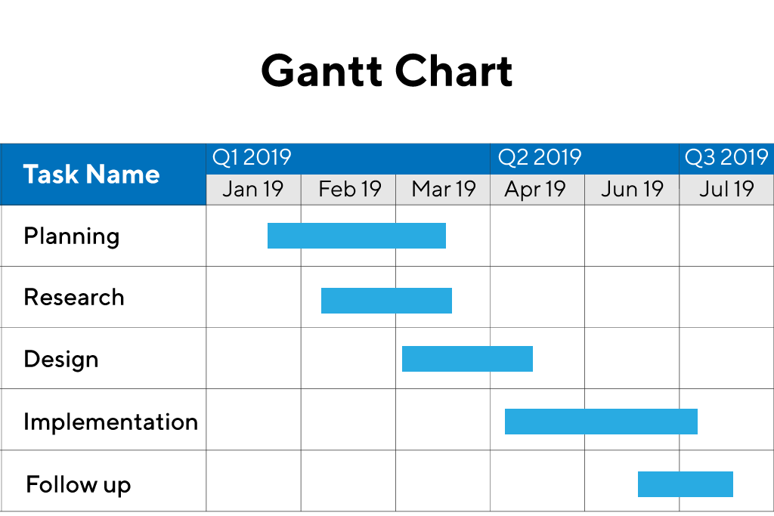

## What are its Use Cases?

Even a century after its introduction, the Gantt chart continues to be an important tool in project and program management. Described in 1999 as “one of the most widely used management tools for project scheduling and control.”

The anatomy is straightforward: Tasks to perform appear on the vertical axis, and time intervals, or activity duration, appear along the horizontal axis.

Gantt charts are commonly used by teams in construction, consulting, marketing, manufacturing, HR, software development, and event planning.

## What are the Pros and Cons?

A Gantt chart excels at illustrating a “big picture” view for projects of any size. It also enables project stakeholders to identify milestones and monitor progress by showing which tasks need to be completed by a specific date. In addition, you can easily identify any functions that fall behind schedule and take the appropriate action.

### [Download the Cross-Functional Partnerships Checklist ➜](https://go.productplan.com/cs/c/?cta_guid=9e363dbd-9d42-4550-8d7f-bc9dae05ae68&signature=AAH58kGKS2XG27xA7hE0Jap6dObtKv58KA&placement_guid=3fa6d5d9-0d4d-435e-9254-5101713ba85f&click=69eed635-ef25-44ef-9adf-e381f50827f7&hsutk=be04e3240086950e82dd056b7efcd848&canon=https%3A%2F%2Fwww.productplan.com%2Fglossary%2Fgantt-chart%2F&utm_referrer=https%3A%2F%2Fwww.google.com%2F&portal_id=3434168&redirect_url=APefjpFzXM6B1hLe37XdVcm9YsdT92nwBsUmD0Gkka6FaIsB0e4k6VdYAsBMNwajDxLparWTmuxbvB-GmUzAvh1n2bzNeF5BLjSpfzRy-xVKaoXkk8CvpaABBJ5WFcprJdZsgJDuv-LXMsnkIATiIx1QL95sPTU9gjHrQYtaBJ_bC9aZyfWYvVdjCOQpCHgVTyWl0mCrJ4gx3Vl_75O63CmHQa3GkedgaErrWDt1W4R5Ekb69TwLU6QA7utKlR1XVaNR19qP3BvkyUU2QCaW-D1_Mk_AyBm1mA&__hstc=48140984.be04e3240086950e82dd056b7efcd848.1619062424387.1619062424387.1619223410085.2&__hssc=48140984.1.1619223410085&__hsfp=2512781797" \o "Download the Cross-Functional Partnerships Checklist ➜" \t "_blank)

While a Gantt chart provides a simple visual into the progress of a project, preparing and managing one often grows increasingly complex due to the sheer number of tasks and resources required for larger projects. Other disadvantages include:

* The need for constant updating
* Bar size doesn’t indicate the amount of work
* Difficulty in seeing the entire chart on a single page

## How are Gantt Charts Useful for Product Managers?

Product managers can use Gantt charts to provide a strategic, high-level view of a project. They can use them to identify tasks and resources needed for a project, and share due dates for task completion.

### [Download the 2021 PM Report ➜](https://go.productplan.com/cs/c/?cta_guid=7c4b1f58-208f-44eb-93f7-be47c67d6c0b&signature=AAH58kFFu3qRcPzqXCxsPOTmu2RpolfA0w&placement_guid=35d36a84-b157-43a1-acb7-b972dcb1d1ad&click=d76ad413-5d88-4d9c-86ed-68b235e33571&hsutk=be04e3240086950e82dd056b7efcd848&canon=https%3A%2F%2Fwww.productplan.com%2Fglossary%2Fgantt-chart%2F&utm_referrer=https%3A%2F%2Fwww.google.com%2F&portal_id=3434168&redirect_url=APefjpHG2eEh26DPRnoTdqhnHOnMk79PMI9TyXAVVYe1TwUDa3olPndkrfx9Ino5UyYyVQgrMmXgloa9deJ-JdDZ8VJ5dZG9YqmaNqOs-tu2gEXyBpQZg0ztqY6FG0q5Hd4RxQl42K-FCo6yBYU2iv9kHMJo84QNRBHDMEjOyzdO3CIQjmmI3DAKXpRXheNKcLTlZG0oGqitBtC5q0F3vqT4kdJdeatM6WFa27XjGdLGphA8kaLXDJAih7JpqgL-jLQxQzEVXrB8&__hstc=48140984.be04e3240086950e82dd056b7efcd848.1619062424387.1619062424387.1619223410085.2&__hssc=48140984.1.1619223410085&__hsfp=2512781797" \o "Download the 2021 PM Report ➜" \t "_blank)

## Why is a Gantt Chart Not Good for a Product Roadmap?

A [product roadmap](https://www.productplan.com/books/building-product-roadmap/), which is a high-level strategic document created and maintained to communicate the strategic vision and objectives of a product, is used by managers in many, such as product, IT, and marketing. Styles include roadmap timeline, roadmap without dates, and kanban. [Read more about different roadmap styles](https://www.productplan.com/books/product-roadmap-styles/).

While a [Gantt chart provides a project overview](https://blog.easyagile.com/the-difference-between-roadmaps-and-gantt-charts-65a261ec5643) and a good deal of insight into the progress of a project, it doesn’t have the inherent flexibility of a product roadmap. Another key differentiator between the two is that a traditional Gantt chart doesn’t indicate task dependencies. If a task falls behind schedule, you can’t see how that will impact other tasks. Ultimately, what sets the two apart is that roadmaps enable [product teams to have greater control](https://www.productplan.com/roadmap-timelines/) over whether to include a roadmap timeline, how granular that timeline should be, and which audiences should be allowed to see date-related details.

Topic 10: Business Models

<https://www.investopedia.com/terms/t/timevalueofmoney.asp>

Time value of money

What Is the Time Value of Money (TVM)?

The [time value](https://www.investopedia.com/terms/t/timevalue.asp) of money (TVM) is the concept that money you have now is worth more than the identical sum in the future due to its potential [earning capacity](https://www.investopedia.com/terms/e/earning-potential.asp). This core principle of finance holds that provided money can earn interest, any amount of money is worth more the sooner it is received. TVM is also sometimes referred to as present discounted value.

## Understanding Time Value of Money (TVM)

The time value of money draws from the idea that rational investors prefer to receive money today rather than the same amount of money in the future because of money's potential to grow in value over a given period of time. For example, money deposited into a savings account earns a certain interest rate and is therefore said to be compounding in value.

### KEY TAKEAWAYS

* Time value of money is based on the idea that people would rather have money today than in the future.
* Given that money can earn compound interest, it is more valuable in the present rather than the future.
* The formula for computing time value of money considers the payment now, the future value, the interest rate, and the time frame.
* The number of compounding periods during each time frame is an important determinant in the time value of money formula as well.

Further illustrating the rational investor's preference, assume you have the option to choose between receiving $10,000 now versus $10,000 in two years. It's reasonable to assume most people would choose the first option. Despite the equal value at the time of disbursement, receiving the $10,000 today has more value and [utility](https://www.investopedia.com/terms/u/utility.asp) to the beneficiary than receiving it in the future due to the opportunity costs associated with the wait. Such opportunity costs could include the potential gain on interest were that money received today and held in a savings account for two years.

## Time Value of Money Formula

Depending on the exact situation in question, the time value of money formula may change slightly. For example, in the case of annuity or [perpetuity](https://www.investopedia.com/terms/p/perpetuity.asp) payments, the generalized formula has additional or less factors. But in general, the most fundamental TVM formula takes into account the following variables:

* FV = Future value of money
* PV = Present value of money
* i = interest rate
* n = number of compounding periods per year
* t = number of years

Based on these variables, the formula for TVM is:

**FV = PV x [ 1 + (i / n) ] (n x t)**

## Time Value of Money Examples

Assume a sum of $10,000 is invested for one year at 10% interest. The future value of that money is:

FV = $10,000 x [1 + (10% / 1)] ^ (1 x 1) = $11,000

The formula can also be rearranged to find the value of the future sum in present day dollars. For example, the value of $5,000 one year from today, compounded at 7% interest, is:

PV = $5,000 / [1 + (7% / 1)] ^ (1 x 1) = $4,673

## Effect of Compounding Periods on Future Value

The number of compounding periods can have a drastic effect on the TVM calculations. Taking the $10,000 example above, if the number of compounding periods is increased to quarterly, monthly, or daily, the ending future value calculations are:

* Quarterly Compounding: FV = $10,000 x [1 + (10% / 4)] ^ (4 x 1) = $11,038
* Monthly Compounding: FV = $10,000 x [1 + (10% / 12)] ^ (12 x 1) = $11,047
* Daily Compounding: FV = $10,000 x [1 + (10% / 365)] ^ (365 x 1) = $11,052

This shows TVM depends not only on interest rate and time horizon, but also on how many times the compounding calculations are computed each year.

## Frequently Asked Questions

### What is the Time Value of Money?

The time value of money is the idea that, all else being equal, money is more valuable when it is received closer to the present. The key to understanding the time value of money is the concept of [opportunity cost](https://www.investopedia.com/terms/o/opportunitycost.asp). To illustrate, consider the fact that, if an investor receives money today, they can invest that money and earn a positive return. If, on the other hand, they receive that money one year in the future, they effectively lose the positive return they could have otherwise earned.

### Why is the Time Value of Money important?

Time value of money is very important because it can help guide investment decisions. For instance, suppose an investor can choose between two projects: Project A and Project B. Both projects have identical descriptions except that Project A promises a $1 million cash payout in year 1, whereas Project B offers a $1 million cash payout in year 5. If the investor did not understand the time value of money, they might believe that these two projects are equally attractive. In fact, however, time of money dictates that Project A is more attractive than Project B because its $1 million payout has a higher [present value](https://www.investopedia.com/terms/p/presentvalue.asp).

### How is the Time Value of Money used in finance?

Time value of money is the central concept underlying [discounted cashflow analysis (DCF)](https://www.investopedia.com/terms/d/dcf.asp), which is one of the most popular and influential methods for valuing investment opportunities. It is also an integral part of financial planning and risk management activities, such as in the case of pension fund managers who need to ensure that their account holders will have adequate funds to finance their retirement. Simply put, it would be hard to find a single significant area of finance that is not influenced in some way by the time value of money.

Revenue generation

<https://www.cognism.com/revenue-generation>

# Revenue Generation

Revenue generation is one of the most important activities any business can engage in. It is defined as a process by which a company plans how to market and sell its products or services, in order to generate income.

It may involve some or all of the following tasks:

* Establishing the business goals for the financial year, e.g., monthly or annual revenue targets.
* Aligning the [B2B sales](https://www.cognism.com/sales-leaders?hsLang=en) and marketing strategy to match the revenue targets.
* Creating an organisational structure that ensures the revenue generation strategy can be implemented successfully.
* Reviewing all sales and marketing procedures and making sure that best practice is being applied in all areas of the business.
* Using metrics to measure the progress of revenue generation and adjusting the strategy as necessary.
* Providing training and education for staff, so that all colleagues are working to maximise revenue generation.

## Revenue generation: the importance of B2B data

For business leaders, one thing that can frustrate revenue generation is [B2B data](https://www.cognism.com/b2b-data?hsLang=en). If the data you are using for [B2B lead generation](https://www.cognism.com/b2b-lead-generation?hsLang=en), for building contact lists for sales reps or creating marketing messages is not of sufficient quality, it leads to a broken sales funnel. This makes it harder for your sales team to:

* Identify new opportunities in the market.
* Operate a sales process that turns leads into customers.
* Close deals.

This in turn can lead to a sharp drop in revenue. How best to prevent this nightmare scenario from occurring

Price structure; price elasticity

<https://outlier.ai/data-driven-daily/pricing-strategy-price-elasticity-of-demand-theory/>

# Pricing Strategy: Price Elasticity of Demand Theory

This is part 4 of a 5 part series on Pricing Strategy – Part 1.

The [price elasticity of demand](https://en.wikipedia.org/wiki/Price_elasticity_of_demand) is the way to measure the responsiveness of your customers demand for your product in reaction to a change in price. By understanding and measuring this metric, you’ll have a better idea of what to expect to happen to your revenue after making a price change.

## Definition

The own-price elasticity of demand for a product is calculated as the percent change in quantity of a product demanded in response to a percent change in that own product’s price¹.

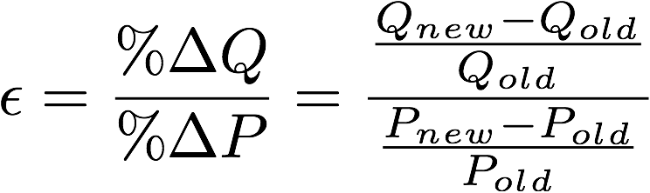

For example, if you’ve sold 100 units at $50 per unit and after changing the price to $55, you sell 95 units, then your own-price elasticity of demand is -0.5. This result is a unit-less (because it is measured in percentage changes), negative number (because changes in price move in the opposite direction as changes in quantity)² between 0 and negative infinity.

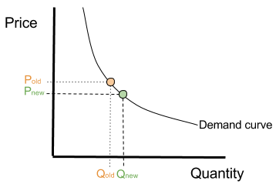

## Interpretation

The most important aspect of the price elasticity of demand is how it relates to -1. If the price elasticity of demand is between 0 and -1, then the percent change in quantity is smaller than the percent change in price. You would make more revenue by raising price since the number of lost sales is made up by the higher price for the units sold. Because of this, when price elasticity of demand is between 0 and -1, it is called inelastic, because customers are not sensitive to your changes in price.

On the other hand, if price elasticity of demand is less than -1, then the opposite is true. You would make more revenue by dropping price since the number of new sales will make up for the lower price point. In this case, the price elasticity of demand is called elastic, because customers are sensitive to changes in price.

## Measurement and use

There are a few ways to measure the price elasticity of demand using survey techniques, such as [choice-based conjoint analysis](https://en.wikipedia.org/wiki/Conjoint_analysis_(marketing)) or the [price sensitivity meter](https://en.wikipedia.org/wiki/Van_Westendorp%27s_Price_Sensitivity_Meter). However, surveys need to be taken with a grain of salt due to a number of factors, such as the incentive structure and potential biases. The most accurate view of price elasticity of demand for your product is by making price changes to see how customers respond.

It is important to keep in mind that the price elasticity of demand is not typically a constant value for all consumers, at all times. You should estimate the price elasticity of demand for each customer segment and when demand shifts due to seasonal effects, for example.

Even if you don’t conduct surveys or change prices to compute the price elasticity of demand, there are many factors that influence it that you should always have in mind. In particular, products that have many close substitutes are highly elastic because it is easy for customers to switch to a cheaper option. Also, products that are considered luxury goods are highly elastic because if the price changes significantly, the customer can move on without it. These concepts reflect what should be a driving goal for your company – to create a unique product that is deeply ingrained into a customer’s life or workflow.

Channels of distribution

<https://www.investopedia.com/terms/d/distribution-channel.asp#:~:text=A%20distribution%20channel%20represents%20a,sells%20directly%20to%20the%20consumer>.

# Distribution Channel

## What Is a Distribution Channel?

A distribution channel is a chain of businesses or intermediaries through which a good or service passes until it reaches the final buyer or the end consumer. Distribution channels can include [wholesalers](https://www.investopedia.com/terms/w/wholesaling.asp), [retailers](https://www.investopedia.com/articles/markets/122415/worlds-top-10-retailers-wmt-cost.asp), distributors, and even the Internet.

Distribution channels are part of the downstream process, answering the question "How do we get our product to the consumer?" This is in contrast to the upstream process, also known as the supply chain, which answers the question "Who are our suppliers?"

A distribution channel, also known as placement, is part of a company's marketing strategy, which also includes the product, promotion, and price.

## Understanding Distribution Channels

A distribution channel is a path by which all goods and services must travel to arrive at the intended consumer. Conversely, it also describes the pathway payments make from the end consumer to the original vendor. Distribution channels can be short or long, and depend on the number of intermediaries required to deliver a product or service.

Goods and services sometimes make their way to consumers through multiple channels—a combination of short and long. Increasing the number of ways a consumer is able to find a good can increase sales. But it can also create a complex system that sometimes makes [distribution management](https://www.investopedia.com/terms/d/distribution-management.asp) difficult. Longer distribution channels can also mean less profit each intermediary charges a manufacturer for its service.

## Direct and Indirect Channels

Channels are broken into two different forms—direct and indirect. A direct channel allows the consumer to make purchases from the manufacturer while an indirect channel allows the consumer to buy the goods from a wholesaler or retailer. Indirect channels are typical for goods that are sold in traditional brick-and-mortar stores.

Generally, if there are more intermediaries involved in the distribution channel, the price for a good may increase. Conversely, a direct or short channel may mean lower costs for consumers because they are buying directly from the manufacturer.

## Types of Distribution Channels

While a distribution channel may seem endless at times, there are three main types of channels, all of which include the combination of a producer, wholesaler, retailer, and end consumer.

The first channel is the longest because it includes all four: producer, wholesaler, retailer, and consumer. The wine and adult beverage industry is a perfect example of this long distribution channel. In this industry—thanks to laws born out of prohibition—a winery cannot sell directly to a retailer. It operates in the three-tier system, meaning the law requires the winery to first sell its product to a [wholesaler](https://www.investopedia.com/terms/w/wholesale-trade.asp) who then sells to a retailer. The retailer then sells the product to the end consumer.

The second channel cuts out the wholesaler—where the producer sells directly to a retailer who sells the product to the end consumer. This means the second channel contains only one intermediary. Dell, for example, is large enough to sell its products directly to reputable retailers such as Best Buy.

The third and final channel is a [direct-to-consumer](https://www.investopedia.com/ask/answers/052115/what-difference-between-direct-and-indirect-distribution-channel.asp) model where the producer sells its product directly to the end consumer. Amazon, which uses its own platform to sell Kindles to its customers, is an example of a direct model. This is the shortest distribution channel possible, cutting out both the wholesaler and the retailer.

### KEY TAKEAWAYS

* A distribution channel represents a chain of businesses or intermediaries through which the final buyer purchases a good or service.
* Distribution channels include wholesalers, retailers, distributors, and the Internet.
* In a direct distribution channel, the manufacturer sells directly to the consumer. Indirect channels involve multiple intermediaries before the product ends up in [the hands of the consumer](https://www.investopedia.com/terms/i/invisiblehand.asp).

## Choosing the Right Distribution Channel

Not all [distribution channels](https://www.investopedia.com/ask/answers/052115/what-difference-between-direct-and-indirect-distribution-channel.asp) work for all products, so it's important for companies to choose the right one. The channel should align with the firm's overall mission and strategic vision including its sales goals.

The method of distribution should add value to the consumer. Do consumers want to speak to a salesperson? Will they want to handle the product before they make a purchase? Or do they want to purchase it online with no hassles? Answering these questions can help companies determine which channel they choose.

Secondly, the company should consider how quickly it wants its product(s) to reach the buyer. Certain products are best served by a direct distribution channel such as meat or produce, while others may benefit from an indirect channel.

If a company chooses multiple distribution channels, such as selling products online and through a retailer, the channels should not conflict with one another. Companies should strategize so one channel doesn't overpower the other.

## Frequently Asked Questions

### What is a distribution channel?

The term “distribution channel” refers to the methods used by a company to deliver its products or services to the end consumer. It often involves a network of intermediary businesses such as manufacturers, wholesalers, and retailers. Selecting and monitoring distribution channels is a key component of [managing supply chains](https://www.investopedia.com/terms/s/scm.asp).

### What is the difference between direct and indirect distribution channels?

Direct distribution channels are those that allow the manufacturer or service provider to deal directly with its end customer. For example, a company that manufactures clothes and sells them directly to its customers using an e-commerce platform would be utilizing a direct distribution channel. By contrast, if that same company were to rely on a network of wholesalers and retailers to sell its products, then it would be using an indirect distribution channel.

### What are the three types of distribution channels?

The three types of distribution channels are wholesalers, retailers, and direct-to-consumer sales. Wholesalers are intermediary businesses that purchase bulk quantities of product from a manufacturer and then resell them to either retailers or—on some occasions—to the end consumers themselves. Retailers are generally the customers of the wholesalers and offer high-touch customer service to the end customers. Lastly, direct-to-consumer sales occur when the manufacturer sells directly to the end customer, such as when the sale is made directly through an e-commerce platform.

Strategic partners

<https://blog.benchmarkcorporate.com/what-is-a-strategic-partner#:~:text=A%20strategic%20partner%20is%20another,to%20improve%20their%20market%20position>.

## WHAT IS A STRATEGIC PARTNER?

A strategic partner is another business entity with which you form an agreement to share resources with the mission of growth and mutual success. There are different types of strategic partnerships.

* Horizontal Partnership: Businesses within the same field join alliances to improve their market position. Example: Facebook and Instagram.
* Vertical Partnership: Businesses team up with companies within the same supply chain (suppliers, distributors and retailers), often to stabilize supply chains and increase sales. Example: LiveNation and Ticketmaster.
* Equity Partnership: An investor acquires a percentage interest in a business, providing needed capital and sharing in profits and losses.
* Joint Venture: Two or more businesses form an entirely new legal entity in which the profits and risks are shared, and the original companies continue to exist on their own. Example: Microsoft and NBC’s creation of MSNBC.
* Merger: Two companies agree to go forward as a single new company and the original companies no longer exist. Example: Exxon and Mobil, now Exxon Mobil Corp.
* Acquisition: One company takes over another company and establishes itself as the new owner. Example: AOL and Time Warner, now Time Warner.

**Why Do I Need One?**

A strategic partnership can be an extremely powerful tactic that gives your business a competitive edge. According to a study by the CMO Council, 85 percent of business owners believe partnerships are essential for business success.There are several reasons why it is a commonly relied-upon growth plan.

* Expansion into new markets
* Increased brand awareness
* Product line extension
* Access to new customers
* Improved supply chain performance
* Added value for existing customers
* Acceleration of innovation
* Strengthening of weaknesses
* Sourcing of capital

[Ready to explore your exit and growth options?](https://blog.benchmarkcorporate.com/cs/c/?cta_guid=253c752c-60c7-4552-9441-56a31e0bd5cd&signature=AAH58kESQXndl8_OOeRxpZk5Dq1G82sFwg&pageId=9712959119&placement_guid=88c88bfe-b31c-4c15-a624-3a301fb553aa&click=470769e7-41d9-4e22-8216-101d5a90642f&hsutk=d88ba407af69aeb35469f63f4613f9fc&canon=https%3A%2F%2Fblog.benchmarkcorporate.com%2Fwhat-is-a-strategic-partner&utm_referrer=https%3A%2F%2Fwww.google.com%2F&portal_id=4039078&redirect_url=APefjpGqVg4854h_5pa9soVY6Gyr72-cGJ0PDAafyIhUyWUBsq0Mulmrwnn5q7YtwWSPd83w117DsA70S-5a-TyDovbQVDdGUGBNRk0BPuasus3ScjLx3ng0Dy0fZ6e8AnwO7qOO_Ie1T0WZOwpcvqCm_KVNrYC7eUIzofUauT_9RdzH4kJ6VQs&__hstc=177227834.d88ba407af69aeb35469f63f4613f9fc.1619224436065.1619224436065.1619224436065.1&__hssc=177227834.1.1619224436065&__hsfp=2512781797&contentType=blog-post)

A successful partnership must be built on a solid growth strategy and make sense from a capabilities perspective. The goals, values and culture of all partners should be aligned. You also need to have the right infrastructure in place. And the timing of the venture can be critical depending on the market. A partnership is a major endeavor and you absolutely want to get it right. Unfortunately, most organizations are not armed with the proper connections, resources and management capabilities to maximize the potential of a partnership. According to a report by the Business Performance Innovation Network (BPI):

* 43 percent of business partnerships have high failure rates.
* 45 percent are unable to maintain long-term, successful relationships.
* 42 percent of partnerships are not well leveraged.
* 67 percent of companies that agree to work together lack formal partnering strategies.

**How to Get It Right**

The smartest way to ensure that you are entering into a successful partnership is to seek the guidance of an advisor such as Benchmark International. We have the connections, experience, data-driven analytics, and knowledge to help you devise a carefully crafted growth strategy that is built on confidence and captures the most value. If you are a founder, an owner, an entrepreneur, or part of the leadership of an established company, we encourage you to reach out to us and start the conversation about how a strategic partnership can benefit your busines

Topic 11: Ethics and social responsibility

Ethics. codes of ethics; theoretical frameworks; broader ethical considerations

<https://www.betterteam.com/code-of-ethics#:~:text=250%20million%20candidates.-,A%20code%20of%20ethics%20and%20professional%20conduct%20outlines%20the%20ethical,safety%2C%20and%20conflicts%20of%20interest>.

# Code of Ethics

How to create a code of ethics with a free downloadable template.



A code of ethics and professional conduct outlines the ethical principles that govern decisions and behavior at a company or organization. They give general outlines of how employees should behave, as well as specific guidance for handling issues like harassment, safety, and conflicts of interest.

Special Offer

[Try Betterteam for FREE](https://app.betterteam.com/signup)

Send jobs to 100+ job boards with one submission

[Post Jobs for FREE](https://app.betterteam.com/signup)

* Completely free trial, no card required.
* Reach over 250 million candidates.

A code of ethics and professional conduct outlines the ethical principles that govern decisions and behavior at a company or organization. They give general outlines of how employees should behave, as well as specific guidance for handling issues like harassment, safety, and conflicts of interest.

## Code of Ethics Compared to a Code of Conduct:

A code of ethics is broad, giving employees or members a general idea of what types of behavior and decisions are acceptable and encouraged at a business or organization. A code of conduct is more focused. It defines how employees or members should act in specific situations.

## Can You Combine a Code of Conduct and Code of Ethics?

Yes, in most cases businesses will combine both of these documents into one as there is significant overlap between them. It is rare to find businesses that have two separate policies. Whilst they are technically different documents, employees will have less difficulty recalling important points around conduct and ethics if they have a single document to refer to.

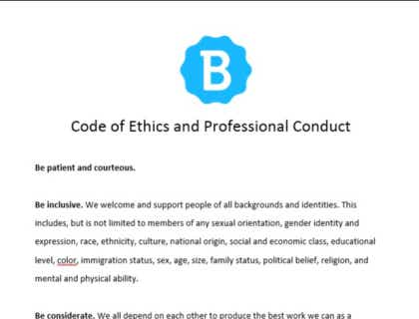

## Code of Ethics and Professional Conduct Download

Download the code of ethics and professional conduct sample above as a PDF document.

[Download Sample](https://www.betterteam.com/download/Code-of-Ethics-and-Professional-Conduct-Template-Download-20201120.docx)

## Code of Ethics and Professional Conduct Sample Template:

### 1. Be inclusive.

We welcome and support people of all backgrounds and identities. This includes, but is not limited to members of any sexual orientation, gender identity and expression, race, ethnicity, culture, national origin, social and economic class, educational level, color, immigration status, sex, age, size, family status, political belief, religion, and mental and physical ability.

### 2. Be considerate.

We all depend on each other to produce the best work we can as a company. Your decisions will affect clients and colleagues, and you should take those consequences into account when making decisions.

### 3. Be respectful.

We won't all agree all the time, but disagreement is no excuse for disrespectful behavior. We will all experience frustration from time to time, but we cannot allow that frustration become personal attacks. An environment where people feel uncomfortable or threatened is not a productive or creative one.

### 4. Choose your words carefully.

Always conduct yourself professionally. Be kind to others. Do not insult or put down others. Harassment and exclusionary behavior aren't acceptable. This includes, but is not limited to:

* Threats of violence.
* [Insubordination.](https://www.betterteam.com/insubordination)
* Discriminatory jokes and language.
* Sharing sexually explicit or violent material via electronic devices or other means.
* Personal insults, especially those using racist or sexist terms.
* Unwelcome sexual attention.
* Advocating for, or encouraging, any of the above behavior.

### 5. Don't harass.

In general, if someone asks you to stop something, then stop. When we disagree, try to understand why. Differences of opinion and disagreements are mostly unavoidable. What is important is that we resolve disagreements and differing views constructively.

### 6. Make differences into strengths.

We can find strength in diversity. Different people have different perspectives on issues, and that can be valuable for solving problems or generating new ideas. Being unable to understand why someone holds a viewpoint doesn’t mean that they’re wrong. Don’t forget that we all make mistakes, and blaming each other doesn’t get us anywhere.

Instead, focus on resolving issues and learning from mistakes.

## What to Include in Your Code of Ethics and Professional Conduct:

A code of ethics and professional conduct consists of four key sections detailed below. You can cover all of them in a short summary Code of Ethics and Professional Conduct as we have above, or expand on them in detail so employees are clear on how to handle many common situations.

### 1. The work environment.

Employees should act with integrity, comply with laws, maintain a professional work environment and comply with company policies. They should treat customers, colleagues, and partners ethically at all times.

## Work Environment Code of Conduct Topics.

* Equal opportunity.
* Discrimination and harassment.
* Violence policy.
* Safety policy.
* Substance abuse.
* Gambling policy.
* Privacy policy.
* Misconduct explanation and policy.

### 2. Conflicts of interest.

A company's reputation depends on the actions and integrity of its employees. It is essential that they avoid relationships and activities that hurt, or appears to hurt, their ability to make objective and fair decisions.

## Conflict of Interest Code of Conduct Topics.

* Corporate asset contributions.
* Running for public office.
* Insider trading and financial interests.
* Investments in companies employees do business with.
* Employee political interests.
* Significant financial interests in other companies.
* Securities transactions.
* Taking out loans.

### 3. Protecting company assets.

Employees should always act to protect company assets, including physical, intellectual, and electronic or digital properties.

## Company Assets Code of Conduct Topics.

* Preparing, maintaining, and disclosing accurate records.
* Information security.
* Protecting communication and information technology systems.
* Protecting external communications.
* Use of company property.
* Use of property owned by others.
* Facility security.
* Protecting intellectual property.

### 4. Anti-bribery and corruption.

A company's integrity is essential for maintaining trustworthiness and reputation. Employees should always do their work fairly, honestly, and legally.

## Anti-Bribery & Corruption Code of Conduct Topics.

* Doing business with governments.
* Choosing and maintaining service providers.
* Receiving gifts and entertainment.
* Loans, bribes, and kickbacks.
* Relationships with former employees.
* Obligations of departing and former employees.
* Interaction with competitors.
* Relationships with affiliates, international entities, and customers.

### 5. Attendance and punctuality.

Employees are expected to be regular and punctual in attendance. This means being in the office, ready to work, at starting time each day. Absenteeism and tardiness burden other employees and the company.

### 6. Absence without notice.

Employees who are unable to work due to illness or an accident should notify their supervisor. This allows the company to arrange for coverage of their duties and helps others continue to work in their absence. If an employee does a report for work and the company is not notified of an employee's status for 3 days, it is typically considered a [job abandonment](https://www.betterteam.com/job-abandonment).

### 7. General harassment and sexual harassment.

This company is committed to providing a work environment free of discrimination and unlawful harassment. Actions, words, jokes, or comments based on an individual’s sex, race, ethnicity, age, religion, or any other legally protected characteristic are not tolerated.

### 8. Cell phone use at work.

Personal [cell phone usage](https://www.betterteam.com/cell-phone-policy) during work hours is discouraged, except in extreme cases such as an emergency.

### 9. Dress code.

A professional appearance is important when employees work with customers or potential customers. Employees should be well-groomed and [dressed appropriately](https://www.betterteam.com/dress-code-policy) for the business and for their position.

### 10. Substance abuse.

The manufacture, distribution, possession, sale, or purchase of controlled substances of abuse on company property is prohibited. Being under the influence of illegal drugs, alcohol, or substances of abuse on company property is prohibited. Working while under the influence of prescription drugs that impair performance is prohibited.

### 11. Tobacco products.

The use of tobacco products on company property, outside of permitted areas, is specifically prohibited.

### 12. Internet use at work.

Employees may use the Internet when appropriate to access information needed to conduct a business company business. Use of the Internet must not disrupt or injure the company computer network. Use of the Internet must not interfere with an employee's productivity.

## How to Write a Code of Ethics and Code of Conduct:

### 1. Review your mission statement and core values.

The goal of a code of ethics is to help employees make decisions that are in line with what the company or organization values. This should be distilled into your mission statement and core values, so it's a good place to start.

### 2. Talk to stakeholders.

What do management, employees, and clients think are the most important values of the company to uphold? Get input from everyone involved to be sure your code reflects what the company stands for. You can have them all look at a code of conduct template to get ideas for how their own might look like.

### 3. Review past ethical issues.

Where has your company faltered with ethics in the past? Where has it shined? Call attention to problem areas and reinforce the strengths you already have.

### 4. See where other companies have faltered.

Have other companies in your industry had recent ethical failures? Avoid the same pitfalls by covering these issues in your code.

### 5. Create a draft code for input and discussion.

Give everyone a chance to help decide on the contents of the code of ethics by inviting them to discuss and give input on a draft.

### 6. Create a final draft and share it.

Once you've got a final draft approved, share it throughout the organization. Also, make sure that a copy of it is added to your [employee handbook](https://www.betterteam.com/employee-handbook).

Social businesses

<https://www.investopedia.com/terms/s/social-enterprise.asp#:~:text=A%20social%20enterprise%20or%20social,used%20to%20fund%20social%20programs>.

# Social Enterprise

## What Is a Social Enterprise?

A social enterprise or social business is defined as a business that has specific social objectives that serve its primary purpose. Social enterprises seek to maximize profits while maximizing benefits to society and the environment. Their profits are principally used to fund social programs.

## Understanding Social Enterprises

The concept of a social enterprise was developed in the UK in the late 1970s to counter the traditional commercial enterprise. Social enterprises exist at the intersection of the private and volunteer sectors. They seek to balance activities that provide financial benefits with social goals, such as providing housing to low-income families or job training.

Funding is obtained primarily by selling goods and services to consumers, although some funding is obtained through grants. Because profit-maximization is not the primary goal, a social enterprise operates differently than a standard company.

While earning profits is not the primary motivation behind a social enterprise, revenue still plays an essential role in the sustainability of the venture. [Sustainable revenue](https://www.investopedia.com/terms/s/sustainablegrowthrate.asp) differentiates a social enterprise from a traditional charity that relies on outside funding to fulfill its social mission. This goal does not mean social enterprises cannot be profitable; it's simply that their priority is to reinvest profits into their social mission, rather than fund payouts to shareholders.

The [Organization for Economic Cooperation and Development (OECD](https://www.investopedia.com/terms/o/oecd.asp)) identifies social enterprises as being highly participatory, with stakeholders actively involved and a minimum number of paid employees.

### KEY TAKEAWAYS

* A social enterprise is a business with social objectives that serve its primary purpose.
* Maximizing profits is not the primary goal of a social enterprise as is with a traditional business.
* Unlike a charity, social enterprises pursue endeavors that generate revenues, which fund their social causes.
* Regarding employment, preference is given to job-seekers from at-risk communities.

## Special Considerations

Employees of social enterprises come from many backgrounds, but priority is given to those who are from at-risk sections of the community. These include long-term unemployed workers, those who have historically worked in jobs where they were informally paid, and members of marginalized groups. The social enterprise may seek to provide a living wage, which in most cities is above the minimum wage. Sometimes, drawing employees from at-risk groups may be the stated social goal of the enterprise.

## Social Enterprise vs. Social Entrepreneurship

A social enterprise is not to be confused with [social entrepreneurship](https://www.investopedia.com/terms/s/social-entrepreneur.asp), which tends to focus on individuals who develop solutions to social and environmental problems using existing business techniques and strategies. Social entrepreneurs seek innovative ways and operate to drive change, whereas social enterprises form to fulfill a business purpose and solve societal needs through their commercial activities.

## Examples of a Social Enterprise

Many social enterprises successfully maximize improvements in social well-being. For example, Warby Parker is an American eyeglass retailer that donates a pair of glasses to someone in need for every pair sold. Tom's, a California-based retailer, similarly has pledged to donate a pair of shoes or sunglasses for every pair sold. Also, Climate Smart trains businesses and gives them software tools that let them track and cut their greenhouse gas emissions.

Topic 12: Globalization

Cultural differences in communication

<https://www.businesstopia.net/communication/cultural-barriers-communication#:~:text=Cultural%20diversity%20makes%20communication%20difficult,%2C%20ethnocentrism%2C%20manners%20and%20opinions>.

# Cultural Barriers to Communication

“Culture is the pattern of taken-for-granted assumptions about how a given collection of people should think, act, and feel as they go about their daily affairs”  
-Joynt & Warner, 1996

Culture is all socially transmitted behavior, arts, architectures, languages, signs, symbols, ideas, beliefs, norms, traditions, rituals, etc. which is learnt and shared in a particular social group of the same nationality, ethnicity, religion, etc.

Culture is handed down from one generation to another. It gives people their way of seeing the world and interpreting life. A single culture has many sub-cultures.

Cultural diversity makes communication difficult as the mindset of people of different cultures are different, the language, signs and symbols are also different.

Different cultures have different meaning of words, behaviors and gestures. Culture also gives rise to prejudices, ethnocentrism, manners and opinions. It forms the way people think and behave. When people belonging to different cultures communicate, these factors can become barriers.

The way you communicate is affected by the culture you were brought up in. The opposite is also true. Culture is, to a large extent, determined by the way we communicate.

In America, people communicate freely and that is a part of their culture. In Germany, an Indian who is used to being very indirect with his communication might find their direct way of speaking rude. Being direct is part of the German culture and it is reflected in the way they communicate. Communication shapes culture and culture shapes communication.

## Causes of Cultural Barriers

### [Language](https://www.businesstopia.net/communication/language-barriers)

There are billions of people in the world who do not understand English or cannot communicate in English properly. Not speaking properly can cause various misunderstandings and be a barrier to communication.

Different cultures have developed their own language as a part of their heritage. People are comfortable communicating in their own language whereas have to work hard to learn new languages.  
For example, separation of East and West Germany for 40 years caused the language to differ a lot. The dialect became very different as people of East Germany had an influence of Russian language whereas West Germany had influence of English. They had a barrier in communicating with each other for decades.

Even when people try to express in their own language, many misunderstandings arise. It becomes more profound in people speaking different languages.

### [Signs and Symbols (Semantics)](https://www.businesstopia.net/communication/semantic-barriers-communication)

[Non-verbal communication](https://www.businesstopia.net/communication/non-verbal-communication-different-cultures) cannot be relied upon in communication between people from different cultures as that is also different like language. Signs, symbols and gestures varies in different cultures.

For example, the sign “thumbs up” is taken as a sign of approval and wishing luck in most of the cultures but is taken as an insult in Bangladesh. Similarly, the “V” hand gesture with palm faced outside or inside means victory and peace in US, but back of hand facing someone showing the sign is taken as insulting in many cultures.

The culture sets some meanings of signs like the ones mentioned above, which might not be the same in other culture.

### Stereotypes and Prejudices

Stereotyping is the process of creating a picture of a whole culture, overgeneralizing all people belonging to the same culture as having similar characteristics and categorizing people accordingly. It is a belief about a certain group and is mostly negative.

Stereotyping can be done on the basis of many things like nationality, gender, race, religion, ethnicity, age, etc.  
For example, Asian students are stereotyped to be good at Math which is a positive stereotype. But, there is also cultural stereotype of all people following a particular religion as being violent like Islam and is negative stereotyping.

Negative stereotyping creates prejudices as it provokes judgmental attitudes. People look at those cultures as evil and treat the people following the religion wickedly. Media is a tool of mass communication which promotes stereotypes and prejudices and creates more communication barriers.

### Behavior and Beliefs

Cultural differences causes behavior and personality differences like body language, thinking, communication, manners, norms, etc. which leads to miscommunication.  
For example, in some cultures eye contact is important whereas in some it is rude and disrespectful.  
Culture also sets a specific norms which dictates behavior as they have guidelines for accepted behavior. It explains what is right and wrong. Every action is influenced by culture like ambitions, careers, interests, values, etc. Beliefs are also another cause for cultural barrier.

For instance, mostly, people who believe in god can cope with their lows of life easily than atheists but atheists are more hardworking at all times which relates to their behavior and communication.

Cite this article as: businesstopia, "Cultural Barriers to Communication," in Businesstopia, January 6, 2018, <https://www.businesstopia.net/communication/cultural-barriers-communication>.

Appropriate amount of emotion that must be displayed is also different in different cultures. Roles are defined by culture. Good communication only occurs between people with different cultures if both accept their differences with open mind.

### Ethnocentrism



Ethnocentrism is the process of dividing cultures as “us” and “them”.

The people of someone’s own culture are categorized as in-group and the other culture is out-group. There is always greater preference to in-group. There is an illusion of out-group as evil and inferior. This evaluation is mostly negative.

If the culture is similar to us, then it is good and if is dissimilar, it is bad. Other’s culture is evaluated and assessed with the standard being their own culture. Ethnocentrism affects the understanding of message, and encourages hostility.  
For example, the books in schools use reference of their own culture to describe other cultures by either showing common things or differences.

### Religion

Similar to ethnocentrism and stereotyping, religion also disrupts communication as it creates a specific image of people who follow other religions. People find it difficult to talk to people who follow different religions. Religious views influence how people think about others. It creates differences in opinions.

For example, in Pakistan, the Christians have to speak up for their rights as the majority is of Islam and the Christians are discriminated. There is also a lack of communication between these religious groups.

## Overcoming cultural barriers

There are other cultural barriers like frames of reference, political opinions, priorities of life, age, etc. Cross cultural communication is not only a barrier but also an opportunity for creativity, new perspectives, and openness to new ideas and unity in the world.

To make [communication effective](https://www.businesstopia.net/blog/effective-communication-skills), the causes of cultural communication barriers must be eliminated as much as possible. Cross cultural understanding must be increased as it decreases communication barrier caused by culture difference.

Ethical issues

<https://sprigghr.com/blog/hr-professionals/6-ethical-issues-in-business-and-what-to-do-about-them/>

# 6 Ethical Issues in Business and What to Do About Them

Ethical issues in business can be a difficult challenge to navigate for any business owner. Though there are laws and statutes that exist to hold workers and employers accountable, these alone do not entirely deter employees from behaving unethically.

### What Are Ethical Issues in Business?

Ethical issues in business encompass a wide array of areas within an organization’s ethical standards. Fundamental ethical issues in business include promoting conduct based on integrity and trust, but more complex issues include accommodating diversity, empathetic decision-making, and compliance and governance that is consistent with the organization’s core values. According to the [Global Business Ethics Survey](https://43wli92bfqd835mbif2ms9qz-wpengine.netdna-ssl.com/wp-content/uploads/2019-Global-Business-Ethics-Survey-Report.pdf) of 2019, 25% of employees still feel that their senior managers do not have a good understanding of key ethical and compliance business risks across the organization.

In order to manage the ethical issues in business that arise in your organization, you first need to develop a thorough understanding of what those issues can look like. Understanding how to detect and, most importantly, deter these issues before they become a problem can ensure your focus stays on business growth and success instead of remediation.

### 6 Ethical Issues in Business and How to Address Them

#### Download our infographic to use as a quick reference and reminder of common ethical issues to avoid!

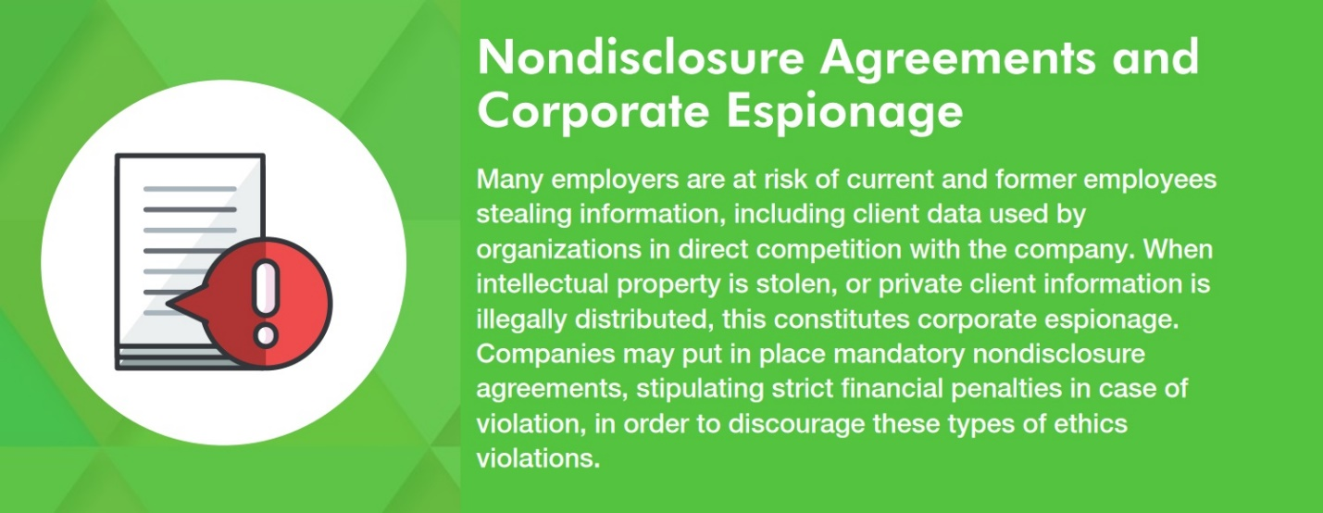

## Ethical Issues in Business

 Download Infographic

#### 1. Harassment and Discrimination in the Workplace

Harassment and discrimination are arguably the largest ethical issues that impact business owners today. Should harassment or discrimination take place in the workplace, the result could be catastrophic for your organization both financially and reputationally.

Every business needs to be aware of the anti-discrimination laws and regulations that exist to protect employees from unjust treatment. The U.S. Equal Employment Opportunity Commission (EEOC) defines many [different types of discrimination and harassment statutes](https://www.eeoc.gov/laws/types/) that can have an effect on your organization, including but not limited to:

* Age: applies to those 40 and older, and to any ageist policies or treatment that takes place.
* Disability: accommodations and equal treatment provided within reason for employees with physical or mental disabilities.
* Equal Pay: compensation for equal work regardless of sex, race, religion, etc.
* Pregnancy: accommodations and equal treatment provided within reason for pregnant employees.
* Race: employee treatment consistent regardless of race or ethnicity.
* Religion: accommodations and equal treatment provided within reason regardless of employee religion.
* Sex and Gender: employee treatment consistent regardless of sex or gender identity.

#### 2. Health and Safety in the Workplace

As outlined in the regulations stipulated by the Occupational Safety and Health Administration (OSHA), employees have a right to safe working conditions. According to their [2018 study](https://www.bls.gov/news.release/pdf/cfoi.pdf), 5,250 workers in the United States died from occupational accidents or work-related diseases. On average, that is more than 100 a week, or more than 14 deaths every day. The top [10 most frequently cited violations of 2018](https://www.osha.gov/top10citedstandards) were:

1. Fall Protection, e.g. unprotected sides and edges and leading edges
2. Hazard Communication, e.g. classifying harmful chemicals
3. Scaffolding, e.g. required resistance and maximum weight numbers
4. Respiratory Protection, e.g. emergency procedures and respiratory/filter equipment standards
5. Lockout/Tagout, e.g. controlling hazardous energy such as oil and gas
6. Powered Industrial Trucks, e.g. safety requirements for fire trucks
7. Ladders, e.g. standards for how much weight a ladder can sustain
8. Electrical, Wiring Methods, e.g. procedures for how to circuit to reduce electromagnetic interference
9. Machine Guarding, e.g. clarifying that guillotine cutters, shears, power presses, and other machines require point of operation guarding
10. Electrical, General Requirements, e.g. not placing conductors or equipment in damp or wet locations

However, health and safety concerns should not be limited to physical harm. In a [2019 report](https://www.ilo.org/safework/events/safeday/WCMS_686645/lang--en/index.htm) conducted by the International Labour Organization (ILO), an emphasis was placed on the rise of “psychosocial risks” and work-related stress and mental health concerns. Factors such as job insecurity, high demands, effort-reward imbalance, and low autonomy, were all found to contribute to health-related behavioural risks, including sedentary lifestyles, heavy alcohol consumption, increased cigarette smoking, and eating disorders.

#### 3. Whistleblowing or Social Media Rants

The widespread nature of social media has made employees conduct online a factor in their employment status. The question of the ethics of firing or punishing employees for their online posts is complicated. However, the line is usually drawn when an employee’s online behavior is considered to be disloyal to their employer. This means that a Facebook post complaining about work is not punishable on its own but can be punishable if it does something to reduce business.

In the same vein, business owners must be able to respect and not penalize employees who are deemed whistleblowers to either regulatory authorities or on social media. This means that employees should be encouraged, and cannot be penalized, for raising awareness of workplace violations online. For example, a [Yelp employee published an article](https://medium.com/@taliajane/an-open-letter-to-my-ceo-fb73df021e7a#.f1nm1qoff) on the blogging website Medium, outlining what she claimed as the awful working conditions she was experiencing at the online review company. She was then fired for violating Yelp’s terms of conduct. The ambiguity of her case, and whether her post was justifiable, or malicious and disloyal conduct, shows the importance of implementing clear social media policies within an organization. In order to avoid this risk of ambiguity, a company should stipulate which online behaviors constitute an infringement.

[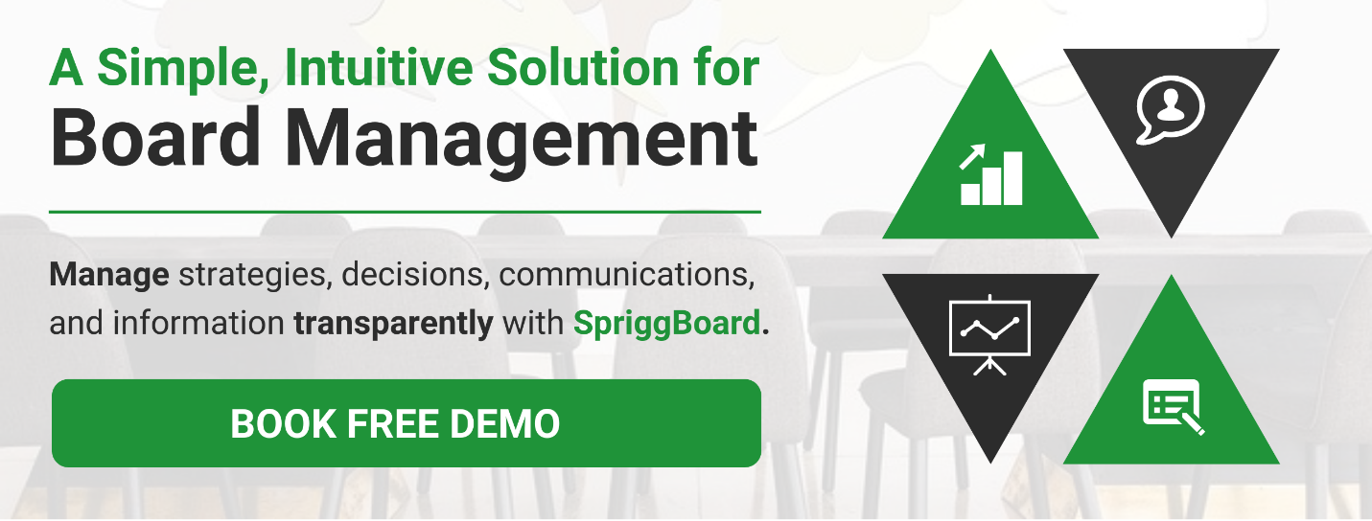](https://sprigghr.com/spriggboard/#demo-form)

#### 4. Ethics in Accounting Practices

Any organization must maintain accurate bookkeeping practices. “Cooking the books”, and otherwise conducting unethical accounting practices, is a serious concern for organizations, especially in publicly traded companies.

An infamous example of this was the 2001 scandal with American oil giant Enron, which was exposed for inaccurately reporting its financial statements for years, with its accounting firm Arthur Andersen signing off on statements despite them being incorrect. The deception affected stockholder prices, and public shareholders lost over $25 billion because of this ethics violation. Both companies eventually went out of business, and although the accounting firm only had a small portion of its employees working with Enron, the firm’s closure resulted in 85,000 jobs lost.

In response to this case, as well as other major corporate scandals, the U.S. Federal Government established the Sarbanes-Oxley Act in 2002, which mandates new financial reporting requirements meant to protect consumers and shareholders. Even small privately held companies must keep accurate financial records to pay appropriate taxes and employee profit-sharing, or to attract business partners and investments.

#### 5. Nondisclosure and Corporate Espionage

Many employers are at risk of current and former employees stealing information, including client data used by organizations in direct competition with the company. When intellectual property is stolen, or private client information is illegally distributed, this constitutes corporate espionage. Companies may put in place mandatory nondisclosure agreements, stipulating strict financial penalties in case of violation, in order to discourage these types of ethics violations.

#### 6. Technology and Privacy Practices

Under the same umbrella as nondisclosure agreements, the developments in technological security capability pose privacy concerns for clients and employees alike. Employers now have the ability to monitor employee activity on their computers and other company-provided devices, and while electronic surveillance is meant to ensure efficiency and productivity, it often comes dangerously close to privacy violation.

According to a [2019 survey](https://www.amanet.org/articles/the-latest-on-workplace-monitoring-and-surveillance/) conducted by the American Management Association, 66% of organizations were found to monitor internet connections, with 45% tracking content, keystrokes, and time spent on the keyboard, and 43% storing and reviewing computer files as well as monitoring employee emails. The key to using technological surveillance in an ethical manner is transparency. According to the same survey, 84% of those companies tell their employees that they are reviewing computer activity. In order to ensure employee surveillance does not turn into an ethical issue for your business, both employees and employers should remain conscious of the actual benefits of being monitored, and whether it is a useful way of developing a record of their job performance.

#### Take our Ethical Issues in Business Infographic to go!

## Ethical Issues in Business

 Download Infographic

### Final Thoughts on Addressing Ethical Issues in Business

Avoiding ethical issues in business always starts with top management. Providing clearly written policies and processes that ensure those policies are both acknowledged and adhered to, can ensure transparency and ethical business practices are applied.

In order to effectively detect and, most importantly, deter ethical issues in business from surfacing in your organization, there are several everyday efforts you can take. Be sure to communicate and enforce a robust code of ethics when making decisions and ask the same of your employees. Remain aware of the discrimination laws that exist in your region. Stay informed on the rules that impact your industry, and ensure your organization is acting in compliance with those regulations. Collaborate with accountants, maintaining transparency and honesty in your financial reports. Be present in your company, making sure your organization and employees alike are always doing the right and ethical thing

**Topic 11: Ethics and social responsibilities**

## Defining social responsibilities and ethics

Business ethics are the act of determining and making the right choices. Companies develop a set of rules and principles that guide their decisions and actions, creating positive influences on employees and consumers. Though every business forms a unique set of principles, they usually follow the same ethical standards.

Social responsibility is a business's duty to make ethical decisions that positively impact society. Organizations need to consider how their actions affect communities to create long-lasting trusting relationships. In order to be socially responsible, companies must strictly follow their codes of ethics.

Being socially responsible and following basic business ethics have the following benefits:

* **Gaining more customers:** Consumers are more likely to continually support businesses that care about the impact they make. Being positives influences on communities and maintaining ethical standards allows businesses to gain new customers and maintain existing ones. Existing customers are also more likely to promote the company by word of mouth.
* **Recruiting from a wider candidate group:** Professionals are increasingly searching for careers with companies that are ethically and socially responsible. Promoting a strong code of ethics that includes social responsibility can help companies attract and retain more candidates.
* **Getting an advantage over similar businesses:** Companies that promote social responsibility often acquire more customers than businesses in the same industry. Organizations can see advantages over their competition by considering their impact on the community.
* **Creating a positive work culture:** When employees agree with a company's code of ethics and social responsibility, they are more likely to feel motivated and support the organization. Employers who encourage employees to take action in their community also gain more approval and commitment.

## How businesses incorporate social responsibilities and ethics

Organizations have countless options to implement strong business ethics and exemplify social responsibilities. Below are some of the ways businesses can incorporate these important elements:

### Develop a mission and objective

One of the first steps that businesses should complete is to craft a mission and objective that support ethics and social responsibility. A mission and objective serve as the foundation for all goals and actions that a business takes, so it's key to carefully consider these ideas. When writing the mission and objective, companies need to think about how they can support their communities, promote a positive business culture and better society as a whole.

### Create and maintain core values

Core values reinforce the company mission and show how the company intends to uphold its social standards. Both the business and employee need to follow these core values, so it's important to define a clear set that lasts long term. Core values that support social responsibility and ethics include:

* Integrity
* Kindness
* Openness
* Humility
* Community
* Knowledge
* Growth
* Transparency

Employers can select four or five core values to focus on and grow their business around.

**Read more:** [**36 Core Values That Are Essential To the Workplace**](https://www.indeed.com/career-advice/career-development/core-values)

### Focus on impact in the local community

Society starts with the local community. Businesses that focus on the area they operate in can make a large impact on their residents. By promoting social awareness on a small scale, a company can spread its positive influence on a local group. This group is then inspired to advance that positive influence by helping others, which can increase awareness of the company's brand. Companies that operate in multiple locations should strive to make positive changes in each community.

**Related:** [**Social Responsibility: Definition and Examples**](https://www.indeed.com/career-advice/career-development/social-responsibility)

### Support environmentally and socially conscious initiatives

One of the main aspects of being socially responsible is supporting progressive societal efforts. Doing so shows that organizations are actively taking part in making their communities and society better places. Taking part in these efforts can also attract more customers and loyal employees.

Companies should select initiatives that align with their core values and missions, which can help build their brand and culture. For example, a grocery store could support a nonprofit that provides food to underprivileged families. Making green efforts, such as implementing recycling programs and installing low-energy lights and appliances, are common initiatives that businesses can take.

**Related:** [**What Is Corporate Social Responsibility?**](https://www.indeed.com/career-advice/career-development/corporate-social-responsibility)

### Encourage communication

Employees should feel comfortable expressing their ideas and opinions in order to foster strong business ethics. Managers should have open-door policies in which employees can approach them with feedback about the culture. Encouraging feedback helps employees feel comfortable being open, which improves morale and supports both employee and organizational growth. Employees who feel heard and respected are also more likely to stay loyal to the organization.

### Consider ethics during the hiring process

Ethical companies need to hire ethical employees to build a positive culture. Employees also represent the companies they work for, so it's important to hire professionals who can positively influence society on their companies' behalf. During the hiring process, employers should seek employees who have similar core values and believe in the business's mission. Asking questions directly related to values and ideologies allows employers to find like-minded candidates.

### Lead by example

Employers should lead by example, abiding by the code of ethics they implement. When employees see leaders following their own business ethics, they are more likely to follow them, too. It also encourages accountability for both the employees and the company leaders. For example, if one of the employer's core values is open communication, they should regularly update employees on company events and changes.

### Express compassion

Companies that support best business ethics should be generous and kind to consumers and employees. They should genuinely care about the livelihood of those who support them to develop trusting relationships. One way a company can demonstrate compassion is by making socially conscious decisions that positively affect the community or employees regardless of cost. Making compassionate decisions helps ethical companies gain the trust and support of team members and consumers.

## What is business ethics?

The term business ethics refers to the set of moral principles that guides a company's conduct. These principles govern every aspect of the company's operations, including its interaction with the government and other businesses, its treatment of its employees and its relationship with its customers. Whenever any ethical dilemmas or controversies arise, a business references these foundational principles to help resolve those situations.

**Related:** [**Business Ethics: Definition and 11 Workplace Examples**](https://www.indeed.com/career-advice/career-development/what-are-business-ethics)

## Why is business ethics important?

Business ethics ensure that companies operate according to all applicable laws. This maintains the company's respect among its peers and customers and protects it from legal liability. A company's ethics also help it attract quality team members. Businesses that care for their teams according to the highest ethical standards are often attractive to job seekers. Ethical treatment can also increase employee retention and reduce hiring and training costs.

A business that treats its customers or clients ethically can build trust and create longstanding relationships. These customers are likely to return and may recommend the business to people within their sphere of influence. Also, a business known for its effective ethical principles can gain respect and elevate the quality of its brand.

**Related:** [**Business Ethics: Definition, Types and Why Ethics Matter**](https://www.indeed.com/career-advice/career-development/example-of-ethics)

## 7 types of business ethics

There are various types of business ethics. Both the nature of the company's business and its location can affect its code of ethics. The following are some common business ethics:

### 1. Personal responsibility

Personal responsibility is a vital attribute for employees in both entry-level and senior positions. This could entail completing tasks your manager has assigned or simply fulfilling the duties of your job description. If you make a mistake, you acknowledge your fault and do whatever you need to do to fix it.

**Related:** [**Responsibility vs. Accountability: What's the Difference?**](https://www.indeed.com/career-advice/career-development/difference-accountability-responsibility)

### 2. Corporate responsibility

Businesses have responsibilities to their employees, their clients or customers and their board of directors. Some of these may be contractual or legal obligations, others may be promises. For example, a commitment to conduct business fairly and to treat people with dignity and respect. Whatever those obligations are, the business has a responsibility to keep them.

**Related:** [**What Are Key Responsibility Areas and Why Are They Important?**](https://www.indeed.com/career-advice/career-development/key-responsibility)

### 3. Loyalty

Loyalty is a valuable quality for both corporate leaders and team members. It's important for team members to be loyal to their coworkers, managers and the company. This might involve speaking positively about the business in public and only addressing personnel or corporate issues in private. Customer or client loyalty is important to a company not only to maintain good business relations but also to attract business by cultivating a positive reputation.

**Related:** [**Personal Ethics and Business Ethics Compared**](https://www.indeed.com/career-advice/career-development/personal-ethics-vs-business-ethics)

### 4. Respect

Respect is an important business ethic, both in the way the business treats its clients, customers and employees and in the way its team members treat one another. When you show respect to someone, that person feels like a valued member of the team or an important customer. It indicates that you care about their opinions, you keep your promises to them and you work quickly to resolve any issues they may have.

**Related:** [**Respect in the Workplace: How To Show Respect and Promote It**](https://www.indeed.com/career-advice/career-development/workplace-respect)

### 5. Trustworthiness

A business cultivates trustworthiness with its clients, customers and employees through honesty, transparency and reliability. Team members should feel they can trust their companies to keep to the terms of their employment. Clients and customers should be able to trust the business with their money, data, contractual obligations and confidential information. Being trustworthy encourages people to conduct business with you and helps you maintain a positive reputation.

### 6. Fairness

When a business exercises fairness, it applies the same standards for all team members, regardless of rank. The same expectations of honesty, integrity and responsibility placed upon the entry-level employee also apply to the chief executive officer (CEO). Fairness means that a business strives to treat its customers with equal respect, offering the same goods and services to all based on the same terms.

### 7. Social and environmental responsibility

Corporate social and environmental responsibility means that a company recognizes its impact outside of the marketplace. Many companies look for ways to help their communities through volunteer work or financial investments. They may also adopt measures to reduce waste and promote a safe and healthy environment.

**Related:** [**How To Improve Ethical Leadership Skills (With Examples)**](https://www.indeed.com/career-advice/career-development/ethical-leadership)

**Topic 12: Globalization**

## An overview of cultural differences in communication

Your culture affects the way you communicate with others, as it includes beliefs and behavioral norms that influence how you think and what you do while communicating. Knowing about the culture-based features that impact communication is essential, for cultures differ and exchanging data is essential for your career development. To learn more about cultural differences in communication, check out this article.

## What are cultural differences in communication?

Cultural differences in communication relate to the dissimilarities between communicators exchanging information with each other that are caused by differences in their respective cultures. These contrasts manifest in the way in which each communicator thinks and behaves, so they change the communication and its outcomes. Cultural differences have a major impact on communication due to several reasons, such as:

* **Culture drives the way you behave.**Each social group in the world has developed unique beliefs, habits, and norms of behavior over a long period of time. This collection of societal characteristics is called a culture. Culture directs how people think, so it directs their behavior.
* **Communication is an important form of behavior.**Your communication relates to what you do while exchanging information with others, so it’s one of your behaviors.
* **Culture informs your communication.** Your communication is informed by the beliefs, habits, and behavioral norms with which you identify. In other words, it’s informed by your culture. Essentially, your culture informs the decisions you make when communicating with others, your actions in the communication process, and your reactions to the communication of others.
* **Each culture is different.** Each homogenous social group with shared beliefs, habits, and behavioral norms has a unique culture. This culture differs from another that does not match its characteristics. Consequently, culture varies across societies based on its characteristics.
* **Culture’s influence on communication is not always obvious.** While some cultural differences that impact communication are obvious, others are difficult to identify. For example, two people can be dressed in similar suits and have totally different cultures that drive the way they perceive each other, react to what is being said, and understand each other. Consequently, it can be difficult to resolve cultural differences in communication.
* **Culture influences beliefs and values.** Culture has an unseen influence on people because it impacts their beliefs and values, which cannot be seen by others, to inform their behavior, which can be seen by their coworkers and employers.
* **Culture is a part of the personality.** As culture affects a person’s beliefs, values, and behaviors, it’s a part of their personality. This makes it difficult to modify your cultural differences or those of others that impact communication.
* **It’s difficult to change a culture.** It’s hard to change the culture of a social group because it has a hereditary component. In other words, culture, including the cultural differences that impact communication, is inherited. This is why cultural characteristics are shared by the individuals of a society at a point in time even without anyone making an effort to preserve them.
* **Your culture impacts your soft skills.** Culture is a part of a professional’s unique personality. One’s personality generates their natural abilities or soft skills. Consequently, culture influences the soft skill set of all workers, which includes communication skills.
* **A strong culture can make you a competent communicator.** Communication skills involve capabilities in active listening, empathy, discipline, collaboration, teamwork, verbal communication, nonverbal communication, and written communication. These proficiencies enable you to tailor your communication to suit different audiences, solve issues, and achieve shared targets.
* **Cultural differences can be difficult to bridge.**It’s easier to ignore the existence of cultural differences when communicating to achieve corporate goals. However, they can be difficult to overcome because each culture-based dissimilarity is a part of a communicator’s personality.

**Learn more:**[**New Year’s Resolution: Ways To Communicate Successfully in 2021**](https://www.glassdoor.com/blog/new-years-resolution-5-ways-to-communicate-successfully-in-2021/)

## Examples of cultural differences in communication

The various ways in which cultural differences in communication manifest in the workplace can be assessed using a variety of techniques. The method developed by Geert Hofstede, a Dutch psychologist, identifies cultural characteristics which generate these differences. Based on Hofstede’s extended framework, examples of culture-based dissimilarities in communication include:

### Power distance

This refers to how people with relatively less power in a social group accept the unequal distribution of power. For example, a person who believes in more power distance accepts an unequal power structure in the communication process. In contrast, one who values less power distance does not do so. The latter individual is likely to challenge authoritarian communicators and prefer being an equal contributor when exchanging information.

### Individual-focused vs. group-focused

**Masculinity versus femininity:** According to Hofstede, cultures that prefer assertiveness, heroism, material reward, and achievement are more masculine, while those that prefer modesty, cooperation, quality of life, and caring for the weak are more feminine. However, while the cultural differences can be used to differentiate communicators effectively, assigning them to fit inaccurate gender stereotypes is unnecessary. These differences include the following:

* Assertiveness versus modesty
* Heroism versus cooperation
* Material reward versus quality of life
* Achievement versus caring for the weak

**Individualism versus collectivism:** This differentiates cultures based on whether people prefer to work for themselves or work with others. Therefore, it closely resembles the differences articulated in the masculinity versus femininity dimension. Subsequently, it makes sense to treat Hofstede’s masculinity versus femininity and individualism versus collectivism ideas in an individual-focused versus group-focused dimension.

In the context of communication, a person from a more individual-focused culture would prefer using their communication skills to gain short-term, personal rewards while someone from a more group-focused culture would opt for utilizing their power of communication to gain long-term benefits for their team. Additionally, the latter individual would be an effective team player while the former would lack teamwork skills.

[Discover companies hiring by location, job title, and industry](https://www.glassdoor.com/Reviews/index.htm)

### Uncertainty avoidance

This refers to the ability of societies to comfortably navigate uncertainty. As the communication process is fraught with ambiguity in the initial stage when everything is usually unresolved, a communicator with more uncertainty avoidance would be less effective in navigating concerns and sharing information than one with less uncertainty avoidance.

### Long-term orientation versus short-term orientation

This dimension refers to whether people value short-term or long-term goals and achievements. For example, a communicator with a long-term orientation would prefer gaining value with their communication in the future. In contrast, someone who is orientated to the short-term would opt for achieving immediate gains through their communication.

### Indulgence versus self-restraint

A culture’s capabilities in relation to controlling desires or indulging them are explored through this dimension. For example, an individual from a culture that prefers indulgence, which relates to a social group in which the majority of individuals prefer indulgence over self-restraint, is likely to be an ineffective communicator. This is because an effective communicator can listen to others, empathize with them, and act with discipline. In contrast, someone who has inherited a cultural belief in behaving with self-restraint and the ability to do so is more likely to become a successful communicator.

**Learn more:**[**How to Negotiate Your Salary**](https://www.glassdoor.com/blog/guide/how-to-negotiate-your-salary/)

## Tips for intercultural communication

Use these tips to improve intercultural communication:

### Communicate more with people from similar cultures

While many societies that are linked with each other geographically or historically have similar cultures, there are others in distant, socially disconnected locations that have dramatically different cultural features. For example, some social groups have learned a language, which involves capabilities for verbal and written communication, recently while others have developed their language naturally for thousands of years. Consequently, cultural features that impact communication are not comparable between all cultures.

In a professional setting, you’re more likely to invest in your communication and get fewer returns when you’re engaging with people from significantly dissimilar cultures. For the best communication outcomes, engage with people whose cultures resemble yours or limit critically important communications to culturally similar communicators.

### Identify behaviors that reflect cultural differences

While culture’s impact on behaviors can be difficult to identify accurately, you can spot behaviors that are significantly different from those that your culture generates. When engaged in the communication process, use your active listening and empathy skills to identify behaviors among other communicators that differ from the behavioral norms with which you identify. Then, develop methods for addressing these differences.

### Inform people about the communication targets

Use your communication skills to keep your coworkers, superiors, clients, or investors informed of what you’re trying to achieve with your communication at every stage of the communication process. Use your active listening and empathy skills to evaluate whether your audience understands these targets. Make any necessary adjustments to your communication strategy to ensure that everyone is on the same page.

### Engage people with your communication

Try to engage the people you converse with by appealing to their reason, by sharing facts that support your talking points, and their emotions, by maintaining positivity and energy in your communications. This is likely to transcend differences in cultures that are similar to yours.

As discussed, culture-based dissimilarities between communicators can exponentially impact their communication. Use what you have learned about cultural differences in communication to improve your effectiveness in your current job or enhance your prospects when searching for a [new employment opportunity](https://www.glassdoor.com/Job/index.htm).

## Ethical Issues in Business: The Definition

Before going any further, it’s important to understand what we mean by ethical issues in business today.

Ethics is a broad term. At its core, acting ethically in business means building a company around integrity and trust as well as complying with regulations. However, there are many other issues that fall under the ethical issues in business definition, including empathy, diversity and acceptance, and carrying out business in accordance to the company’s values.

## Types of Ethical Issues in Business

If you are to run an ethical business, you first need to know what types of issues you can expect to face and may need to overcome.

### 1. Discrimination

One of the biggest ethical issues affecting the business world in 2020 is discrimination. In the last few months, many corporations have come under fire for lacking a diverse workforce, which is often down to discrimination. However, discrimination can occur at businesses of all sizes. It applies to any action that causes an employee to receive unequal treatment.

Discrimination is not just unethical; in many cases, it is also illegal. There are statutes to protect employees from discrimination based on age, gender, race, religion, disability, and more. Nonetheless, the gender and race pay gaps show that discrimination is still rampant. Other common instances of discrimination include firing employees when they reach a certain age or giving fewer promotions to people of ethnic minorities.

### 2. Harassment

The second major ethical issue businesses face is harassment, which is often related to racism or sexism. This can come in the form of verbal abuse, sexual abuse, teasing, racial slurs, or bullying. Harassment can come from anyone in the company, as well as from customers. In particular, it is an ethical issue for the business if a supervisor is aware of harassment from a client and takes no action to prevent it.

In addition to causing a toxic workplace, harassment can cause employees to leave the company prematurely — a second reason why some businesses lack diversity. Harassment can have a long-term impact on employees: psychologically, in terms of earnings, and even impacting a person’s entire career path.

### 3. Unethical Accounting

Publicly-traded companies may engage in unethical accounting to appear more profitable than they actually are. In other cases, an accountant or bookkeeper may change records to skim off the top.

### 4. Health and Safety

Another type of ethical issue that is often protected by law is health and safety. Companies may decide to cut corners to reduce costs or perform tasks faster. As well as injuries, failing to take workers’ safety into account can lead to psychosocial risks (like job insecurity or lack of autonomy), which can cause work-related stress.

### 5. Abuse of Leadership Authority

Abuse of power often manifests as harassment or discrimination. However, those in a leadership role can also use their authority to pressure employees to skip over some aspects of proper procedure to save time (potentially putting the employee at risk), punish workers who are unable to meet unreasonable goals, or ask for inappropriate favors.

In addition, abuse of authority can extend beyond the workforce. Managers can use their position to change reports, give themselves credit for the work of a subordinate, misuse expenses, and accept gifts from suppliers or clients.

### 6. Nepotism and Favoritism

Nepotism is when a company hires someone for being a family member. Favoritism occurs when a manager treats an employee better than other workers for personal reasons.

Not only are nepotism and favoritism unfair, they are also disheartening to employees. Workers often find they have to work much harder to receive a promotion or other rewards.

### 7. Privacy

Employees have recently found that the distinction between work life and personal life has become less clear. This is mainly due to the advances in technology.

For one thing, employers may punish for posts on social media, particularly if they complain about work conditions or the company as a whole. Employers may even fire workers who post controversial statements that go against company values.

Another ethical issue surrounds the use of devices belonging to the company. Employers can now monitor all worker activity on laptops and cellphones. Whereas this is supposed to check that employees are sticking to work-related activities during the business day, some employers take it further, tracking keystrokes and reading emails. The question is where to draw the line between monitoring and spying.

### 8. Corporate Espionage

The opposite to the above can also happen: workers can misuse company data. An employee may steal intellectual property or provide a competitor with information about a client. Usually, this is for monetary purposes, but it can also help an employee secure a position at another firm.



## How to Avoid Ethical Issues in Business

A common method businesses use to manage ethical issues is to simply deny the problem exists. Companies often combine this with a gag order to stop employees talking. If you want to maintain a good reputation, this is the worst thing you can do. After all, sooner or later, the [unethical behavior](https://myva360.com/blog/the-ugly-truth-about-unethical-business-practices-2020/) will come to light.

A better strategy is to take an active role, seeking out and correcting unethical behaviors as early as possible. There are a few key tactics that every business owner needs to implement.

### Create Company Policies

Make sure employees read company policies when they start working at your business. Include both a privacy policy and a social media policy. The first should tell workers what computer activity and other information you will be able to access; the second should lay out how you expect employees to behave publicly on social media.

### Monitor Only Pertinent Information on Laptops and Other Devices

It may be necessary to track employee activity to some extent (particularly if you are concerned that workers are spending too much work time on personal activities — which, in itself, can be an unethical behavior). However, you don’t want to go overboard and create a culture of distrust.

### Provide Ongoing Training

This should cover aspects like harassment prevention. It’s worthwhile seeking outside support for this from a reputable agency or professional, as low-quality training can even [make the problem worse](https://www.ottolearn.com/post/104-most-harassment-prevention-training-doesnt-work).

### Require Employees to Sign a Nondisclosure Agreement

Employees should sign a nondisclosure agreement before they start working with any sensitive information. To create an effective deterrent, specify that violating agreements will result in severe penalties.

### Create a Meritocracy

Strive to create a meritocracy where you reward employees [according to performance](https://myva360.com/blog/how-to-do-a-remote-employee-assessment/).

### Take an Active Role in Daily Activities

Become as involved as you are able in the day-to-day activities at your company. This could help you detect harassment in its early stages and prevent theft, whether monetary or of company materials.

### Double Check Your Books on a Regular Basis

By checking your books regularly, you’ll notice if anyone is stealing from you. In the case you do detect theft, you’ll need to decide whether firing the employee is enough or if it’s also necessary to report the crime to the law enforcement.

## Ethical Issues in Business: Examples

To understand how ethical issues in business can manifest themselves, it’s a good idea to look at some real life examples.

### Enron

An especially infamous example of unethical behavior comes from Enron. For years, the energy company was submitting inaccurate financial statements. Collusion with the accounting firm Arthur Andersen LLP meant that Enron’s auditor kept signing off on the falsified statements.

When the truth finally came out, both companies went out of business. This led to the dissolution of thousands of jobs and significant losses for Enron shareholders.

### Fox News

Sexual harassment and abuse allegations against figures high up in Fox News started in 2016 — just over a year before the #MeToo movement took off. Multiple women at the television network said that sexual harassment from superiors led to them being fired, demoted, or denied jobs entirely.

It was later revealed that Fox News had settled several lawsuits (some of them years earlier), but the network was more concerned with covering up the allegations than resolving the underlying issue.

### Tyson Foods

Many companies have come under fire in recent months for not taking steps to protect employees from COVID-19. Some of the worst offenders are the meat processing plants, as workers are unable to social distance and are rarely entitled to sick days. As a result, plants across the country have seen outbreaks.

Tyson Foods initially shut a few of its facilities, but the company later reopened everywhere. Now, it has the [highest rate of positive cases](https://investigatemidwest.org/2020/04/16/tracking-covid-19s-impact-on-meatpacking-workers-and-industry/) of all meat processing plants in the U.S. (at least according to some estimates). In fact, more than 100 labor rights, food justice, animal welfare, and environmental justice groups recently [sent a letter](https://foe.org/wp-content/uploads/2020/07/Sign-on-Letter-to-Tyson-Shareholders-COVID-19-Worker-Safety-7.6.2020.pdf) asking shareholders to demand a response.

### Richemont

Racial discrimination is often subtle, which makes it extra difficult to combat. However, there have been some instances where discrimination was blatant enough to win a lawsuit. One example is that of Richemont, the luxury goods company.

After black employee Cheryl Spragg called in sick due to a back injury, the company decided to spy on her to confirm the veracity of her claim. Spragg, who found the surveillance intimidating, sued Richemont for both breach of privacy and for being passed over for promotions three times due to her race. The judge ruled in her favor for both, saying that a reasonable course of action would have been to ask a health professional for evidence of Spragg’s injury. Furthermore, the judge found that the company had a [preference for white continental Europeans](https://assets.publishing.service.gov.uk/media/5bdae198e5274a6e112470aa/Mrs_C_Spragg_-v-_Richemont_UK_Ltd_-_Case_2206044_2017_-_Full.pdf).

It’s important to be clear about what ethical issues in business you can expect to face for two main reasons. First, you can ensure that you own behavior and actions are always ethical. Second, it allows you to develop a positive workplace culture where employees treat each other with respect and strive to grow the business — rather than seeking purely personal gains.

Learning about ethical issues in business and how to avoid them is just the start. Take your strategy to the next level by checking out [these top ethical business practices](https://myva360.com/blog/ethical-business-practices) you should be following.